|  |
| --- |
| Name: **RASN Priyantha** |
| Student Reference Number: **10899343** |



|  |  |  |
| --- | --- | --- |
| Module Code:  **PUSL3190** | | Module Name: **Computing Individual Project** |
| Coursework Title: **AI-SecPro – Final Report** | | |
| Deadline Date: **05/05/2025** | Member of staff responsible for coursework: **Dr.Pabudi Abeyrathne** | |
| Programme: **Bsc (Hons) Computer Security** | | |
| Please note that University Academic Regulations are available under Rules and Regulations on the University website [www.plymouth.ac.uk/studenthandbook](http://www.plymouth.ac.uk/studenthandbook). | | |
| Group work: please list all names of all participants formally associated with this work and state whether the work was undertaken alone or as part of a team. Please note you may be required to identify individual responsibility for component parts.  ***We confirm that we have read and understood the Plymouth University regulations relating to Assessment Offences and that we are aware of the possible penalties for any breach of these regulations. We confirm that this is the independent work of the group.***  Signed on behalf of the group: | | |
| Individual assignment: ***I confirm that I have read and understood the Plymouth University regulations relating to Assessment Offences and that I am aware of the possible penalties for any breach of these regulations. I confirm that this is my own independent work.***  Signed: Sasanka Nimes | | |
| Use of translation software: failure to declare that translation software or a similar writing aid has been used will be treated as an assessment offence.  I *have used/not used translation software.  If used, please state name of software………………………………………………………………… | | |
| **Overall mark _____% Assessors Initials ______ Date_________** | | |

*Please delete as appropriateSci/ps/d:/students/cwkfrontcover/2013/14



PUSL3190 Computing Individual Project

**Final Report**

AI-SecPro:

An AI-Driven Penetration Testing Framework

Supervisor: Dr.Pabudi Abeyrathne

Name: RASN Priyantha

Plymouth Index Number: 10899343

Degree Program: Computer Security

# Aknowledgement

I would like to express my heartfelt gratitude to my project supervisor, Dr. Pabudi Abeyrathne, for her exceptional mentorship, kindness, and continuous support throughout the development of this project. Her broad knowledge, dedication, and encouragement were invaluable in shaping the direction and success of this work.

I extend my sincere thanks to all the lecturers and academic staff of my department, whose teachings and guidance throughout my academic journey laid the strong foundation upon which this project was built.

I also wish to acknowledge the valuable contributions of the TryHackMe platform, which provided a rich mix of theoretical learning and practical, hands-on cybersecurity experience. These resources significantly enhanced my understanding and skills in penetration testing.

A special appreciation goes to online educators such as NetworkChuck, UnixGuy, and Dr. Charles Severance, whose insightful videos and clear explanations contributed significantly to my learning. I am equally grateful to all other content creators on YouTube and similar platforms who freely share their knowledge in such meaningful and accessible ways. Their passion for teaching continues to inspire learners around the world, including myself.

Finally, I would like to thank my family for their constant encouragement, emotional support, and belief in me. Their unwavering support has been a source of strength and motivation throughout this project.

To everyone who contributed in any way to the success of AI-SecPro - thank you.

# Abstarct

AI-SecPro is an AI-powered, web-based penetration testing platform designed to automate and streamline the entire offensive security lifecycle-from reconnaissance to reporting. Built with a secure-by-design architecture using a Django backend and a React frontend, AI-SecPro integrates intelligent decision-making engines such as GPT-4 and PentestGPT to guide, contextualize, and optimize penetration testing workflows.

The platform supports both individual task execution and full engagement workflows, allowing cybersecurity professionals to conduct ethical hacking in a controlled, automated environment. AI-SecPro dynamically interprets findings, recommends next-phase actions, and generates professional-grade reports enriched with AI-driven analysis, vulnerability classification, CVE mapping, and tailored remediation strategies.

Its dual-database architecture-PostgreSQL for structured engagement data and MongoDB for unstructured AI-generated insights-ensures scalability, performance, and adaptability. Security is reinforced at every layer through user role management, session hardening, encrypted data channels, and rigorous backend validation processes.

A defining feature of AI-SecPro is its embedded ethical enforcement framework. This includes pre-engagement validation, user consent checks, risk-based action filtering, and a built-in compliance engine to prevent misuse and uphold responsible security testing standards.

Targeted at cybersecurity researchers, professionals, and advanced learners, AI-SecPro reduces manual workload, accelerates testing processes, minimizes errors, and promotes ethical practices through intelligent automation. The platform offers an end-to-end secure, modular, and extensible solution for next-generation penetration testing.

# Table of contents

Aknowledgement 3

Abstarct 4

Table of contents 5

List of figures 7

List of Tables 8

1. Introduction 10

2. Background, Objectives & Deliverables 12

2.1 Background and Problem Statement 12

2.2 Objectives 12

2.3 Scope of the Project 13

2.4 Stakeholders and Target Users 13

2.5 Deliverables 14

3. Literature Review 16

3.1 Overview of Existing Penetration Testing Platforms and Their Limitations 16

3.2 Use of AI in Cybersecurity 16

3.3 Comparisons with Manual Approaches 17

3.4 Ethical, Legal, and Practical Concerns 18

3.5 Gap Analysis and Justification for AI-SecPro 18

4. Method of Approach 20

4.1 Development Methodology 20

4.2 Overview of Chosen Technologies 20

4.3 AI Model Integration 23

4.4 Justification of Technology Choices 23

5. Requirements 25

5.1 Functional Requirements 25

5.2 Non-Functional Requirements 25

5.3 Use Case Diagram 26

5.4 Use Case Description Table 28

6. System Design & Architecture 29

6.1 System Architecture Overview 29

6.2 Data Flow Diagrams (DFD) 30

6.3 Component Breakdown 30

6.3.1 Frontend (React.js) 30

6.3.2 Backend (Django REST API) 31

6.3.3 AI Interaction Layer 31

6.3.4 Admin & Logging 31

6.4 PostgreSQL Entity Relationship Diagram (ERD) 31

7. Implementation 33

7.1 Module-by-Module Breakdown 33

7.2 Screenshots with Descriptions 34

7.3 AI Integration Details 70

7.4 Problems Faced and How They Were Overcome 71

8. Testing 72

8.1 Testing Strategies 72

8.2 Summary of Test Cases and Outcomes 72

8.3 Screenshots of Reports and Output 73

8.4 Security Validation Checks 75

8.5 Limitations and Recommendations 75

9. End-Project Report & Evaluation 77

9.1 Revisit of Original Objectives 77

9.2 Objectives vs Achievements 77

9.3 Analysis of Project Success 77

9.4 Peer Review & Feedback Summary 78

10. Project Post-Mortem 79

10.1 What Went Well 79

10.2 What Didn’t Go Well 79

10.3 Technical and Time Management Challenges 79

10.4 Future Improvements 79

10.5 Lessons Learned 80

11. Conclusions 81

References 82

Bibliography 84

Appendices 85

Appendix A: User Guide 85

Appendix B: PID 86

Appendix C: Stage Plans 101

Appendix D: Interim Report 101

Appendix E: Supervisor Meeting Records 129

# List of figures

Figure 1: figure1: Use Case Diagram 27

Figure 2: SYstem Architecture Diagram 29

Figure 3: Home UI 1 34

Figure 4: Home UI 2 35

Figure 5: Home UI 3 35

Figure 6: Home UI 4 36

Figure 7: Home UI 5 36

Figure 8: Home UI 6 37

Figure 9: Home UI 7 37

Figure 10: Home UI 8 38

Figure 11: Home UI 9 38

Figure 12: Tool UI 1 39

Figure 13: Tools UI 2 39

Figure 14: Tool UI 3 40

Figure 15: Tool UI 4 40

Figure 16: Tool UI 5 40

Figure 17: Web Pentesting Service UI 52

Figure 18: FAQ 56

Figure 19: ABout 1 57

Figure 20: About 2 57

Figure 21: About 3 58

Figure 22: About 4 58

Figure 23: Customer Reviews 59

Figure 24: Contact Details 1 60

Figure 25: Contact Details 2 60

Figure 26: Pricing Plans UI (Free User) 61

Figure 27: Pricing Plan UI 2 (Free User)\ 61

Figure 28: Signup Page 62

Figure 29: Notify Page 62

Figure 30: Verification Link 63

Figure 31: Verified Success 64

Figure 32: Login Page 65

Figure 33: Dashboard 66

Figure 34: Example tool 68

Figure 35: Scan History 69

Figure 36: Pricing UI (Logged Users) 70

Figure 37: Test Results 1 73

Figure 38: Test Results 2 74

Figure 39: Test Results 4 74

Figure 40: Test Results 5 74

# List of Tables

Comparison of AI-SecPro with Existing Tools and Manual Testing 19

Technology Stack Comparison for AI-SecPro Platform Components 24

Use Case Summary for AI-SecPro Functionalities 28

Summary of Test Cases and Outcomes 73

More Achieved 77

# Introduction

In an era where digital systems form the backbone of organizational operations, cybersecurity has become both a strategic necessity and a significant challenge. The rise of sophisticated cyber threats, including zero-day vulnerabilities, automated exploitation tools, and AI-assisted attacks, has escalated the pressure on security professionals to stay ahead of malicious actors. Traditional penetration testing methods-though essential-are increasingly strained by complexity, time constraints, and the manual expertise they demand. These limitations have created a need for intelligent, automated solutions that not only accelerate security testing but also adapt to evolving threat landscapes with precision.

Penetration testing, or ethical hacking, plays a vital role in identifying security weaknesses before adversaries can exploit them. However, conventional tools often operate in isolation and require skilled human operators to interpret outputs, plan follow-up actions, and document findings. The manual nature of these workflows can lead to missed vulnerabilities, inconsistent documentation, and prolonged testing cycles. Moreover, organizations with limited budgets or technical capacity may find it difficult to engage experienced pentesters regularly, leaving systems exposed and non-compliant with security standards. These challenges underscore the importance of scalable, accessible, and intelligent platforms that can democratize ethical hacking while maintaining professional-grade standards.

This project, AI-SecPro, emerges as a direct response to these issues. It is a secure, AI-powered, web-based penetration testing platform built to streamline the offensive security lifecycle-from reconnaissance to final reporting. Unlike traditional tools, AI-SecPro integrates adaptive automation with artificial intelligence to deliver contextual guidance, reduce human error, and accelerate the overall testing process. By embedding ethical enforcement protocols and offering both manual and automated testing workflows, AI-SecPro caters to a diverse range of users, including cybersecurity professionals, researchers, and students in academic and corporate environments.

The purpose of AI-SecPro is to act as a centralized, intelligent engine that not only automates repetitive pentesting tasks but also augments decision-making through AI-driven insights. It is designed to simulate real-world offensive security engagements in a controlled environment while ensuring responsible and ethical use. The platform’s architecture combines robust web technologies and a secure backend with an AI layer capable of interpreting test results, recommending next steps, and generating polished, CVE-informed reports. Through this approach, AI-SecPro bridges the gap between manual and automated testing, enabling both novice and advanced users to perform thorough assessments with clarity and efficiency.

AI-SecPro’s development is also motivated by the need for ethical controls and accountability in offensive security tools. With the growing accessibility of hacking resources, there is a real risk of misuse. To mitigate this, the platform incorporates a multi-layered ethical framework including user verification, engagement scoping, consent-based testing, and backend risk classification mechanisms. This ensures that the system is used only in authorized environments, aligning with industry guidelines and legal compliance requirements.

In terms of key features, AI-SecPro offers end-to-end pentesting lifecycle support-from scanning and vulnerability discovery to exploitation and comprehensive report generation. The AI engine intelligently interprets raw scan data, suggests logical next-phase actions, and assists in crafting human-readable summaries, solutions, and security recommendations. A dual-database setup, with PostgreSQL handling structured data and MongoDB managing AI-generated insights and unstructured analysis, ensures the platform remains both scalable and performance-efficient.

Furthermore, AI-SecPro provides a modern, intuitive user interface that simplifies navigation and task execution. It supports role-based access control, engagement history tracking, and data isolation per user or project. By abstracting the complexities of tool chaining and command-line interactions, the platform empowers users to focus on strategic assessment rather than manual execution.

In summary, AI-SecPro was developed to modernize the way penetration testing is performed-merging human expertise, artificial intelligence, and ethical design into a unified web-based platform. It serves as both a practical tool for current pentesting needs and a blueprint for the future of secure, intelligent vulnerability assessment systems.

# Background, Objectives & Deliverables

## 2.1 Background and Problem Statement

In the current cybersecurity landscape, the demand for proactive security assessments is at an all-time high. Organizations across sectors are increasingly reliant on complex IT infrastructures-ranging from cloud-native environments to distributed networks-that demand continuous scrutiny to identify vulnerabilities before they are exploited. While penetration testing (pentesting) remains a cornerstone of offensive security strategy, traditional pentesting processes suffer from several significant limitations.

Manual pentesting is resource-intensive, often requiring a team of skilled professionals to execute tools, analyze outputs, and compile meaningful reports. These professionals must also stay updated on the rapidly changing threat landscape, which adds cognitive and operational load. The sequential nature of most pentesting engagements, combined with fragmented tool usage, often results in slow turnaround times and inconsistent reporting quality. Moreover, small- and medium-sized organizations that lack dedicated cybersecurity teams are frequently unable to perform routine testing, leaving them exposed to risks that could otherwise be mitigated.

Automation offers an attractive solution but often lacks the context and adaptability necessary for accurate, ethical, and effective testing. Many automated tools operate in isolation, without the ability to correlate findings, apply real-time logic, or guide users through complex testing paths. Furthermore, there is an increasing need for platforms that can enforce ethical practices, ensuring that offensive tools are not misused or deployed without proper authorization. These industry-wide shortcomings served as the core motivation behind the development of AI-SecPro.

AI-SecPro aims to fill this gap by offering a unified, intelligent, and ethically governed platform for conducting web-based penetration testing. It leverages artificial intelligence to dynamically interpret security data, adapt workflows, and generate high-quality reports-ultimately helping reduce human error, enhance testing accuracy, and expand access to responsible offensive security capabilities.

## 2.2 Objectives

The primary objective of AI-SecPro is to design and develop a secure, AI-integrated penetration testing platform that automates and enhances the full pentesting lifecycle. The platform should be web-based, user-friendly, and capable of handling both manual and automated test executions with high levels of accuracy and control. Specific objectives include:

* Lifecycle Automation: Streamline the full penetration testing process from reconnaissance to reporting through an integrated web interface.
* AI Integration: Leverage AI models to interpret scan results, provide contextual guidance, and improve decision-making.
* Professional Reporting: Generate structured, CVE-informed reports with clear remediation suggestions, summaries, and risk assessments.
* Secure Web Application: Protect authentication and user interactions with Google reCAPTCHA, rate limiting, input sanitization, and secure route handling; ensure web pentesting features are secure.
* User Experience: Offer a modern, intuitive UI with secure access control, engagement history, and project-based navigation.
* Data Management: Employ dual-database architecture for optimal handling of both structured operational data and AI-driven unstructured content.
* Scalability & Performance: Ensure the system performs efficiently across varied testing loads while being adaptable to future extensions.
* Accessibility: Enable less-experienced users, students, and smaller organizations to conduct professional-grade pentests without deep tool knowledge.

## 2.3 Scope of the Project

AI-SecPro is scoped to support the entire offensive security assessment lifecycle within a web environment. The scope encompasses:

* Pre-engagement setup including project scoping, consent validation, and risk classification.
* Automated and guided manual penetration testing workflows.
* Real-time AI feedback and next-step recommendations based on scanning results and system behavior.
* Multi-layered user and project management with role-based access control.
* Full lifecycle testing modules: reconnaissance, vulnerability scanning, exploitation, post-exploitation analysis, and structured reporting.
* Secure backend and web application security including input sanitization, route protection, reCAPTCHA, session handling, authentication, and rate limiting etc.
* AI-generated remediation strategies.
* Ethical compliance mechanisms such as usage boundaries, consent enforcement, and responsible disclosure support.
* Integration with external APIs for vulnerability intelligence, reporting, and threat feeds.
* Scalable, cost-effective architecture accessible to professionals, students, and small businesses.

Excluded from this scope are:

* Red team operations (e.g., social engineering, physical security testing)
* Blue team functionalities (e.g., defense monitoring, SIEM integration)
* Deep malware reverse engineering modules

This defined boundary allows the project to stay focused on delivering a high-quality, offensive testing tool aligned with modern web technologies and AI capabilities.

## 2.4 Stakeholders and Target Users

The success of AI-SecPro is tied to understanding the diverse stakeholders and tailoring the platform’s features to meet their respective needs:

Primary Stakeholders

* Project Developer : Responsible for system design, development, testing, and documentation.
* Academic Supervisor: Provides guidance, ensures academic alignment, and evaluates project progress.

Target Users

* Cybersecurity Students: Learners in ethical hacking or cybersecurity programs who require practical exposure to real-world pentesting.
* Freelance Pentesters: Independent professionals who need streamlined tools to automate portions of their workflows.
* SMEs (Small to Medium Enterprises): Businesses lacking in-house cybersecurity teams but seeking affordable security assessments.
* Security Researchers: Individuals exploring AI’s role in offensive security methodologies.

These user groups require a platform that is easy to use, secure by design, and capable of producing credible results with minimal overhead. AI-SecPro aims to deliver exactly that by abstracting complexity while providing actionable, expert-grade results.

## 2.5 Deliverables

The deliverables for the AI-SecPro project are categorized below to reflect both tangible outputs and intangible outcomes:

Core Functional Deliverables

* Web Application Platform: A fully functional AI-SecPro application, accessible either locally or through a test server, enabling users to engage in automated penetration testing.
* Automated Pentesting Engine: This includes modules that facilitate various phases of penetration testing:
  + Reconnaissance: Information gathering, footprinting, and vulnerability scanning.
  + Vulnerability Discovery: Identifying system weaknesses and potential security risks.
  + Exploitation: Techniques and tools to safely exploit vulnerabilities in a controlled manner.
  + Reporting: Automatically generating reports detailing vulnerabilities found, their severity, and remediation steps.
* AI Integration Layer: An AI-powered module that interprets results from penetration testing tools, providing next-step guidance, vulnerability context, and actionable remediation advice.
* Secure User Management System: A robust security layer for handling user authentication, role-based access control, and data isolation. This ensures only authorized users can perform specific actions on the platform.

Documentation Deliverables

* Project Initiation Document (PID): This document is created at the beginning of the project. It provides a comprehensive overview of the project.
* Interim Reports: These reports capture the progress and milestones at various stages of the project. They are used to update stakeholders on the work completed, challenges faced, and next steps.
* Testing Report: Detailed results from the testing phase, including:
  + Unit Tests, Integration Tests, and System-Level Tests.
  + Screenshots and Results of test executions.
* Final Project Report: This structured academic report covering background, implementation, testing, and evaluation phases.

Presentation & Evaluation

* Demonstration Session: A walkthrough of platform features and backend processes.
* Submission Package: Source code, documentation, testing files, and user manuals for evaluation and future reference.

By delivering both the product and the associated learning materials, the project not only demonstrates technical feasibility but also contributes to the broader conversation about the role of AI in ethical hacking.

# Literature Review

## 3.1 Overview of Existing Penetration Testing Platforms and Their Limitations

Penetration testing platforms have long played a pivotal role in helping organizations identify and remediate vulnerabilities before adversaries can exploit them. Traditional tools and frameworks offer a wide range of features, from network scanning to exploitation, but they often lack seamless integration, contextual intelligence, and ease of use.

Many platforms in current use are standalone applications or command-line utilities that require the user to have a deep technical understanding. While these tools are highly capable, they demand significant manual effort for setup, interpretation of results, and reporting. There is also little standardization in workflow—from reconnaissance to exploitation to documentation—resulting in inconsistencies across assessments.

Key limitations include:

* Tool Fragmentation: Pentesters must manually switch between tools for different testing stages, often using scripts or third-party interfaces to chain tasks.
* Lack of Automation: While certain tools support automation via scripts or plugins, there is limited support for full lifecycle automation with context-aware guidance.
* No Ethical Governance: Traditional tools do not restrict or verify how they are used. Without usage boundaries, these tools can easily be misused.
* Poor Reporting Integration: Many tools output raw logs or basic HTML reports without meaningful analysis or standardized remediation advice.
* Steep Learning Curve: Beginners often struggle to use these tools effectively due to lack of documentation or unintuitive interfaces.

These limitations present a barrier to adoption, particularly for small organizations or entry-level cybersecurity learners who may not have the resources or expertise to conduct thorough, compliant penetration tests.

## 3.2 Use of AI in Cybersecurity

Artificial Intelligence (AI) has seen increasing adoption in the cybersecurity domain, with applications ranging from threat detection and user behavior analysis to automated vulnerability management and malware classification. Natural Language Processing (NLP) models such as OpenAI’s GPT (Generative Pre-trained Transformer) family have shown significant potential for interpreting unstructured security data, auto-generating threat narratives, and even suggesting mitigation steps.

AI's primary contributions to offensive security include:

* Data Interpretation: Large Language Models (LLMs) can parse tool output, CVEs, and vulnerability descriptions and convert them into human-readable summaries or decision paths.
* Prompt-Based Guidance: By using structured prompts, LLMs can generate reconnaissance strategies, vulnerability exploit sequences, or custom payloads.
* Automated Documentation: AI can compile findings into structured reports, including severity ratings, impacted systems, and remediation plans.

Recent research and experiments have demonstrated GPT-based applications that can simulate or assist in penetration testing by reading command outputs, interpreting scan results, or proposing next actions in a penetration test scenario. These capabilities drastically reduce the time required for analysis and improve the consistency and readability of outcomes.

However, AI systems also have limitations:

* Hallucination: LLMs may produce plausible-sounding but technically incorrect output.
* Security Risks: Poorly governed AI systems could inadvertently recommend harmful actions or expose sensitive data.
* Bias and Misinterpretation: AI models trained on biased data may misclassify or overlook certain threats.

These considerations highlight the need for tightly integrated, context-aware AI in cybersecurity platforms—governed by ethical rules and user input validation.

## 3.3 Comparisons with Manual Approaches

Manual penetration testing has traditionally been considered the gold standard for security assessments. Human pentesters bring critical thinking, experience, and real-world knowledge that tools alone cannot replicate. Manual testing allows for creative, adaptive strategies that respond to system behavior in real time. In contrast, automated testing often follows pre-defined scripts or signatures, potentially missing edge-case vulnerabilities or logic flaws.

However, manual approaches have several drawbacks:

* Time-Intensive: Conducting comprehensive tests manually can take days or weeks depending on scope.
* Human Error: Analysts may overlook findings or misinterpret tool outputs.
* Inconsistency: Each pentester may follow slightly different procedures, leading to inconsistent results.
* Scalability Issues: Manual testing does not scale well across many systems or repeated testing cycles.

AI-enhanced automation offers a hybrid solution, where machines handle repetitive and data-heavy tasks while human testers intervene at strategic points. This combination ensures that core vulnerabilities are detected and analyzed efficiently, while still allowing space for creative exploitation or in-depth testing where necessary.

AI-SecPro is designed to support this hybrid workflow. It allows automation of common tasks (scanning, parsing results, reporting) while enabling human oversight and input during critical decisions such as selecting exploitation vectors or customizing payloads.

## 3.4 Ethical, Legal, and Practical Concerns

One of the most significant concerns in penetration testing-especially when tools are AI-driven—is ethical and legal responsibility. Unregulated offensive tools can be used to conduct unauthorized scans, exploit systems without consent, or mishandle sensitive data.

Key concerns include:

* Authorization and Consent: Penetration testing must always be conducted with explicit permission. Tools that bypass these checks can violate legal boundaries and ethical norms.
* Data Privacy: During testing, systems may expose sensitive or personally identifiable information. Tools must be designed to handle such data securely.
* Misuse Potential: Without ethical safeguards, automation can be weaponized by malicious actors to launch attacks.
* Legal Liability: Improper or undocumented testing can expose both the tester and the client to compliance risks or legal disputes.

AI-SecPro embeds ethical enforcement as a foundational design principle. The system requires proof of authorization before tests begin and includes logging mechanisms to ensure transparency and accountability. AI-generated outputs are accompanied by warnings and usage boundaries. It also classifies risks and actions into permission levels, limiting potentially destructive commands or suggesting user verification before execution.

By addressing these concerns proactively, AI-SecPro positions itself as a responsible, compliance-ready solution for ethical hacking.

## 3.5 Gap Analysis and Justification for AI-SecPro

Despite the availability of many high-quality penetration testing tools, the industry still lacks an integrated platform that balances intelligence, automation, usability, and ethical governance. The following table illustrates this gap more clearly:

| ****Aspect**** | ****Existing Tools**** | ****Manual Testing**** | ****AI-SecPro (Proposed)**** |
| --- | --- | --- | --- |
| Workflow Integration | Fragmented | Sequential | Fully integrated end-to-end |
| AI Assistance | Rare or plugin-based | None | Built-in AI prompt engine |
| Reporting Capabilities | Basic auto-reports | Manual compilation | Structured, AI-assisted |
| User Experience | Command-line, technical | Expert-level required | Beginner-friendly web UI |
| Ethical Safeguards | Largely absent | Depends on tester’s discipline | Enforced through system controls |
| Accessibility | Requires tool-specific expertise | High knowledge barrier | Accessible for learners & SMEs |

*Table 1: Comparison of AI-SecPro with Existing Tools and Manual Testing*

AI-SecPro is designed specifically to fill this void. It provides:

* A unified dashboard with all key modules (Recon, Scanning, Exploitation, Reporting)
* Prompt-based AI logic to assist in decision-making
* Structured outputs and reports with industry-grade formatting
* Integrated safeguards that restrict potentially unethical behavior
* Support for multiple user roles and use cases

This unique combination makes AI-SecPro not only a technical platform but a transformative step toward modernizing penetration testing-making it faster, smarter, safer, and more accessible.

# Method of Approach

## 4.1 Development Methodology

To efficiently manage the complexity and evolving requirements of the AI-SecPro project, we adopted an Agile development methodology, following an iterative approach. Agile was chosen due to its flexibility, ability to accommodate user feedback, and continuous delivery model-essential for a system that integrates both AI and security tools.

The project was divided into multiple sprints, each lasting two to three weeks. Each sprint included planning, development, testing, and review phases, ensuring incremental delivery of functional modules. Sprint goals were defined based on feature priorities such as:

* Sprint 1: UI design and authentication module
* Sprint 2: Reconnaissance and scanning modules
* Sprint 3: AI integration for report generation
* Sprint 4: Exploitation logic and GPT prompt engineering
* Sprint 5: Report formatting, ethical safeguards, and testing

Scrum-style stand-ups and retrospective meetings helped track progress and refine requirements. GitHub was used for source code management, issue tracking, and collaboration across frontend, backend, and AI teams.

## 4.2 Overview of Chosen Technologies

4.2 Overview of Chosen Technologies (Including MongoDB for Test Results)

The system is built using a modular tech stack, enabling scalability, security, and AI integration. The key technologies include:

Frontend: React

Component-Based Architecture: A modern JavaScript library for building responsive UIs, providing flexibility and reusability.

State Management: Redux enables real-time interaction and state management for dynamic interfaces.

API Integration: Easily integrates with RESTful APIs for seamless communication between frontend and backend.

Customizability: Allows theme and plugin-based customization, enabling future extensibility.

Backend: Django (Python)

Security: A high-level web framework that prioritizes security, providing tools for authentication, session management, and data protection.

Rapid Development: Built-in ORM for easy database interaction and seamless API development (via Django REST Framework).

AI Integration: Ideal for integrating Python-based AI models and libraries, such as Transformers and LangChain.

Admin Tools: Provides an intuitive admin interface for managing the system.

Database: PostgreSQL & MongoDB

PostgreSQL: A powerful, open-source relational database with strong support for indexing, concurrency, and data integrity.

Use Case: Stores structured data such as user accounts, test metadata, vulnerability logs, and generated reports.

Security Features: Supports encryption, access control, and advanced data protection.

MongoDB: A flexible, open-source NoSQL database.Use Case: Stores unstructured or semi-structured data such as test results, session data, and

dynamic configurations.

Scalability: Ideal for applications with high throughput and data that doesn’t fit neatly into relational tables.

JSON-like Documents: Uses a document-based structure that allows for dynamic data modeling.

Integration with Django: MongoDB can be integrated into Django applications using third-party packages like Djongo or MongoEngine, enabling seamless interaction with MongoDB collections.

AI Engine: GPT-4 / PentestGPT

Natural Language Processing: GPT-4 (via OpenAI API) is used for interpreting complex scan results and generating human-readable reports.

Offensive Security Framework: PentestGPT is a prompt-engineered framework built on GPT, designed for structured reasoning in offensive security (e.g., choosing exploits, analyzing vulnerabilities).

Tool Integration: Inputs from vulnerability scanners like Nmap and Nessus are parsed and passed to the AI for recommendation or summarization.

Tools Integration (Web Penetration Testing Phases)

The following tools cover all stages of a comprehensive web penetration test, from reconnaissance to exploitation and reporting. These tools are just a subset of the tools available for use. A full list, including additional tools not listed here, is provided in Chapter 7 (Deliverbles) of the documentation, where their specific functions, usage, and integration within the system are explained.

Reconnaissance & Information Gathering:

Nmap: Used for scanning open ports, services, and OS detection.

WhatWeb: Identifies technologies used by web servers.

Sublist3r: Identifies subdomains for expanded attack surface analysis.

Censys/Shodan: Internet-wide scanning to gather information on exposed systems.

Vulnerability Scanning:

Nikto: A web server scanner for finding common vulnerabilities such as outdated software, server misconfigurations, etc.

OWASP ZAP (Zed Attack Proxy): A dynamic web application security testing tool for finding security vulnerabilities in web applications.

Burp Suite: A comprehensive suite for web application security testing, including a proxy, scanner, and intruder tools for automated vulnerability detection.

Exploitation:

Metasploit Framework: A penetration testing framework used for exploiting vulnerabilities and verifying their impact.

SQLMap: Automates SQL injection and database takeover exploitation.

WFuzz: Web application fuzzer for identifying vulnerabilities such as directory traversal and input validation flaws.

Post-Exploitation & Reporting:

Empire: A PowerShell and Python-based post-exploitation framework for managing compromised hosts.

Metasploit (Post-Exploitation Modules): Used to escalate privileges, maintain persistence, and gather more information from compromised systems.

Recon-ng: A full-featured web reconnaissance framework that aids in gathering additional data post-exploitation

AI Reporting: Automated summarization of findings using GPT-4 (PentestGPT) for generating reports and analysis in human-readable formats.

Security: JWT & Role-Based Access Control

Authentication: Secure login and session management using JSON Web Tokens (JWT) for stateless authentication.

User Roles: Enforces privilege control and ethical boundaries by defining roles such as admin, pentester, and student. Each role has distinct permissions and access controls to ensure a secure and ethical workflow.

## 4.3 AI Model Integration

The AI layer is central to AI-SecPro’s value. We used GPT-4 via OpenAI's API for advanced language processing, and adapted PentestGPT prompts for the cybersecurity domain. Key use cases include:

1. Scan Output Summarization: GPT-4 receives structured data from scanners (like Nmap XML) and converts it into an executive summary highlighting key vulnerabilities.
2. Recommendation Engine: Based on reconnaissance data, GPT suggests next steps (e.g., “consider enumerating SMB shares on port 445”).
3. Report Writing: Raw vulnerability findings are transformed into formal, categorized, and grammar-checked paragraphs for inclusion in professional reports.
4. Prompt Templates: PentestGPT-style prompt templates are stored for repeatable AI behavior. For instance:

“Given this Nmap result, identify potential exploits and rank them by likelihood of success.”

Rate limiting, prompt context boundaries, and validation layers are implemented to ensure that AI outputs are safe, ethical, and non-destructive. No automatic payloads or harmful scripts are generated without user verification.

## 4.4 Justification of Technology Choices

The following decision matrix shows the evaluation criteria for selecting the tech stack:

| ****Criteria**** | ****React**** | ****Django**** | ****Node.js**** | ****Flask**** | ****GPT-4**** | ****PentestGPT**** |
| --- | --- | --- | --- | --- | --- | --- |
| Community Support | High | High | High | Medium | High | Medium |
| Ease of Integration | High | High | Medium | High | High | High |
| Security | Medium | High | Medium | Medium | High | High |
| Performance | High | High | High | High | Medium | Medium |
| AI Readiness | Medium | High | Medium | High | N/A | N/A |
| Customization | High | High | High | Medium | Medium | High |
| Final Score (1–5) | **4.6** | **4.8** | 4.1 | 4.0 | **4.9** | **4.5** |

Table 2: Technology Stack Comparison for AI-SecPro Platform Components

Why Django over Node.js or Flask?

* Django has more built-in tools for admin access, ORM, and security features. It integrates natively with Python-based AI libraries, which are essential for our GPT interactions.

Why React over Angular or Vue?

* React's flexibility and modular component structure enable faster UI development, especially important for building customizable plugins and dashboards.

Why GPT-4 and PentestGPT?

* GPT-4 provides superior contextual understanding and language fluency compared to earlier models like GPT-3.5. PentestGPT provides domain-specific logic through engineered prompts that guide GPT’s output in ethical hacking contexts.

Conclusion

AI-SecPro combines agile software development, a modern tech stack, and advanced AI integration to create a next-generation penetration testing platform. Our methodology ensures iterative development, user-centric feedback loops, and future scalability. The carefully selected technologies empower us to deliver a secure, intelligent, and user-friendly tool that addresses both technical and ethical needs in offensive security.

# Requirements

The development of AI-SecPro was guided by a clear set of functional and non-functional requirements derived from the project objectives, stakeholder needs, and industry best practices. These requirements formed the foundation of the system’s architecture and implementation strategy. This section presents a detailed overview of the core functional features, quality-related expectations, and associated use cases of the platform.

## 5.1 Functional Requirements

Functional requirements define what the system must do to satisfy user needs. These are directly derived from the project's purpose-to provide a fully automated, AI-enhanced penetration testing environment. The following summarizes the key functional requirements of AI-SecPro:

* User Registration and Authentication: The system must support secure user registration, login, and session handling with role-based access controls.
* Dashboard Interface: A user-friendly dashboard must allow authenticated users to manage tests, view previous reports, and track testing status.
* Penetration Testing Modules: Users must be able to initiate individual or full-cycle pentests (Reconnaissance → Scanning → Vulnerability Detection → Exploitation → Reporting).
* AI-Driven Guidance: The platform should dynamically guide users during testing phases by interpreting results and suggesting next steps using AI (GPT-based logic).
* Automated Report Generation: At the end of each engagement, a detailed report including CVE mappings, risk levels, AI-generated remediation strategies, and testing steps must be generated in PDF/HTML formats.
* Project Management Tools: Users should be able to organize multiple pentesting sessions, save intermediate results, and re-run specific modules.
* Admin Panel: For backend control, an admin should manage users, monitor test activity, and configure ethical filters (e.g., engagement policy enforcement).

## 5.2 Non-Functional Requirements

Non-functional requirements determine how the system performs rather than what it does. AI-SecPro was designed with high standards in mind to ensure performance, reliability, and user safety.

* Security: All user data must be encrypted at rest and in transit. Penetration tests must be restricted to legal, validated targets only via consent validation.
* Scalability: The architecture should handle multiple simultaneous users and sessions, with support for horizontal scaling on deployment servers.
* Performance: Each scan and AI-generated suggestion should be returned within acceptable latency bounds (e.g., under 5 seconds for AI responses).
* Usability: The web interface must be responsive, intuitive, and accessible, catering to both experienced cybersecurity professionals and learners.
* Reliability: The system must gracefully handle failures (e.g., tool errors, API rate limits) and provide logs or error messages for troubleshooting.
* Maintainability: Codebase should be modular and documented to enable future developers to easily extend or fix modules.
* Ethical Compliance: Automated pentests must never execute without proper verification of target scope and terms of engagement.

## 5.3 Use Case Diagram

Below is the use case diagram showing primary interactions between the system and various actors:

Actors:

* Pentester (User)
* System Administrator
* AI Engine (internal)

Main Use Cases:

* Authenticate User
* Launch Scan / Full Pentest
* Generate and View Reports
* Manage Test Projects
* Manage Users (Admin only)
* Enforce Ethics Policy (System AI/Admin)

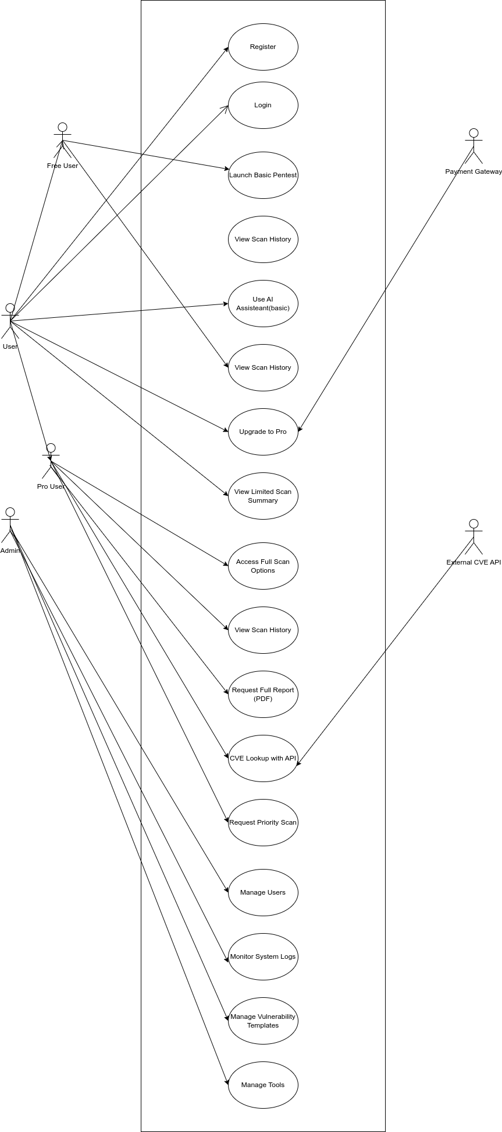Figure 1: figure1: Use Case Diagram

## 5.4 Use Case Description Table

| Use Case ID | Use Case Title | Actor | Description | Pre-conditions | Post-conditions |
| --- | --- | --- | --- | --- | --- |
| UC01 | User Authentication | Pentester | Allows users to log in with secure credentials | User account exists | Session initialized |
| UC02 | Launch Full Pentest | Pentester | Runs an automated multi-phase test (Recon → Report) | Target consent verified | Test initiated, AI logs created |
| UC03 | View AI Suggestions | Pentester | System provides AI-generated guidance based on scan results | Test results available | Suggestions displayed to user |
| UC04 | Generate Report | Pentester | Compiles a test report with AI annotations, CVE analysis, and remediation | Pentest completed | Report stored and downloadable |
| UC05 | Manage Test Projects | Pentester | Create, update, or delete test projects and view associated logs | User logged in | Project state updated in database |
| UC06 | Enforce Ethical Policy | System AI/Admin | Validates test scope and blocks harmful/unethical activities | Scan request initiated | Approved or blocked with reason |
| UC07 | Manage Users | Admin | Add, remove, or update users and view activity logs | Admin access | User DB updated, logs recorded |

Table 3: Use Case Summary for AI-SecPro Functionalities

Summary

The outlined functional and non-functional requirements reflect AI-SecPro's dual goals: to provide powerful, AI-driven pentesting features while ensuring ethical, secure, and scalable use. The use case modeling ensures that all system behaviors are traceable, testable, and user-focused, aligning with modern web-based security platforms' expectations. These requirements shaped both the design and the development trajectory of the system and are critical to its long-term success and adaptability.

# System Design & Architecture

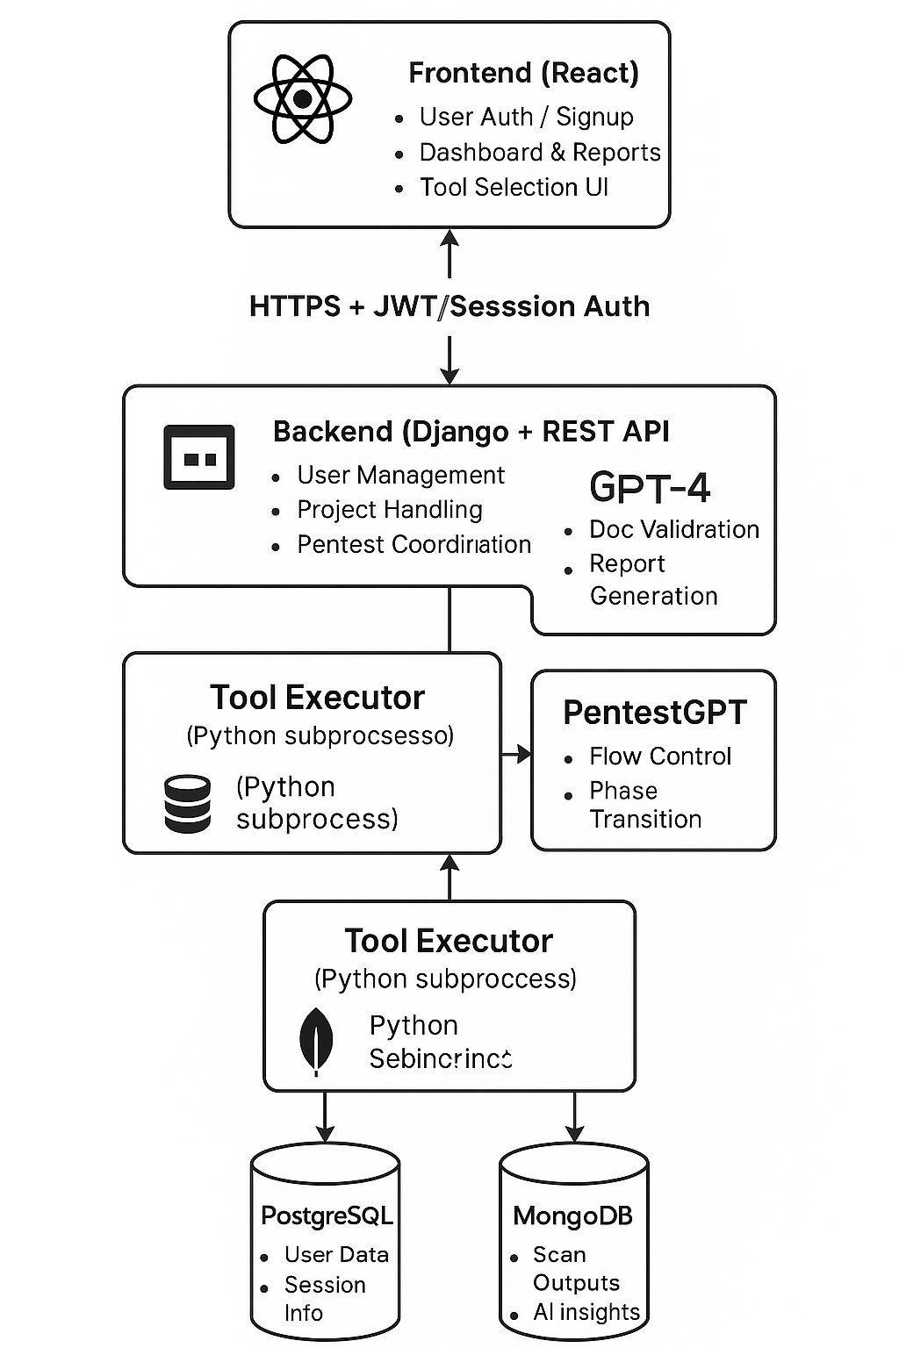Figure 2: SYstem Architecture Diagram

AI-

SecPro’s architecture was strategically designed to support scalability, performance, modularity, and security while enabling seamless integration of AI capabilities for automating the penetration testing lifecycle. This section presents the complete system architecture, functional data flow, component decomposition, and database design that collectively form the foundation of the application.

## 6.1 System Architecture Overview

The system architecture of AI-SecPro follows a modular, multi-tiered web application model. It includes a frontend layer, a backend service layer, an AI interaction layer, and data storage systems. The application is deployed on a containerized environment to ensure scalability and easy updates.

Key Layers:

* Frontend (React.js): Offers a responsive and interactive user interface for users to initiate pentests, view reports, manage projects, and receive AI guidance.
* Backend (Django REST Framework): Handles API requests, coordinates testing workflows, validates scope, and communicates with the AI engine and databases.
* AI Engine (GPT-4 + PentestGPT): Interfaces with OpenAI's API to interpret scan data, generate dynamic suggestions, and produce context-aware reports.
* Database Layer: PostgreSQL is used for structured data (user info, logs, reports), while MongoDB handles semi-structured or rapidly updating data (e.g., live scan results).

## 6.2 Data Flow Diagrams (DFD)

Level 0 – Context Diagram

This represents the system as a single process with interactions from external entities:

* Actors: Pentester (User), Admin, AI Engine, External Tools
* Processes: Receive Input → Validate → Execute Tests → Generate Report
* Data Stores: PostgreSQL, MongoDB

Level 1 – Detailed Functional Flows

Level 1 expands core functions into sub-processes:

* User Management
* Pentest Management
* AI-Powered Interpretation
* Report Generation
* Admin Controls

Data flows between these modules define how user input is processed, interpreted, stored, and returned.

## 6.3 Component Breakdown

The architecture was decomposed into loosely coupled components to enhance modularity and maintainability. Below is a breakdown of the main components:

### 6.3.1 Frontend (React.js)

* Authentication Interface: Supports login, registration, and password resets.
* Dashboard: Visual overview of tests, reports, and AI insights.
* Scan Interface: Launch individual or full-cycle tests, view real-time logs.
* AI Assistant Pane: Displays suggestions and interprets technical results.
* Report Viewer: Allows users to view and export reports in multiple formats.

### 6.3.2 Backend (Django REST API)

* Authentication API: JWT-based token authentication with user roles.
* Scan Controller: Manages scan phases and coordinates tool execution.
* AI Middleware: Parses input/output, sends prompts to the AI engine, receives contextual results.
* Ethics Filter: Ensures tests align with ethical/legal boundaries.
* Report Builder: Compiles results, CVE data, and AI analysis into structured reports.

### 6.3.3 AI Interaction Layer

* Prompt Generator: Formats output from scans into AI-readable prompts.
* GPT Query Module: Calls the OpenAI GPT-4 API or local models securely.
* AI Parser: Converts AI output into usable remediation steps or user messages.
* Feedback Enhancer: Tracks which suggestions were followed and refines guidance.

### 6.3.4 Admin & Logging

* Admin Dashboard: Provides access to user logs, session histories, ethical rule enforcement.
* Activity Logger: Records every scan and AI interaction for accountability.
* Error & Anomaly Detector: Identifies misuse or tool malfunctions.

## 6.4 PostgreSQL Entity Relationship Diagram (ERD)

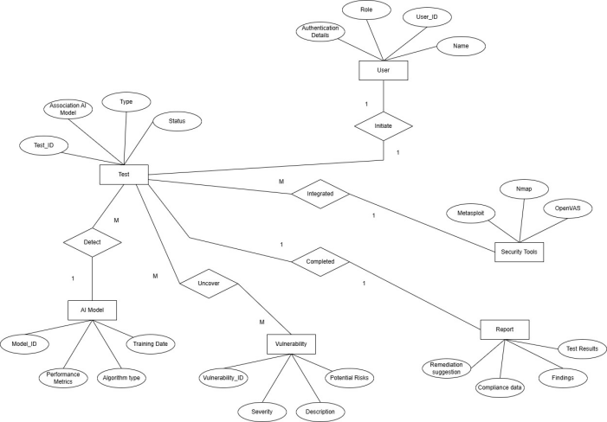

PostgreSQL was selected for managing structured, relational data due to its ACID compliance, mature tooling, and compatibility with Django ORM. The following are key entities and relationships:

6.5 MongoDB Schema Usage and Justification

MongoDB is used in parallel to PostgreSQL to manage non-relational, semi-structured, and real-time data:

Reasons for MongoDB Selection:

* Flexibility: Scan outputs vary based on tools, targets, and responses.
* Speed: Suitable for real-time logging of scan results.
* Scalability: Better handles large, nested documents like tool outputs and AI logs.

Collections:

* LiveLogs: Stores real-time updates from tool execution.
* ScanOutputs: Indexed documents per module (e.g., reconnaissance, vulnerabilities).
* AIConversations: Chat-like entries for AI guidance and user prompts.
* TemporaryCache: Stores transient state between modules or during failure recovery.

Summary

AI-SecPro’s architecture was meticulously designed to support the complex requirements of AI-assisted penetration testing. The use of both relational and non-relational databases ensures that both structured administrative data and unpredictable scan outputs are handled optimally. The separation of concerns through frontend/backend layers and the AI engine enables a robust, scalable, and secure design. The diagrams (architecture, DFD, ERD) provide a visual representation of how components interact and how data flows through the system.

# Implementation

This section provides a detailed breakdown of how AI-SecPro was implemented, focusing on each key module, AI integration, visual representation through screenshots, and challenges faced during development.

## 7.1 Module-by-Module Breakdown

1. User Authentication Module

* Technologies: Django (backend), JWT (token-based authentication), React (frontend)
* Features: Registration, login, role-based access control
* Implementation Highlights:
  + Used Django REST Framework for user model and authentication views.
  + JWT tokens issued upon login and verified for protected routes.
  + React handles session state and redirects.

2. Dashboard Module

* Technologies: React, Chart.js, Axios
* Features: Summary of tests, live updates, and scan history
* Implementation Highlights:
  + Axios used to fetch test summaries from Django APIs.
  + Real-time updates using WebSockets via Django Channels.

3. Pentest Launcher Module

* Technologies: Python (Nmap, Wfuzz, Nikto), Django, MongoDB
* Features: Select test type (Web App, Network, etc.), start/stop scans, track live progress
* Implementation Highlights:
  + Used subprocess in Python to call tools.
  + Results saved in MongoDB for quick retrieval and flexibility.

4. AI Assistant Module

* Technologies: GPT-4 (via OpenAI API), Flask (microservice), Django
* Features: AI-guided suggestions, vulnerability explanations, remediation support
* Implementation Highlights:
  + Flask API used as a middleware to handle prompt engineering.
  + AI responses parsed and saved into PostgreSQL for reuse.

5. Report Generator Module

* Technologies: Django, Jinja2 (PDF templates), PostgreSQL
* Features: Exportable reports (PDF), AI-enhanced analysis, CVE references
* Implementation Highlights:
  + Combined static analysis with GPT-generated explanations.
  + CVE details retrieved via API and embedded in reports.

6. Admin Panel

* Technologies: Django Admin, PostgreSQL
* Features: User monitoring, scan logs, error reports
* Implementation Highlights:
  + Extended default Django admin models.
  + Logs updated in real-time and visualized with filters.

## 7.2 Screenshots with Descriptions

1. Home Page

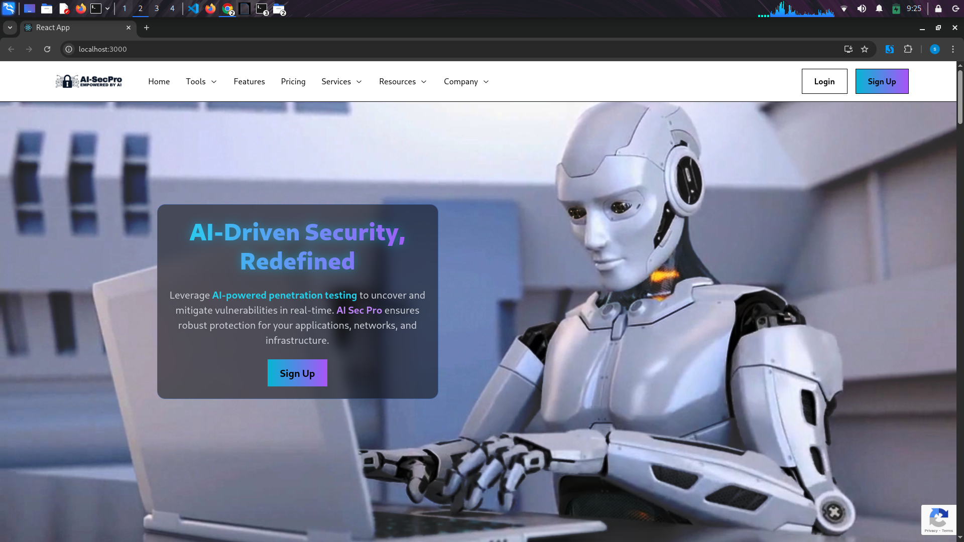Figure 3: Home UI 1

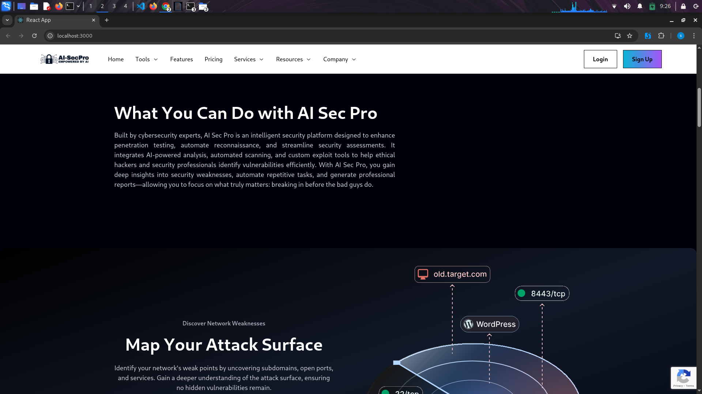Figure 4: Home UI 2

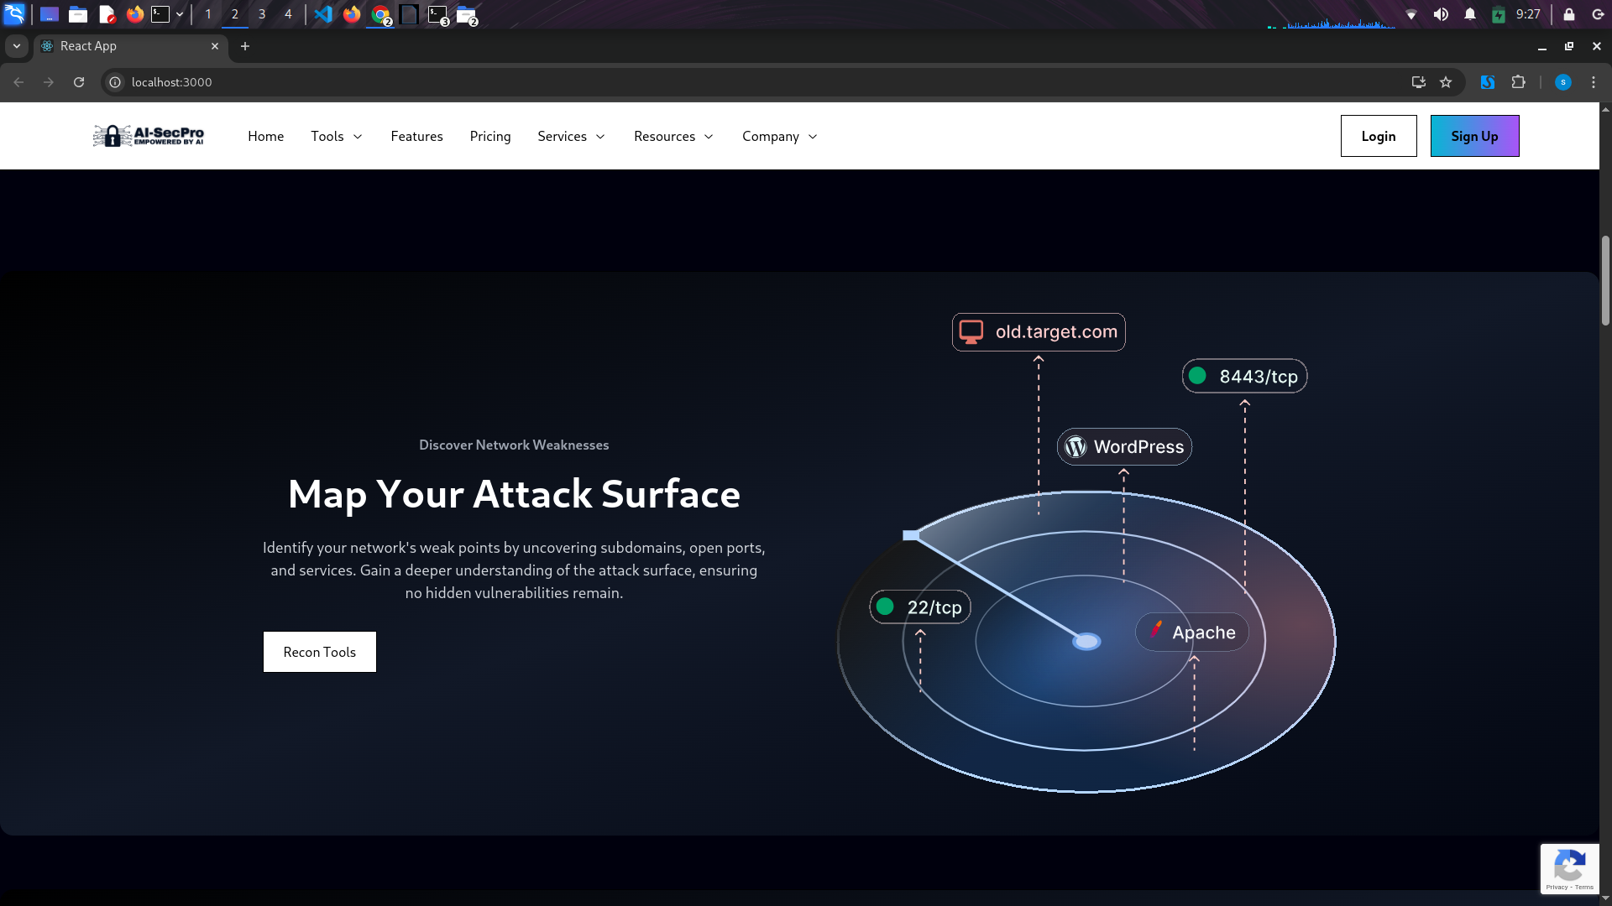Figure 5: Home UI 3

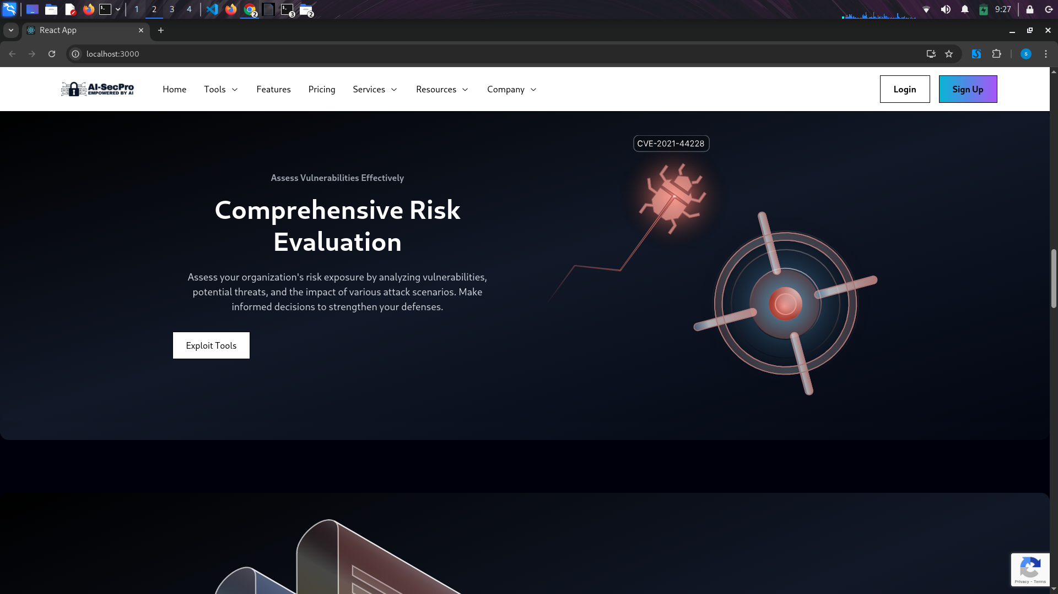Figure 6: Home UI 4

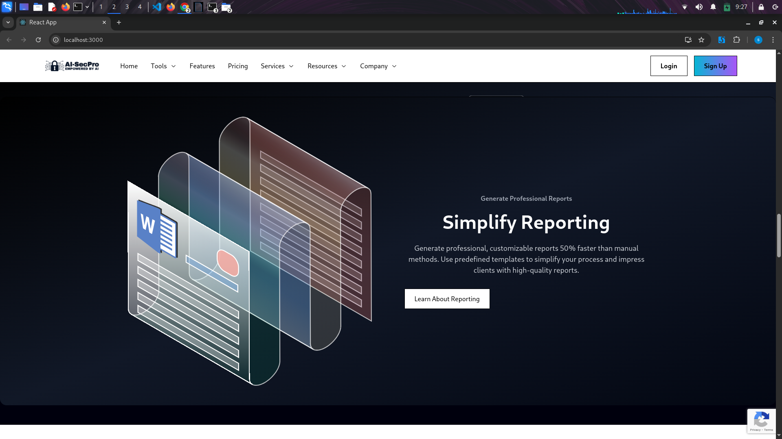Figure 7: Home UI 5

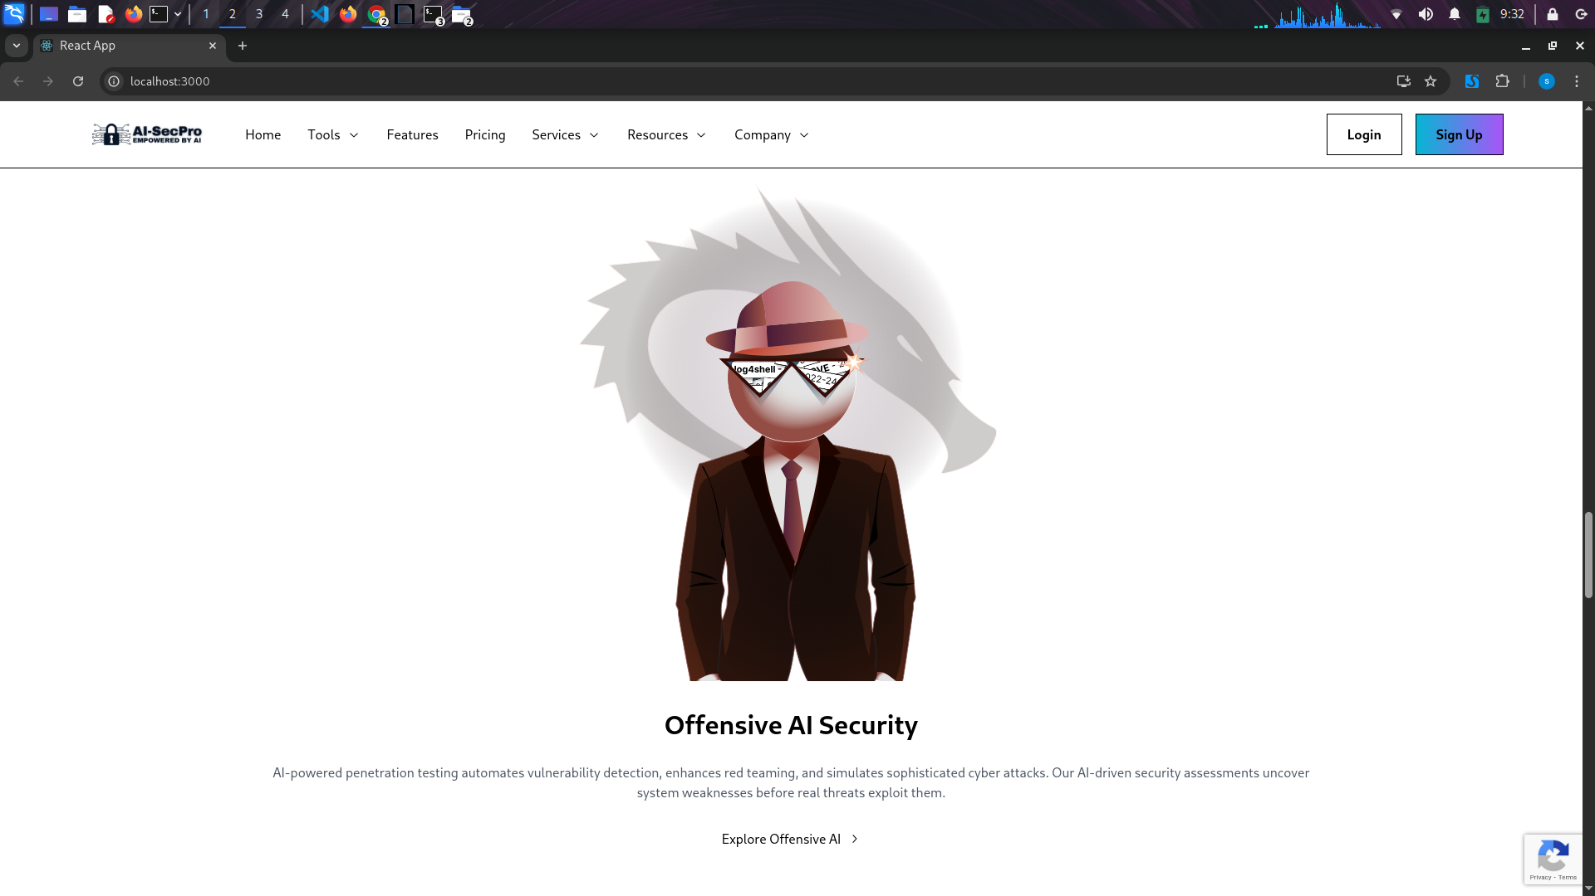Figure 8: Home UI 6

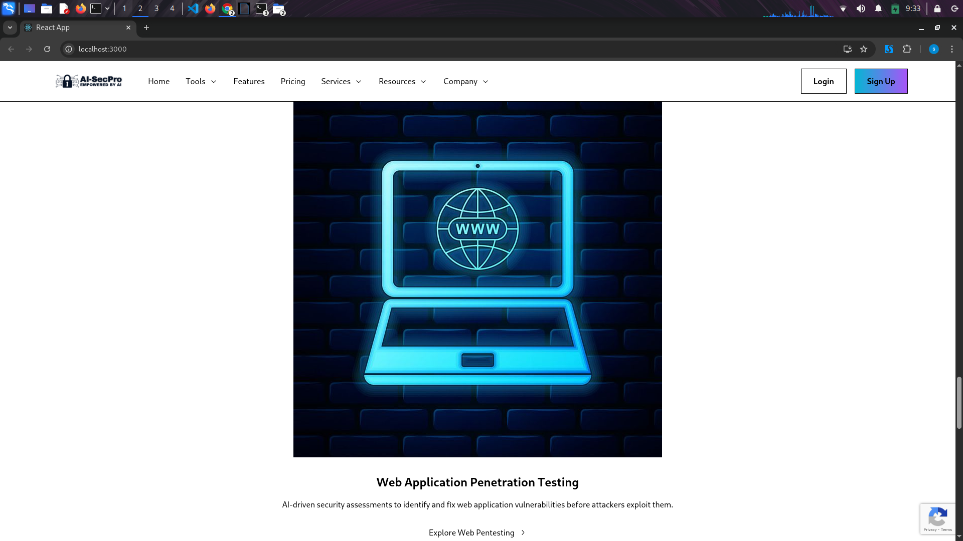Figure 9: Home UI 7

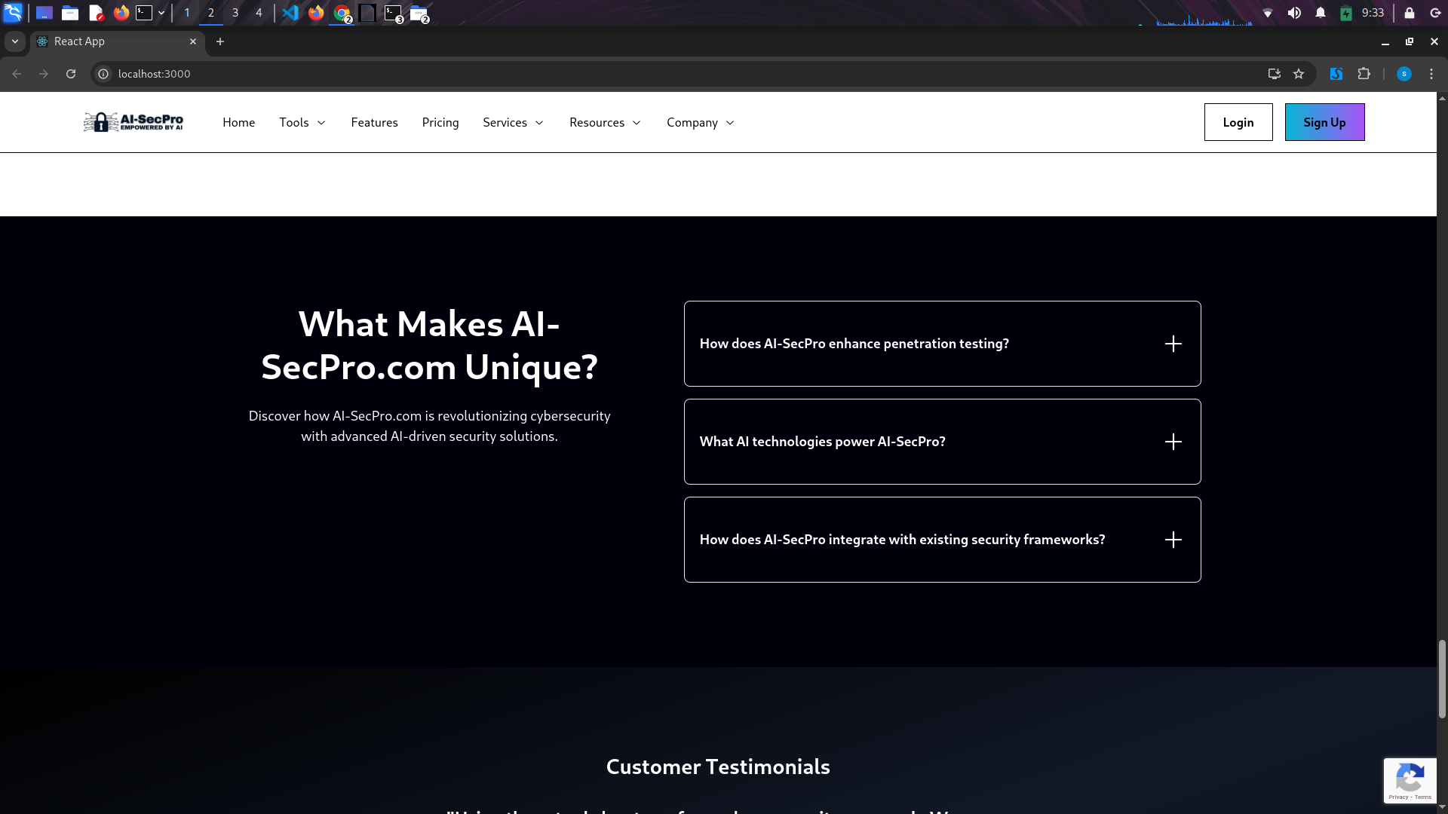Figure 10: Home UI 8

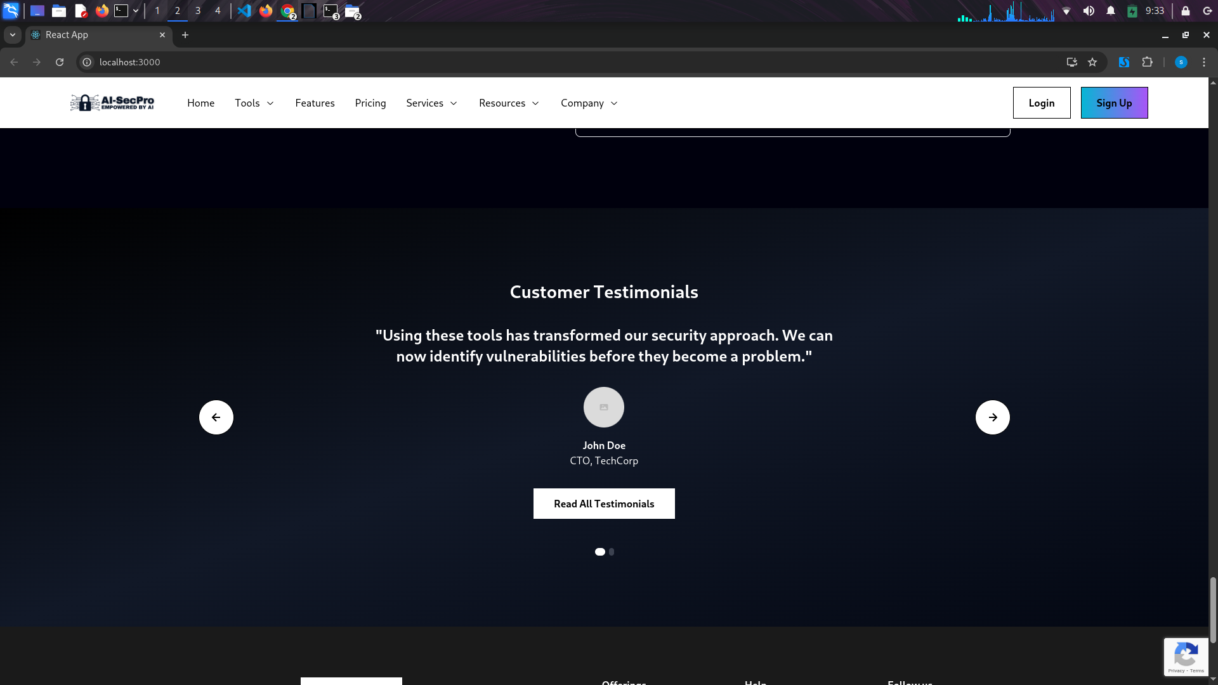Figure 11: Home UI 9

* A professional and user-friendly UI design that showcases the core features of AI-SecPro.

2. Tools

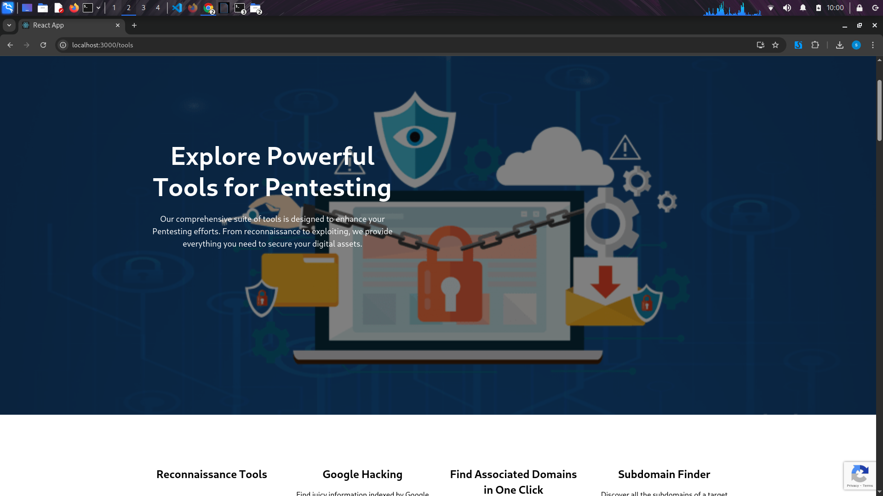Figure 12: Tool UI 1

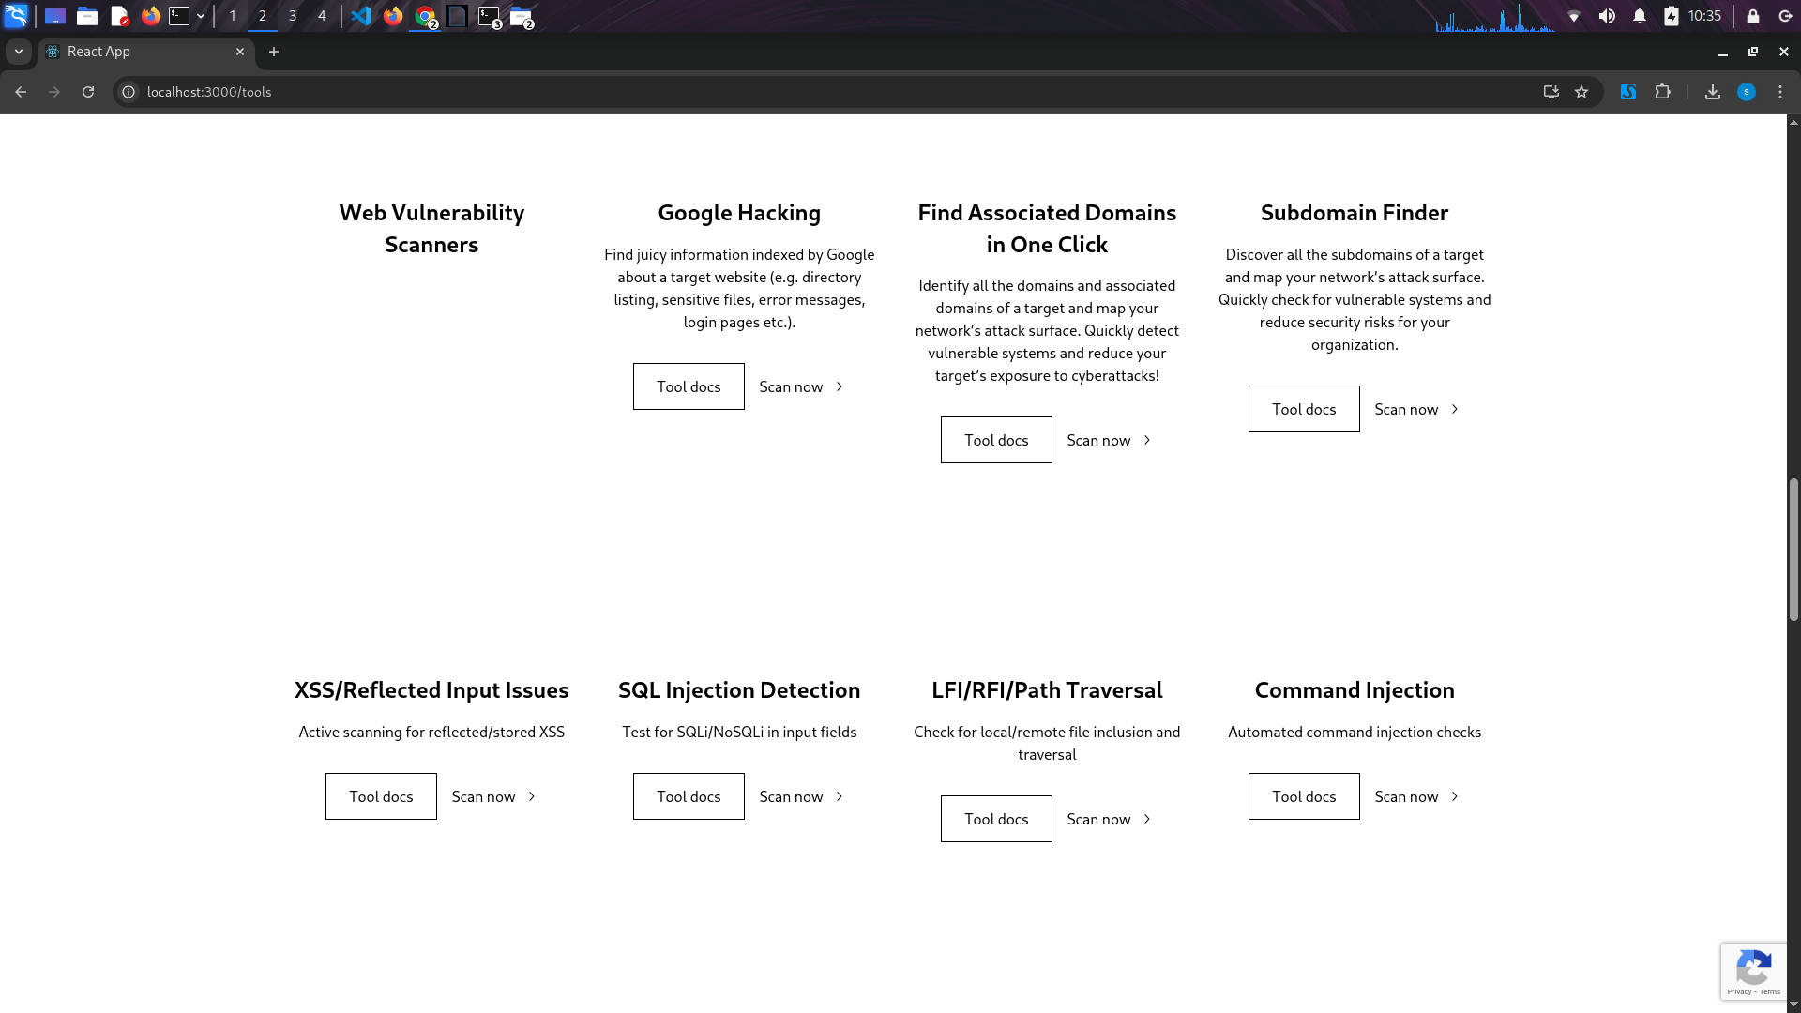Figure 13: Tools UI 2

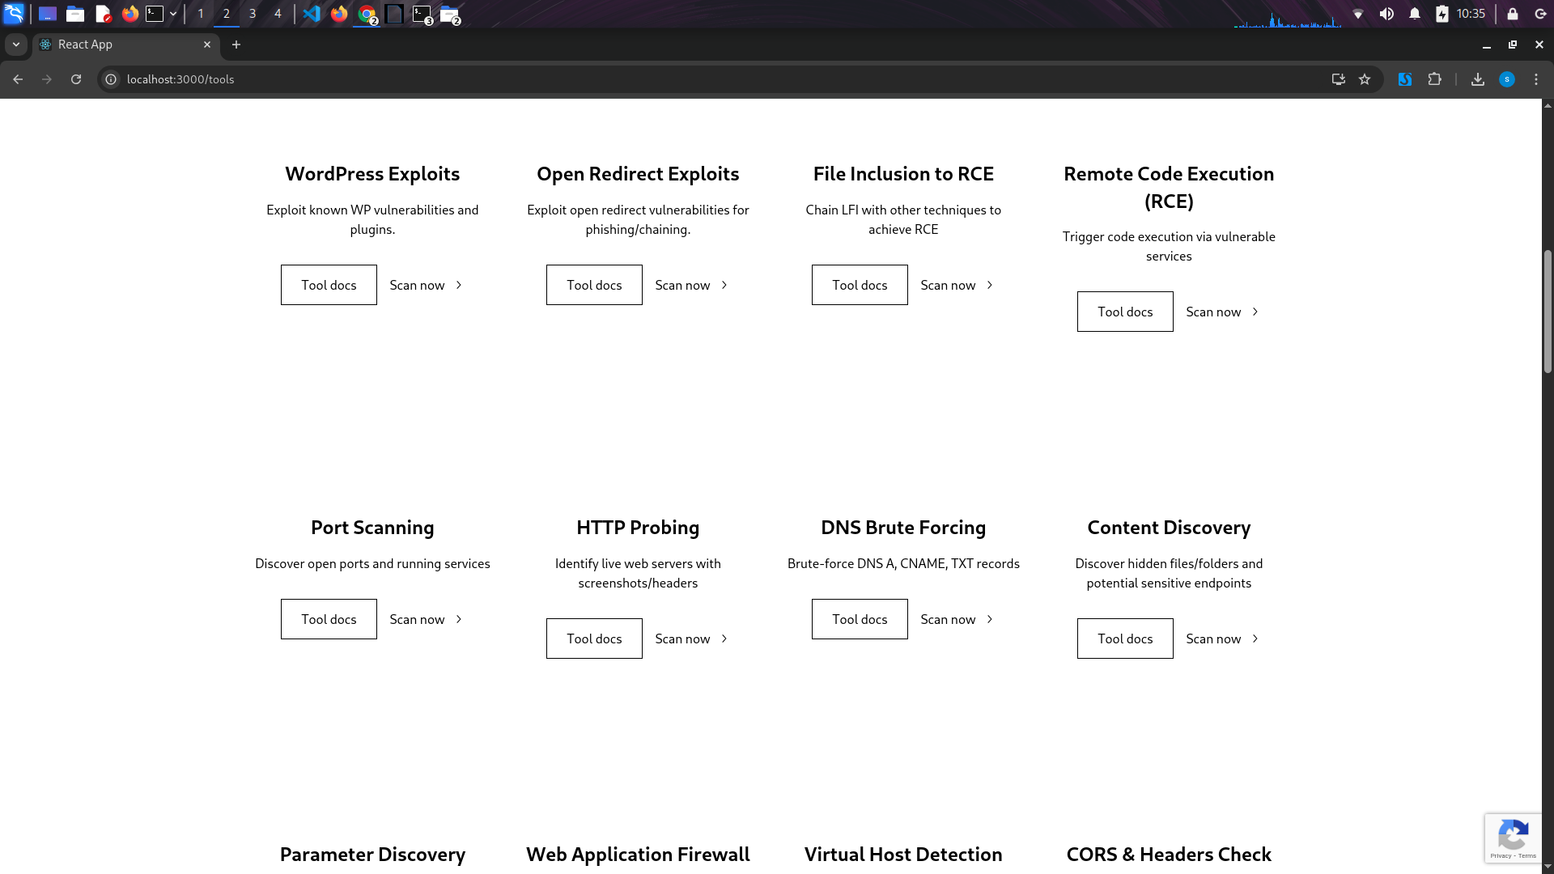Figure 14: Tool UI 3

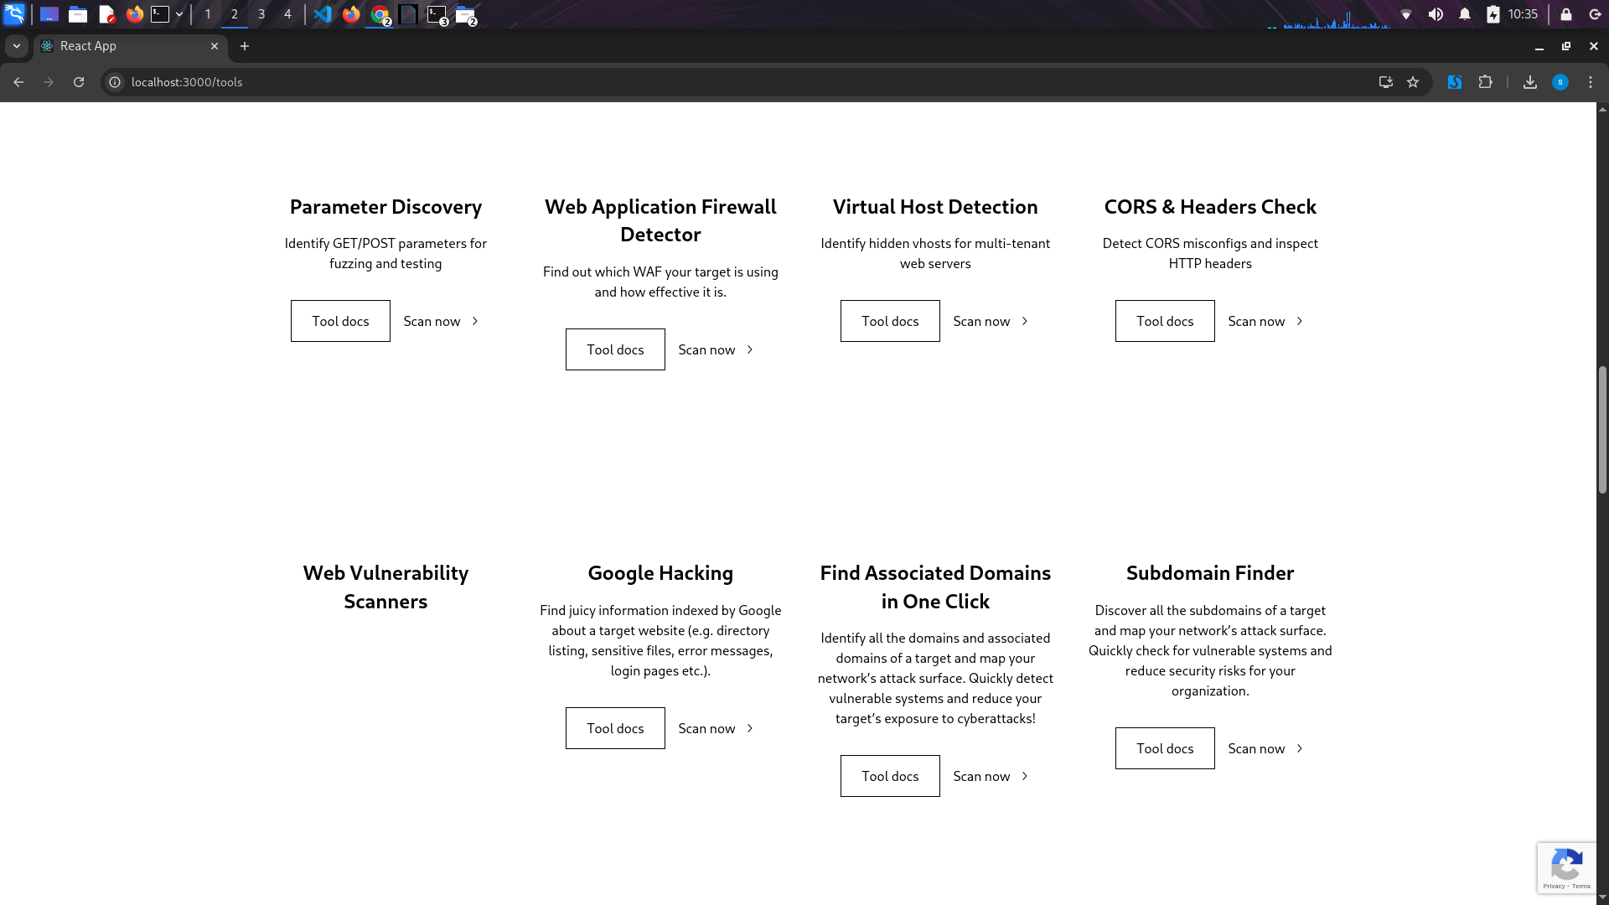Figure 15: Tool UI 4

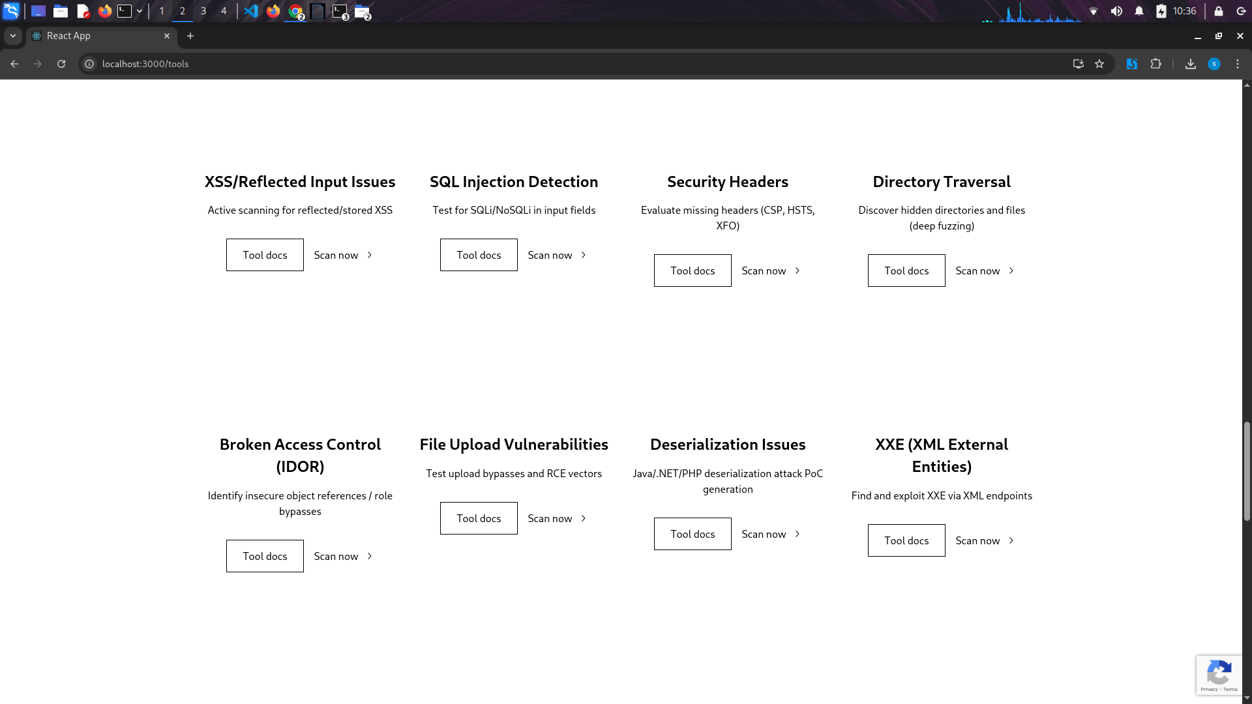Figure 16: Tool UI 5

Recon Tools

1. Subdomain Enumeration

Tools: Subfinder, Assetfinder, Amass, Findomain

AI-Sec Pro Logic:

Finds subdomains using passive and active methods.

Aggregates from multiple sources to avoid duplicates.

AI Output (GPT-4):

Lists discovered subdomains (e.g., dev.target.com, mail.target.com).

Prioritizes based on activity and known exposure (e.g., from Shodan or past leaks).

2. DNS & Zone Data

Tools: dnsx, dig, dnsenum, massdns

AI-Sec Pro Logic:

Gathers DNS A/CNAME/TXT records and tests for zone transfers.

Maps infrastructure based on DNS resolution patterns.

AI Output (GPT-4):

Reveals MX records, SPF misconfigs, wildcard domains.

Flags anomalies for DNS takeover or phishing setups.

3. URL Collection

Tools: gau, gauplus, Waybackurls, Katana

AI-Sec Pro Logic:

Pulls URLs from web archives and known paths.

Sorts by extension (.php, .bak, .action) and parameterized endpoints.

AI Output (GPT-4):

Shows potential legacy endpoints like /old-login.php.

Suggests LFI/RCE/XSS payload injection based on patterns.

4. Crawling & Spidering

Tools: Hakrawler, Crawlee, SpiderFoot, Burp Spider

AI-Sec Pro Logic:

Recursively maps internal links and hidden paths.

Filters dynamic and script-generated endpoints.

AI Output (GPT-4):

Highlights /admin, /internal-api, or deeply nested routes.

Advises on session-based access control testing.

5. JS File Analysis

Tools: LinkFinder, JSParser, SecretFinder

AI-Sec Pro Logic:

Analyzes JS files for secrets, APIs, and hidden parameters.

Traces imported scripts for chained recon.

AI Output (GPT-4):

Finds hardcoded keys, JWT tokens, and internal endpoints.

Links discovered APIs with Swagger or Postman collections.

6. Technology Fingerprinting

Tools: WhatWeb, Wappalyzer, BuiltWith, Nmap (http-enum)

AI-Sec Pro Logic:

Detects CMS, frameworks, language, plugins.

Matches stack components with known CVEs.

AI Output (GPT-4):

Shows stack (e.g., Apache + WordPress + PHP 7.4).

Flags outdated or vulnerable tech.

Suggests CVE-based targeted fuzzing or exploits.

7. Directory Discovery

Tools: ffuf, Dirsearch, Feroxbuster, Gobuster

AI-Sec Pro Logic:

Brute-forces paths for hidden files or admin panels.

Uses wordlists intelligently based on fingerprinting.

AI Output (GPT-4):

Lists found directories (e.g., /backup, /dev, /uploads).

Highlights access controls or misconfigured resources.

Suggests chaining with file upload/LFI in future phases.

8. Parameter Discovery

Tools: ParamSpider, Arjun, Gau

AI-Sec Pro Logic:

Extracts GET/POST parameters from URLs and JS.

Feeds into fuzzers for XSS/SQLi testing.

AI Output (GPT-4):

Lists parameters like id=, file=, lang=.

Classifies based on attack vectors (e.g., LFI-prone).

9. Virtual Host Detection

Tools: VHostScan, Gobuster (vhost), DNSGen

AI-Sec Pro Logic:

Identifies alternate domain configs via Host headers.

Useful in multi-tenant or staging environments.

AI Output (GPT-4):

Detects hidden vhosts (e.g., dev.target.com).

Recommends testing for logic flaws or stale deployments.

10. HTTP Probing

Tools: httpx, curl, httprobe

AI-Sec Pro Logic:

Validates live web services with headers, status, title.

Filters out false positives (e.g., default server pages).

AI Output (GPT-4):

Returns server headers, redirection chains, response times.

Flags interesting ports (e.g., 8080 with admin panels).

11. Screenshotting

Tools: Aquatone, Eyewitness, httpx (screenshot)

AI-Sec Pro Logic:

Captures visual layouts to identify login/admin portals.

Helps in team-based prioritization and reporting.

AI Output (GPT-4):

Displays visual structure of web targets.

Suggests weak branding/authenticity — phishing risk.

12. Archive/Backup Hunting

Tools: Wayback Machine, Commoncrawl, ArchiveBox

AI-Sec Pro Logic:

Finds removed endpoints, leaked backups, or deleted repos.

Cross-matches historical data with current exposure.

AI Output (GPT-4):

Lists old .zip, .tar, or .bak links.

Flags endpoints for sensitive file leaks.

13. CORS & Headers Check

Tools: Corsy, httpx, curl -I

AI-Sec Pro Logic:

Inspects CORS headers and evaluates security headers.

Detects if misconfigs allow arbitrary origins.

AI Output (GPT-4):

Finds missing headers like CSP, X-Frame-Options.

Suggests exploitability via CORS bypass or clickjacking.

14. Sitemap/Robots Discovery

Tools: curl, wget, robots.txt parser

AI-Sec Pro Logic:

Parses robots.txt and sitemap.xml for disallowed paths.

Uses findings for targeted fuzzing.

AI Output (GPT-4):

Reveals restricted areas like /admin/, /backup/.

Recommends directory traversal or auth bypass testing.

15. GitHub Recon

Tools: GitDorker, Github-Subdomains, GitRob

AI-Sec Pro Logic:

Searches code leaks, secrets, and endpoints via GitHub dorking.

Links sensitive data back to target domains.

AI Output (GPT-4):

Finds .env, hardcoded creds, API tokens.

Suggests chaining into login bypass or RCE.

16. SSL/TLS Analysis

Tools: SSLScan, sslyze, testssl.sh

AI-Sec Pro Logic:

Analyzes SSL certs, ciphers, and common misconfigs.

Correlates weak ciphers with downgrade or MITM attacks.

AI Output (GPT-4):

Flags expired or wildcard certs.

Suggests SSL downgrade attacks (e.g., POODLE, BEAST).

Vulnerabilities Scanners

1. Vulnerability Scanning

Tools: Nessus, OpenVAS, Nexpose

AI-Sec Pro Logic:

Scans for open ports, services, OS, and known CVEs.

Correlates vulnerabilities with threat intelligence feeds.

AI Output (GPT-4):

Lists vulnerabilities (e.g., CVE-2022-1388 on port 443).

Scores severity (CVSS), recommends prioritization.

Suggests exploits or patches based on vendor data.

2. Web Application Vulnerability Scanning

Tools: Nikto, OWASP ZAP, Burp Suite Scanner

AI-Sec Pro Logic:

Scans for outdated software, XSS, SQLi, LFI, RFI.

Evaluates headers, cookies, and authentication issues.

AI Output (GPT-4):

Finds reflected XSS in search?q= parameter.

Recommends payloads or logic flaw tests.

Provides remediation references (OWASP/WSTG).

3. Auth & Session Issues

Tools: Burp Suite Pro, ZAP, AuthMatrix

AI-Sec Pro Logic:

Tests session management, token strength, role tampering.

Evaluates logout behavior, multi-login, session expiry.

AI Output (GPT-4):

Flags missing HttpOnly, Secure flags.

Finds privilege escalation (e.g., user accessing /admin).

Suggests session hijack simulation or fix via token hardening.

4. Container & Docker Image Scanning

Tools: Trivy, Grype, Dockle

AI-Sec Pro Logic:

Analyzes Dockerfiles, images for vulnerable packages.

Flags misconfigs (e.g., root user, no healthcheck).

AI Output (GPT-4):

Reports CVEs in alpine:3.14 base image.

Suggests upgrading packages or using minimal base images.

5. Dependency/Package Scanning

Tools: NPM Audit, Yarn Audit, Pip-audit, Snyk

AI-Sec Pro Logic:

Inspects libraries and packages for vulnerabilities.

Maps transitive dependencies and supply-chain risks.

AI Output (GPT-4):

Finds vulnerable lodash <4.17.21.

Suggests exact patched version.

Recommends automated pipeline checks (CI/CD integration).

6. WordPress Vulnerability Scanning

Tools: WPScan, WPSeku

AI-Sec Pro Logic:

Detects plugins, themes, version, and known CVEs.

Checks for default credentials and backup files.

AI Output (GPT-4):

Finds vulnerable revslider plugin.

Flags publicly accessible /wp-config.php.save.

Recommends plugin updates or access controls.

7. API Vulnerability Scanning

Tools: Postman, Burp Suite, ZAP, Nuclei (with API templates)

AI-Sec Pro Logic:

Tests input validation, auth, rate-limiting, and misconfigurations.

Validates OpenAPI/Swagger schemas.

AI Output (GPT-4):

Detects insecure PUT methods and broken auth.

Highlights rate-limit bypass via IP rotation.

Suggests abuse scenarios (e.g., mass user creation).

8. Custom Vulnerability Templates

Tools: Nuclei (custom templates), Dalfox (for XSS), gf + httpx

AI-Sec Pro Logic:

Uses community or AI-generated templates to find niche issues.

Combines recon data into automated scan workflows.

AI Output (GPT-4):

Generates YAML templates for tech-specific CVEs.

Finds unique XSS vectors using Dalfox.

Suggests chaining multiple scans for better depth.

Exploitation Tools (High-Level Protection)

1. WordPress Exploits

Tools: WPScan, Metasploit (aux modules), Nuclei, wpsploit

AI-Sec Pro Logic:

Detects vulnerable plugins/themes and known CVEs.

Chains discovered vulnerabilities for automated exploitation.

AI Output (GPT-4):

Finds vulnerable wp-file-manager <6.9.

Crafts payload for RCE via file upload.

Suggests lateral movement via exposed admin panel.

2. Remote Code Execution (RCE)

Tools: Metasploit, Exploit-DB, Nuclei, Manual CURL/PHP reverse shell

AI-Sec Pro Logic:

Triggers execution through command injection, unsafe deserialization, SSRF, etc.

Confirms shell access and verifies impact.

AI Output (GPT-4):

RCE in upload.php using ; nc <IP> -e /bin/bash.

Confirms callback and provides persistence strategy.

Recommends privilege escalation path if applicable.

3. File Inclusion to RCE (LFI → RCE)

Tools: FFUF, LFI Suite, Burp, Nmap scripts

AI-Sec Pro Logic:

Chains LFI + log injection or proc/self/environ tricks.

Tries PHP wrapper exploitation or Apache logs.

AI Output (GPT-4):

LFI in ?page= leads to /var/log/auth.log inclusion.

Injects PHP webshell via SSH login.

Detects resulting web shell at shell.php.

4. Open Redirect Exploits

Tools: Burp Suite, Nuclei, FFUF + templates

AI-Sec Pro Logic:

Identifies exploitable redirect parameters.

Suggests phishing/SSO bypass or OAuth misuse.

AI Output (GPT-4):

Redirect in redirect=?next= points to attacker.com.

Used in phishing flow or auth token theft.

Suggests defense bypass using payload encoding.

5. Port-Based Exploitation

Tools: Metasploit, Nmap scripts, Ncat, Hydras, Manual payloads

AI-Sec Pro Logic:

Targets weak services (FTP, SMB, RDP, SSH).

Performs brute-force, misconfig testing, and service-specific payloads.

AI Output (GPT-4):

FTP anonymous login allows file upload.

SSH service uses weak credentials (admin:admin).

Exploitable Samba with EternalBlue (CVE-2017-0144).

6. WAF/Firewall Evasion Exploits

Tools: WAFW00F, Burp, Nuclei bypass templates

AI-Sec Pro Logic:

Detects WAF and tries known bypass techniques.

Encodes payloads, uses headers like X-Original-URL.

AI Output (GPT-4):

WAF bypassed using ../../ + null byte for LFI.

RCE payload sent in X-Forwarded-Host.

Detects WAF vendor and evasion thresholds.

7. Virtual Host Takeover

Tools: VHostScan, FFUF, DNS takeover scripts

AI-Sec Pro Logic:

Discovers dangling vhosts or misconfigured subdomains.

Checks takeover viability via response status and headers.

AI Output (GPT-4):

Subdomain dev.target.com points to unclaimed Heroku app.

Provides template to claim and set malicious landing page.

8. CORS Exploits

Tools: Corsy, Burp, curl

AI-Sec Pro Logic:

Detects wildcard origins or reflective origin headers.

Attempts unauthorized cross-origin data access.

AI Output (GPT-4):

Access-Control-Allow-Origin: * on GET /account.

Confirms data leak via malicious origin in browser.

Suggests exfil vector using XHR/Fetch in injected JS.

9. File Upload Exploits

Tools: Burp, Upload Bypass Payloads, PHP Shells

AI-Sec Pro Logic:

Bypasses extension filters, magic bytes checks.

Tries alternate encoding, double extensions.

AI Output (GPT-4):

JPEG polyglot upload leads to shell execution.

Exploit path: uploads/shell.jpg.php.

AI suggests privilege escalation after successful upload.

10. Chaining Exploits

Tools: Custom logic, Bash scripts, Metasploit modules

AI-Sec Pro Logic:

Chains vulnerabilities (e.g., open redirect + RCE).

Uses data from recon, vuln scan, and privilege info.

AI Output (GPT-4):

Open redirect + stolen session → admin panel → file upload → RCE.

Provides attack chain narrative and automated script.

All tools are customizable.

3. Services

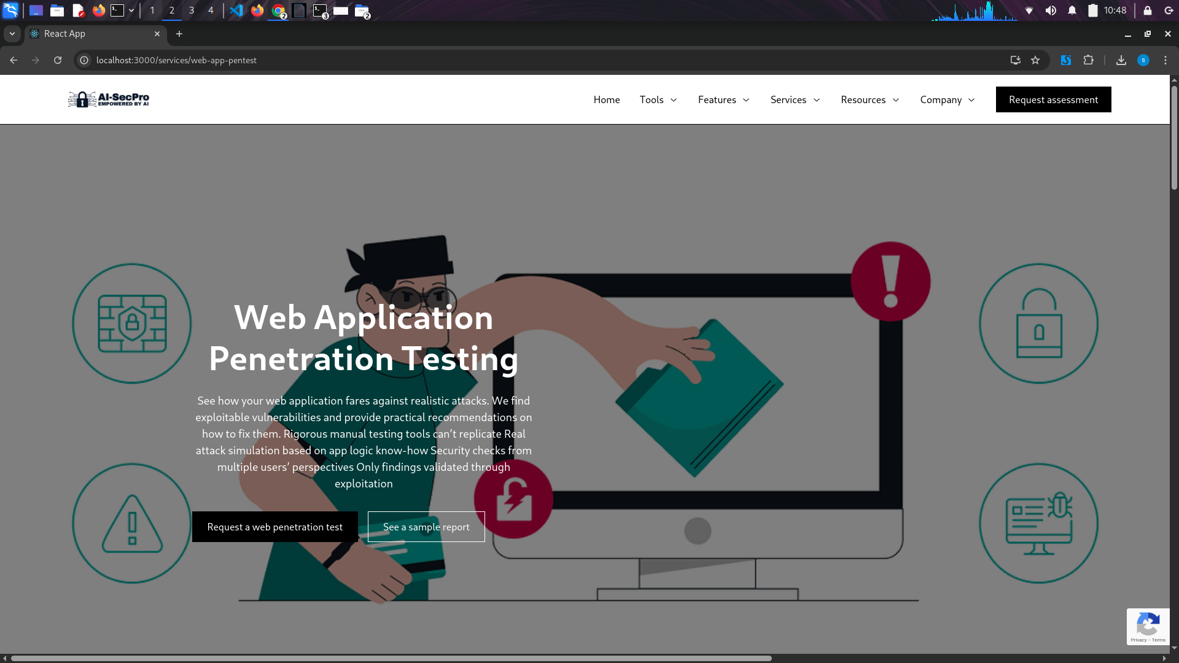Figure 17: Web Pentesting Service UI

Full Process for Web Pentest

1. User Login & Project Setup

Action: The user logs in to AI-SecPro.

Input: The user creates a new project and selects the target (domain or IP address).

Action: The user uploads a Pre-engagement Agreement (contract) which specifies the scope of the pentest (Gray, White, or Black Box).

The agreement is stored in PostgreSQL.

2. Choose Penetration Test Type:

Action: The user is presented with the options to select the type of penetration test:

Gray Box Test: Partial knowledge (user provides basic credentials or partial system access).

White Box Test: Full knowledge (user provides complete access, such as source code, architecture details, or full administrative access).

Black Box Test: No knowledge (attacker has no prior knowledge, simulating a real-world external attack).

AI Process: Based on the selection, PentestGPT dynamically adjusts the testing flow.

3. Pre-Engagement Document Analysis (AI Validation)

Action: The pre-engagement document is validated by GPT-4o using the OpenAI API.

AI Process:

For Gray Box and White Box: GPT-4o checks for necessary credentials or access information.

For Black Box: The document is checked for details on scope (e.g., allowed attack surfaces).

AI Suggestions: If critical information is missing, the user is alerted to upload or clarify the missing details. This step ensures all necessary input is complete before proceeding.

4. Reconnaissance Phase (Tool Selection & Execution)

Gray Box:

Action: Since the user has some knowledge of the system (e.g., access credentials, subdomains), PentestGPT recommends partial recon tools.

Tools used: Nmap, DNSenum, Gobuster, Sublist3r.

Tool Executor runs the tools.

Output: Results are stored in MongoDB (open ports, services, subdomains, etc.).

White Box:

Action: The user provides full access, so PentestGPT can recommend deeper scans.

Tools used: OWASP ZAP, Burp Suite (for web app testing), Static code analysis tools like CodeQL.

Output: Scans are more detailed, analyzing web applications, APIs, and code for security flaws.

Output: Results are stored in MongoDB and parsed by GPT-4o.

Black Box:

Action: PentestGPT suggests tools as if the attacker has no prior knowledge.

Tools used: Nmap for port scanning, Dirb for directory brute-forcing, Gobuster for subdomain discovery, etc.

Output: Results are stored in MongoDB.

5. Vulnerability Scanning & Analysis

Gray Box:

Action: Based on partial access, PentestGPT suggests scanning for vulnerabilities related to exposed services or credentials.

Tools: Nikto, Nessus.

Output: Vulnerability information is parsed by GPT-4o (e.g., CVE details, severity).

Results are saved in MongoDB.

White Box:

Action: Full access allows for more comprehensive scanning, including source code, authentication mechanisms, and service configurations.

Tools: OWASP Dependency Check, CodeQL, Burp Suite (for detailed web app testing).

Output: Results are parsed by GPT-4o for analysis and stored in MongoDB.

Black Box:

Action: PentestGPT chooses tools based on externally visible attack vectors (e.g., open ports, services).

Tools: Nikto, Masscan, Nmap.

Output: Results are stored in MongoDB and analyzed by GPT-4o.

6. Exploitation Phase (Tool Execution Based on Test Type)

Gray Box:

Action: PentestGPT maps any discovered vulnerabilities to corresponding exploits (e.g., using Metasploit or searchsploit).

Tool Executor runs the exploit.

Output: The results (successful exploitation or failure) are logged in MongoDB.

White Box:

Action: With full access, PentestGPT can exploit deeper vulnerabilities, like privilege escalation and accessing sensitive areas of the system.

Tools: Metasploit, searchsploit, custom exploit scripts.

Output: Results are saved in MongoDB, detailing success, access obtained, etc.

Black Box:

Action: Since the attacker has no prior knowledge, the focus is on exploiting external vulnerabilities.

Tools: Metasploit (external exploits), Nikto (web vulnerabilities).

Output: The system logs successful exploits or failed attempts.

7. Post-Exploitation (Optional Phase)

Gray Box:

Action: PentestGPT suggests post-exploitation tasks like privilege escalation or lateral movement within the target system (depending on the level of access).

Tools: linPEAS, pspy (for Linux systems).

Output: Post-exploitation results are logged and saved in MongoDB.

White Box:

Action: Full access allows for deeper post-exploitation analysis, such as altering configurations, maintaining persistence, and gathering sensitive data.

Tools: linPEAS, pspy, custom scripts.

Output: Detailed logs are saved in MongoDB.

Black Box:

Action: The platform may suggest lateral movement if internal network access is gained.

Tools: Metasploit for pivoting, Mimikatz (if Windows target).

Output: Results are logged in MongoDB.

8. Report Generation (Final Report Creation)

Action: GPT-4o generates a detailed penetration test report based on the results from all phases:

Executive Summary: Overview of the pentest, including goals, target, and test type.

Technical Report: Detailed findings, including tool outputs, CVEs, vulnerabilities, and exploits.

Post-Exploitation Notes: If applicable, describe the level of access and any sensitive information gathered.

Recommendations: Specific mitigation or patching suggestions.

AI Integration: The report is formatted in PDF or HTML formats.

4. FAQ

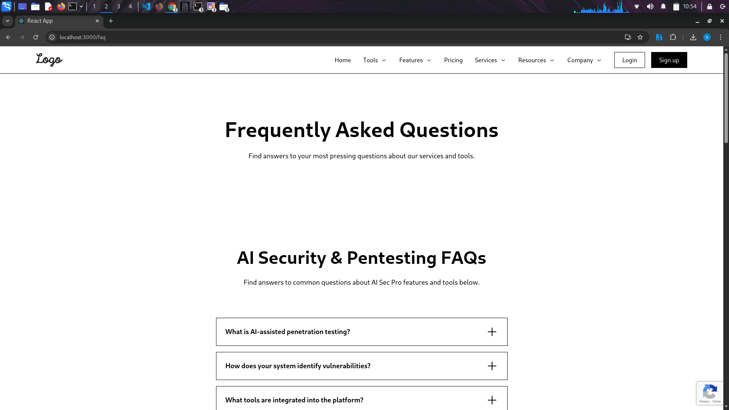Figure 18: FAQ

* Frequently Asked Questions.

5. AI-SecPro About

Figure 19: ABout 1

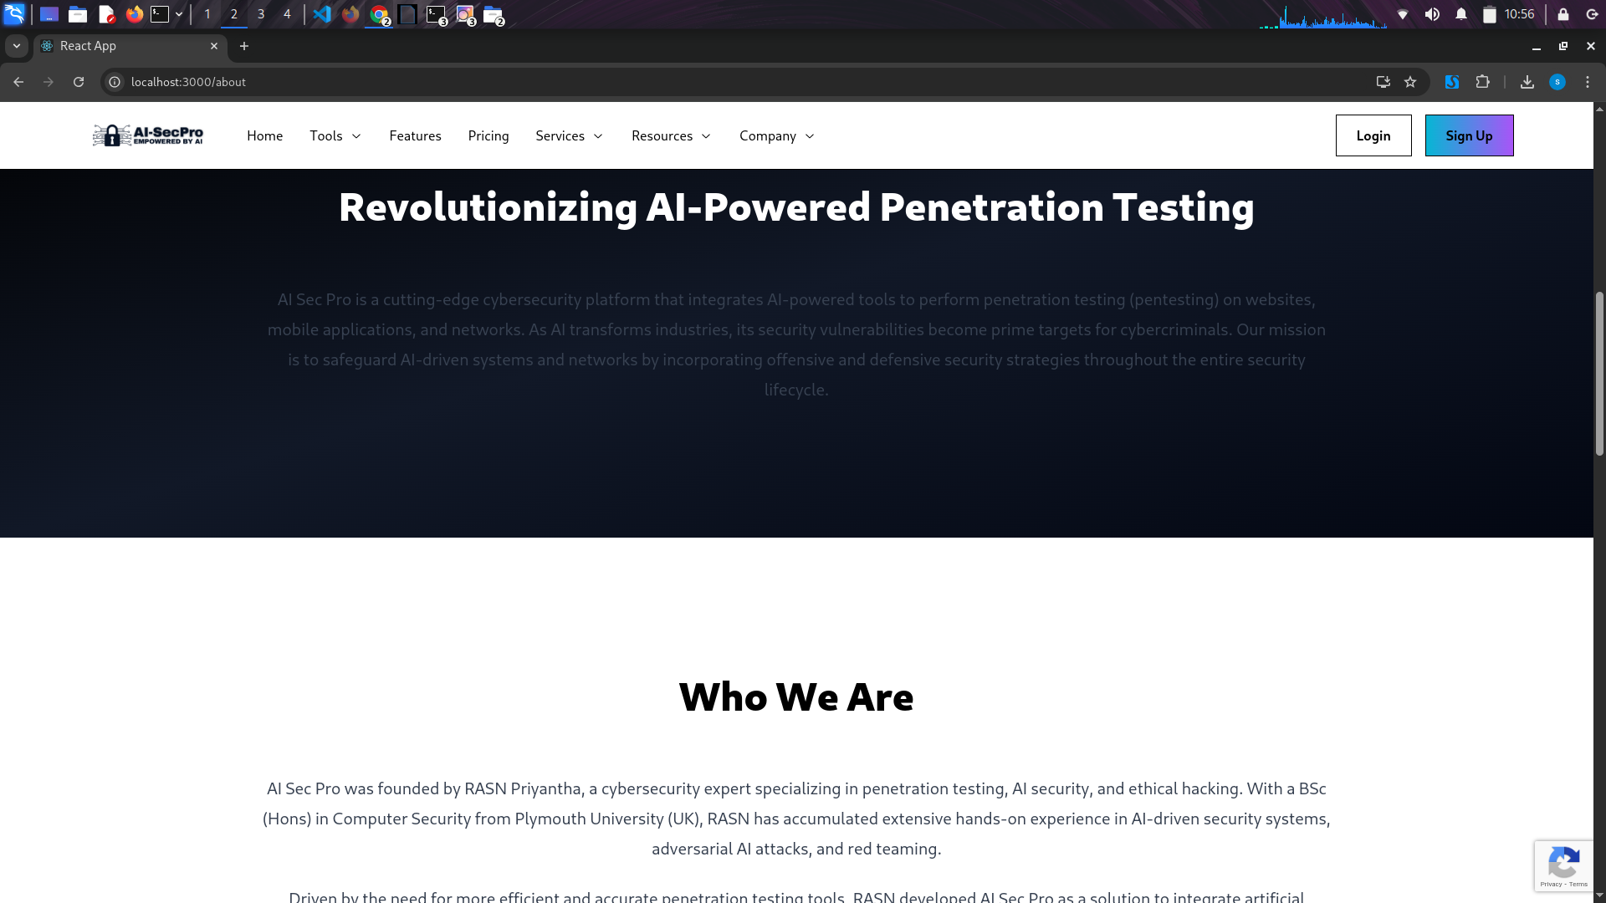Figure 20: About 2

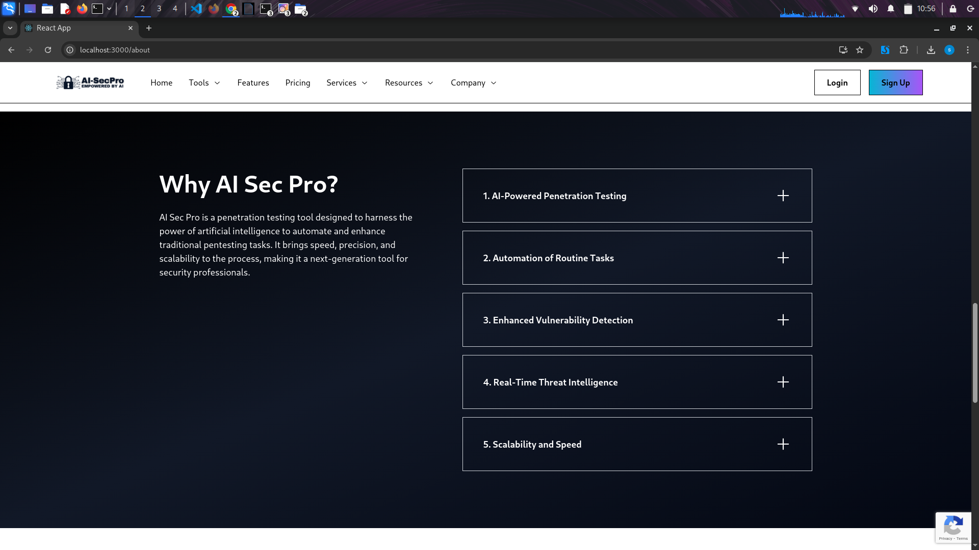Figure 21: About 3

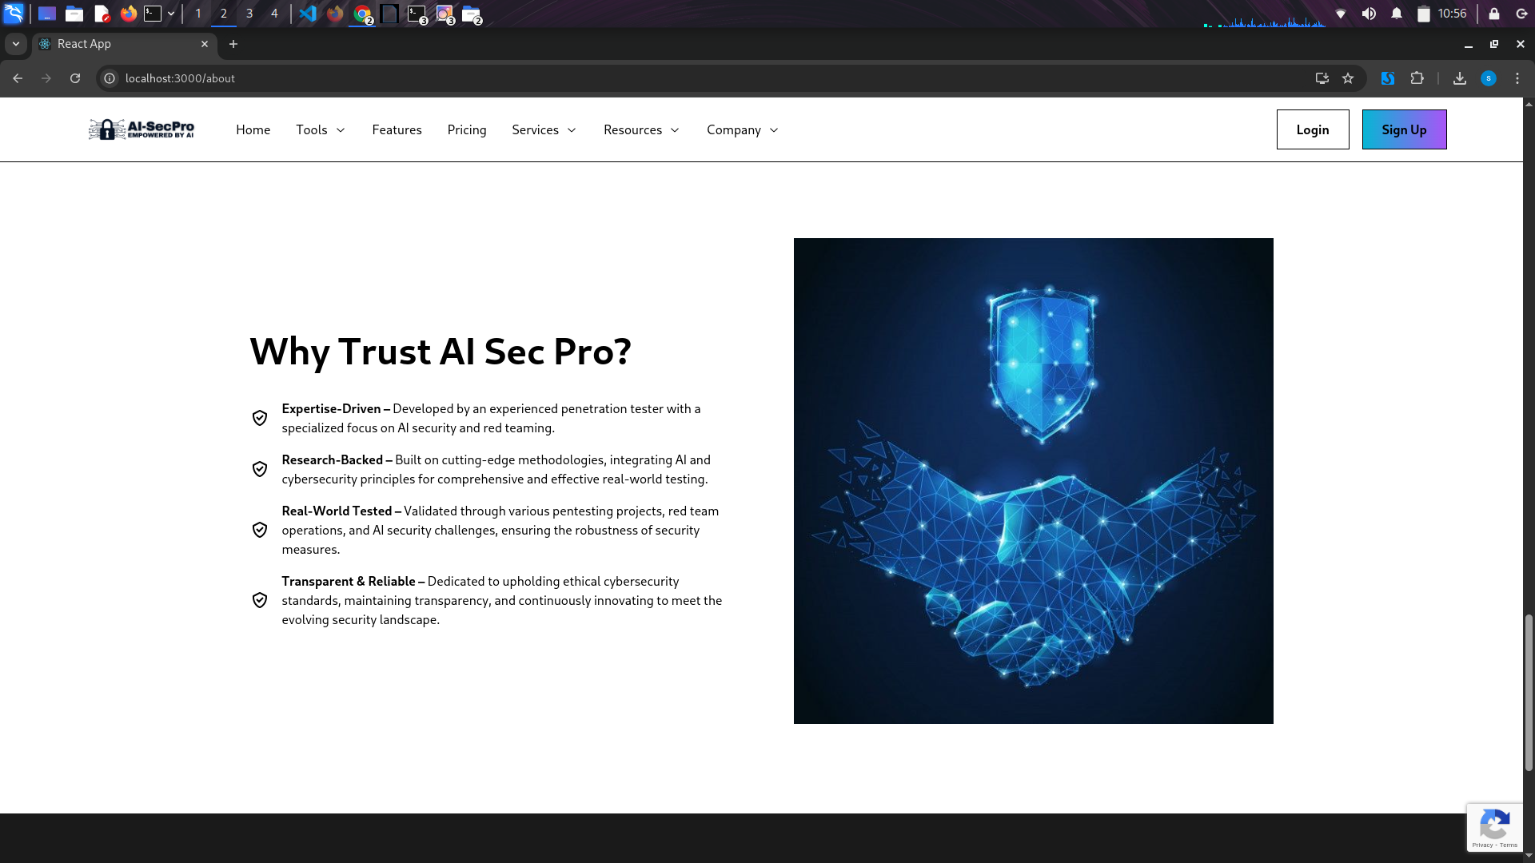Figure 22: About 4

* About AI-SecPro.

6. Customer Reviewes

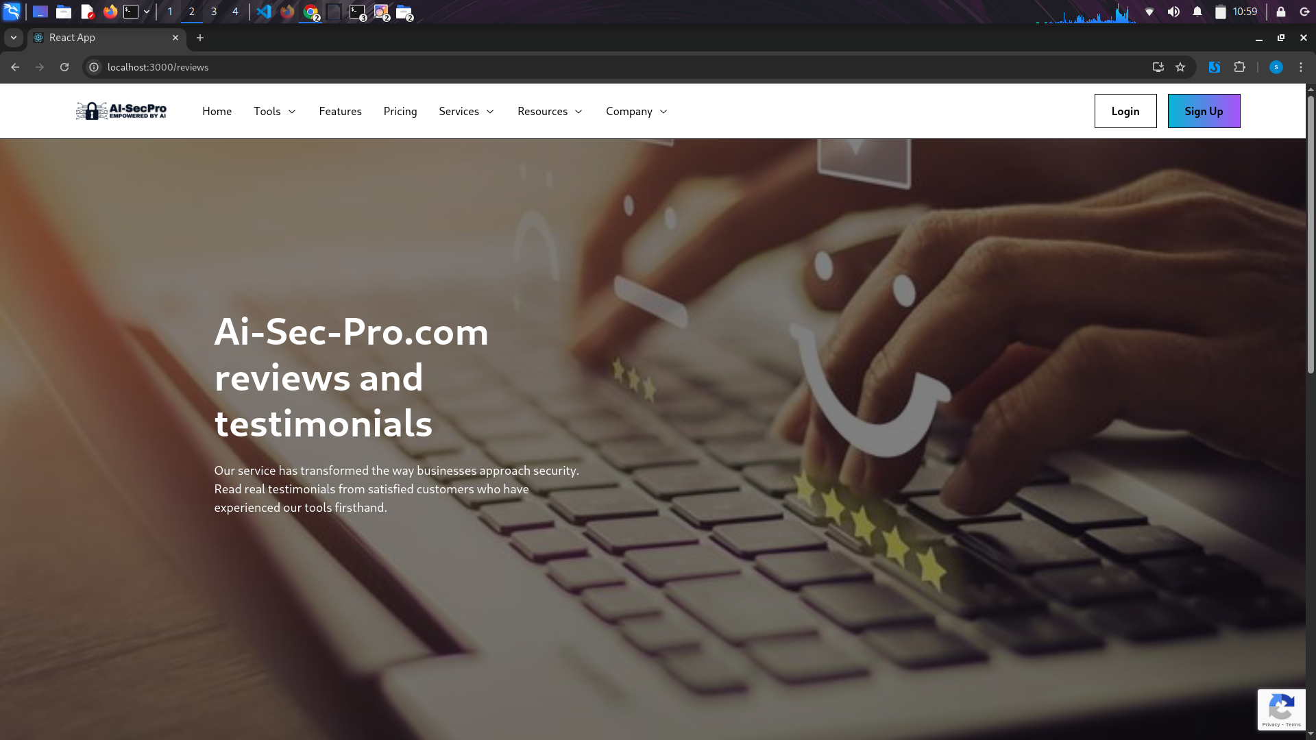Figure 23: Customer Reviews

* Customer Reviews.

7. Contact AI-SecPro

Figure 24: Contact Details 1

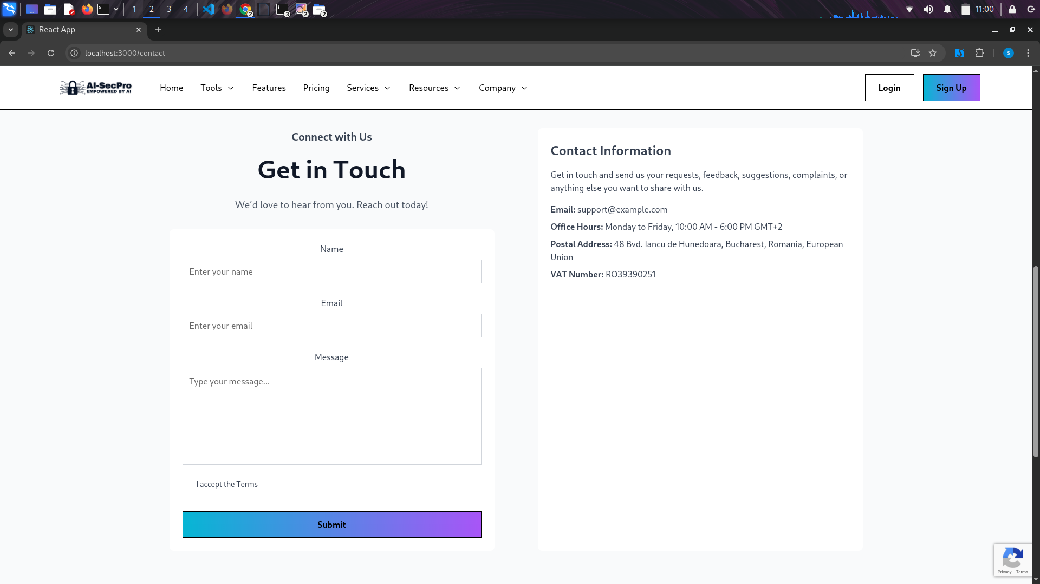Figure 25: Contact Details 2

* Contact Information of AI-SecPro.

8. Pricing Page

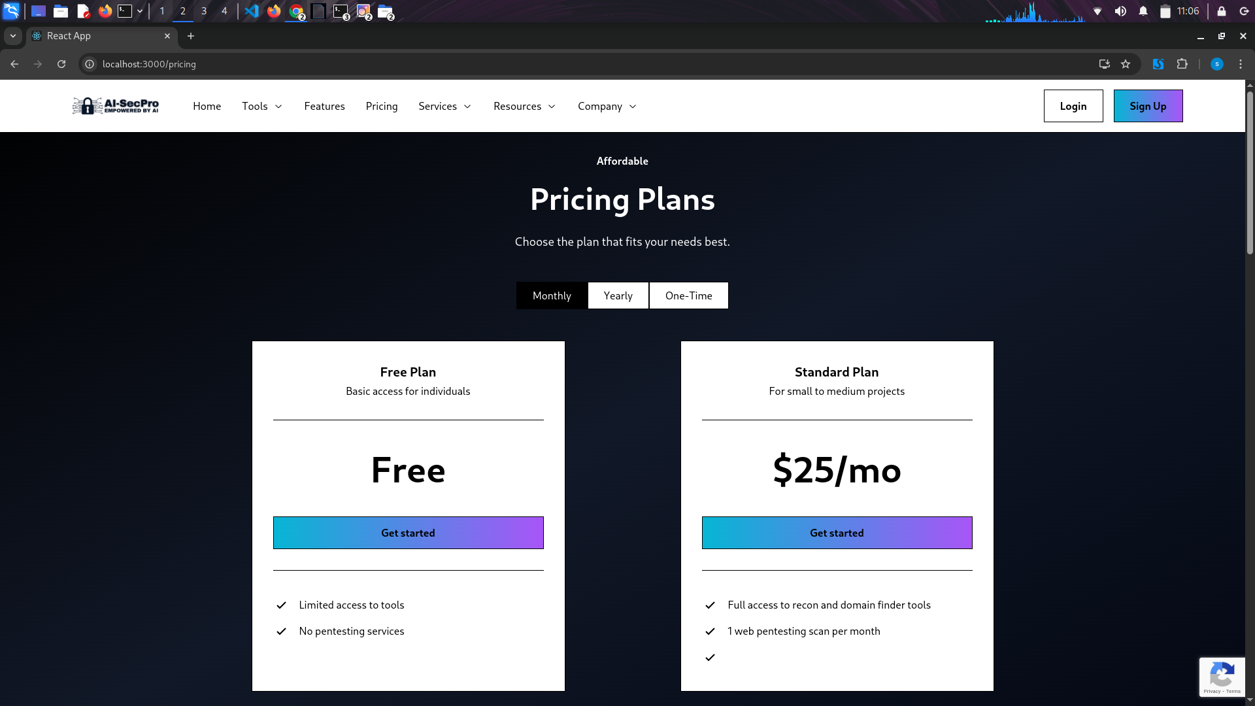Figure 26: Pricing Plans UI (Free User)

Figure 27: Pricing Plan UI 2 (Free User)\

AI-SecPro offers a Free Plan, which is limited to 5 basic scans, suitable for individuals who need occasional testing. The Standard Plan provides unlimited scans with a maximum of 2 hosts, including advanced features such as vulnerability scanning, exploit suggestions, and detailed analysis. This plan is available on a subscription basis, with both monthly and yearly options. Additionally, the Web Penetration Test service is available as a one-time payment for a single scan, offering a comprehensive security check.

9. Signup Page

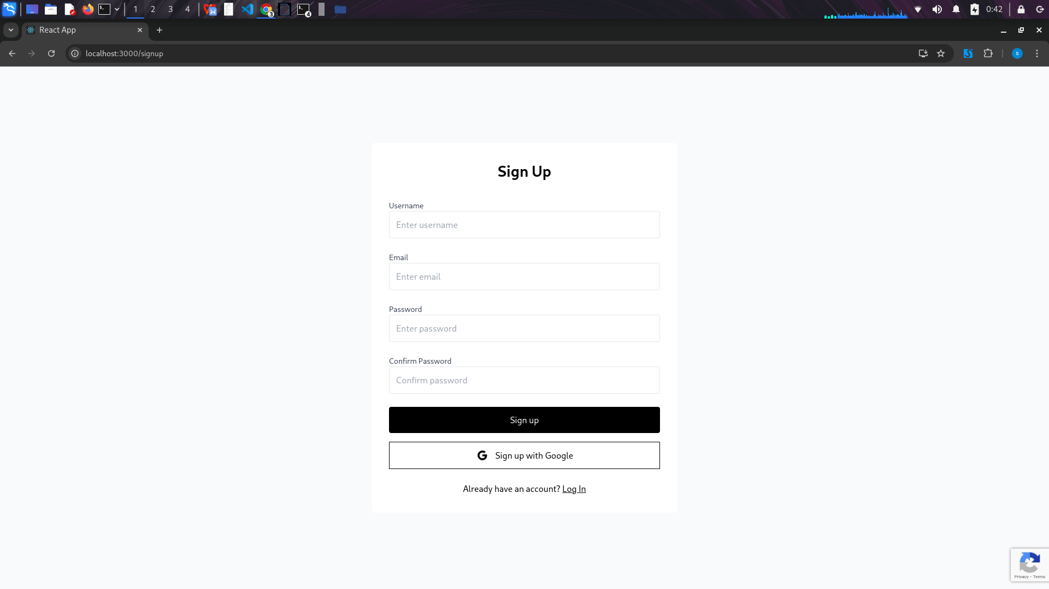Figure 28: Signup Page

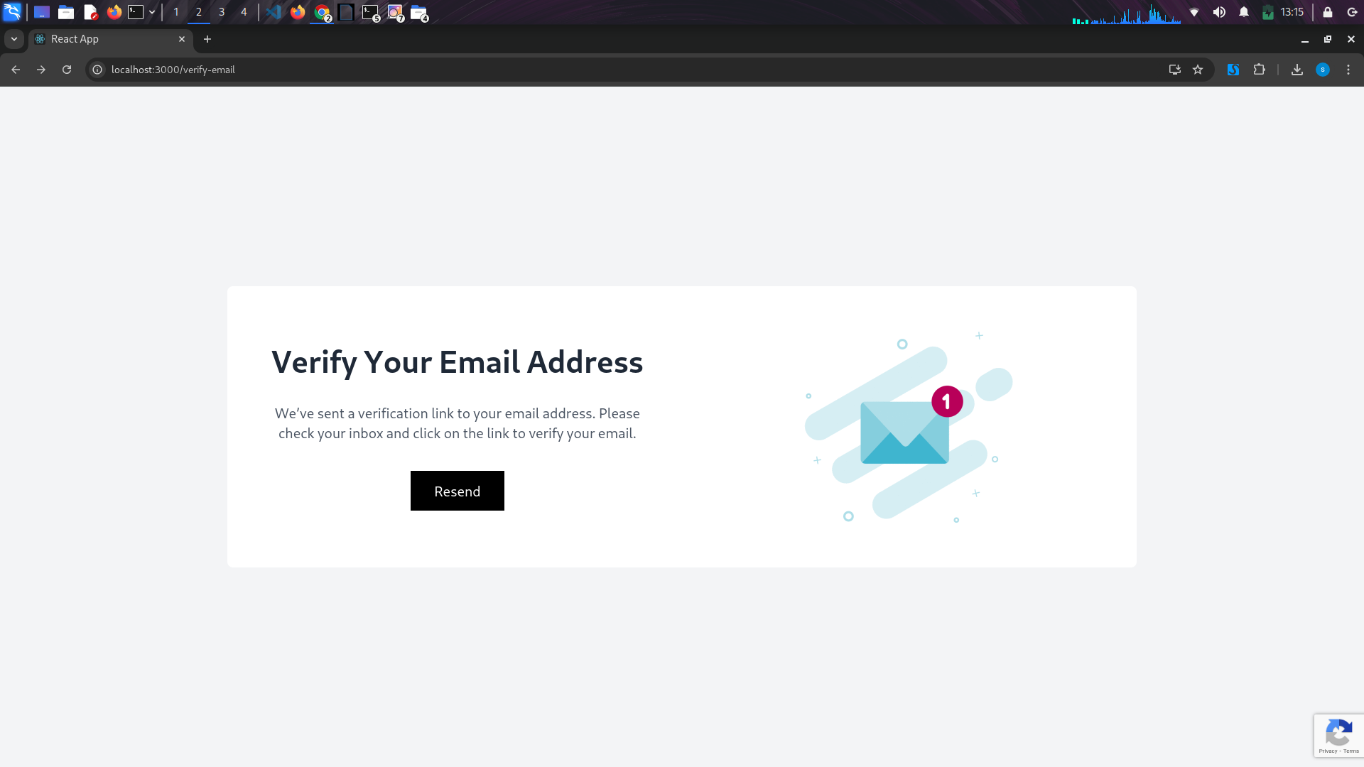Figure 29: Notify Page

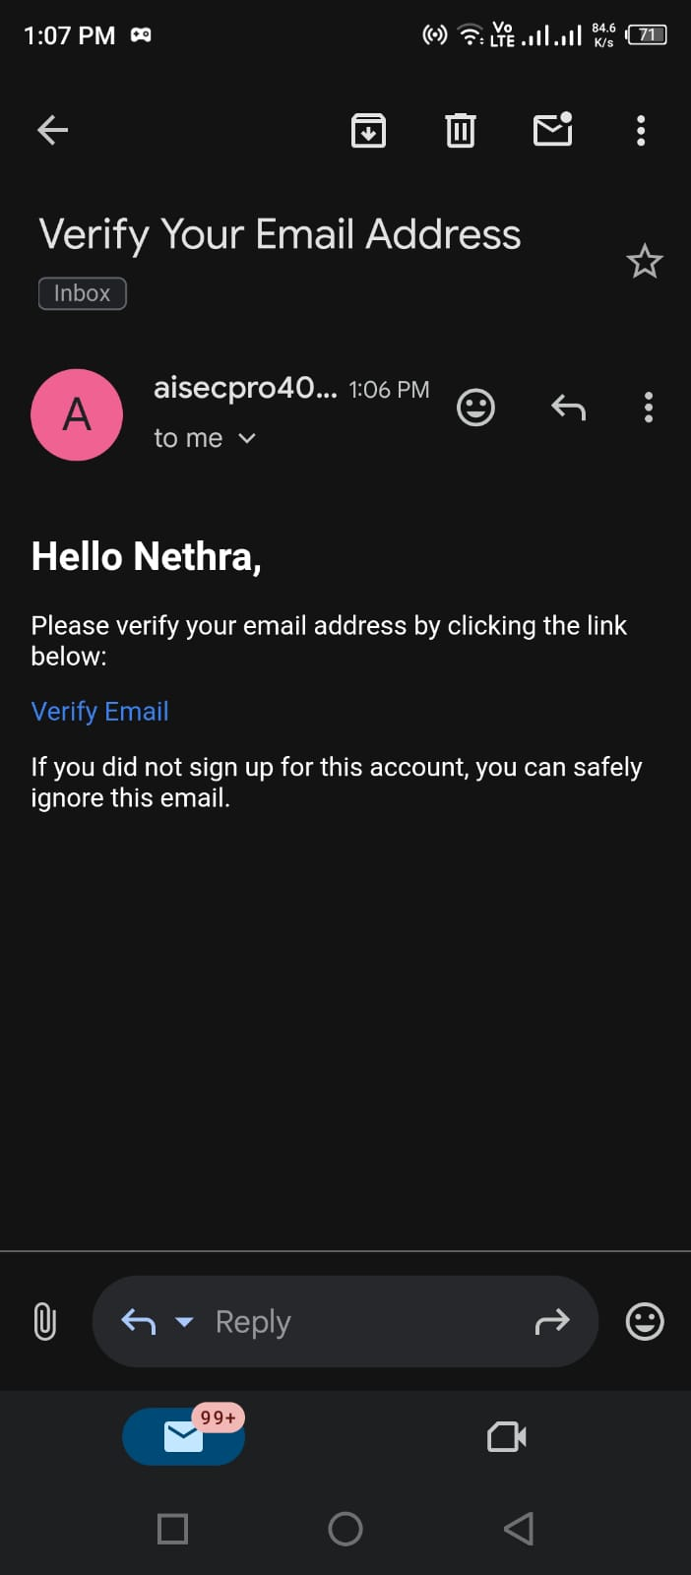Figure 30: Verification Link

Signup Process (Registration)

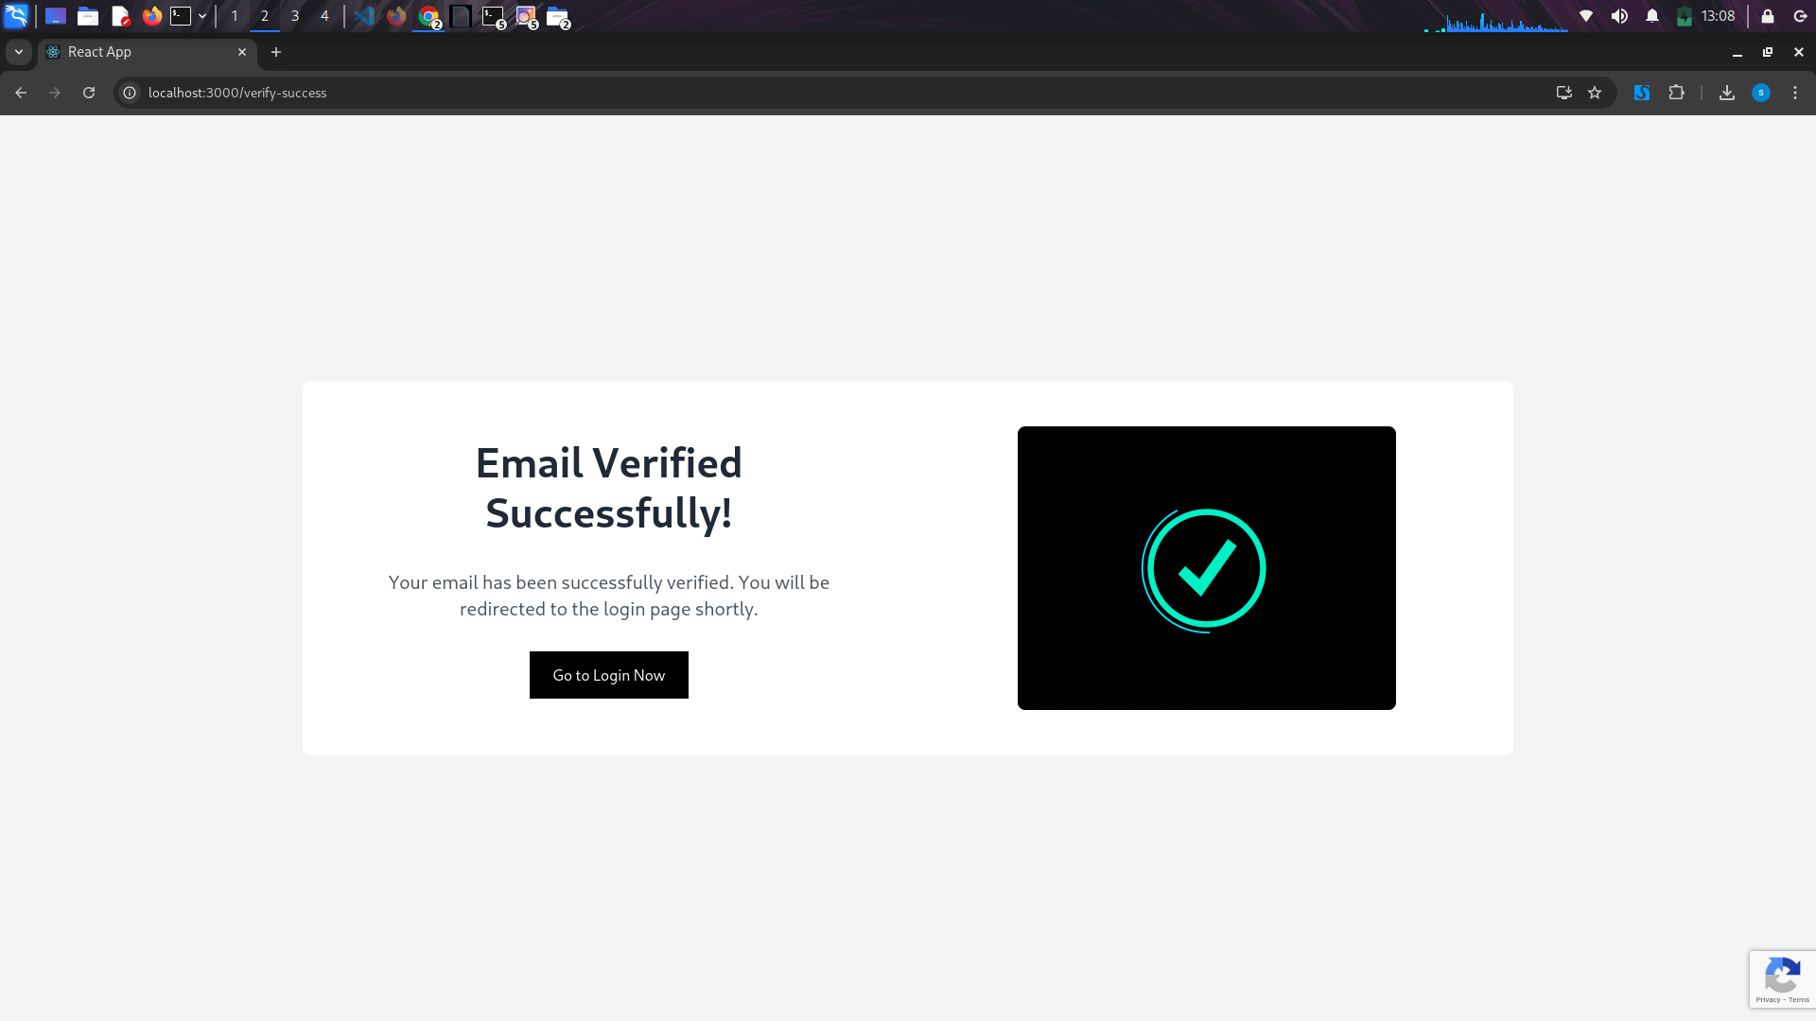Figure 31: Verified Success

Frontend:

Users fill in a signup form (name, email, password).

Basic validation: email format, password strength.

reCAPTCHA v3 token is generated to detect bots.

Signup with Google option (OAuth2 flow).

CSRF token is included in the request for protection.

Backend (Django):

CSRF protection is enforced.

Rate limiting: Prevents abuse (e.g., max 5 attempts/min per IP).

Input sanitization:

Django’s ORM automatically prevents SQL injection.

HTML/script inputs are escaped.

Password hashing: Password is securely hashed with bcrypt (via Django’s make_password()).

User record is saved.

Email verification: A verification link is sent with a time-limited token (e.g., using Django’s EmailMessage).

User must verify the email to activate the account.

10. Login Page

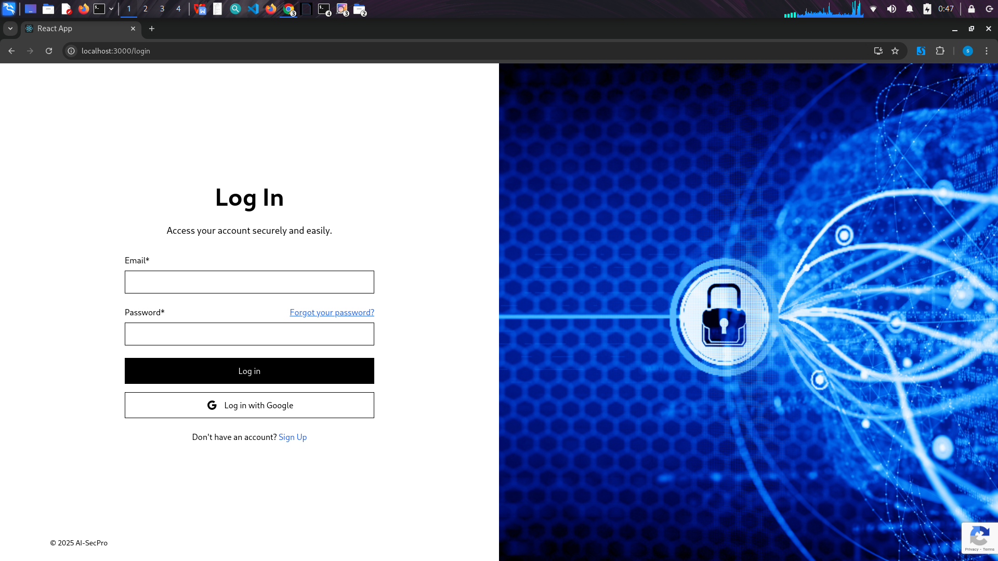Figure 32: Login Page

Login Process

Frontend:

User submits email and password.

reCAPTCHA v3 helps detect bots.

Google login option is available.

CSRF token is sent with the login request.

Backend (Django):

CSRF protection is validated.

Rate limiting: Prevents brute-force attempts.

Input sanitization for safe processing.

Check if email is verified (login not allowed if unverified).

Password is verified using Django’s check_password().

On success: session is created.

Login attempt is logged (for auditing).

11. User Dashboard (For Logged in Users Only)

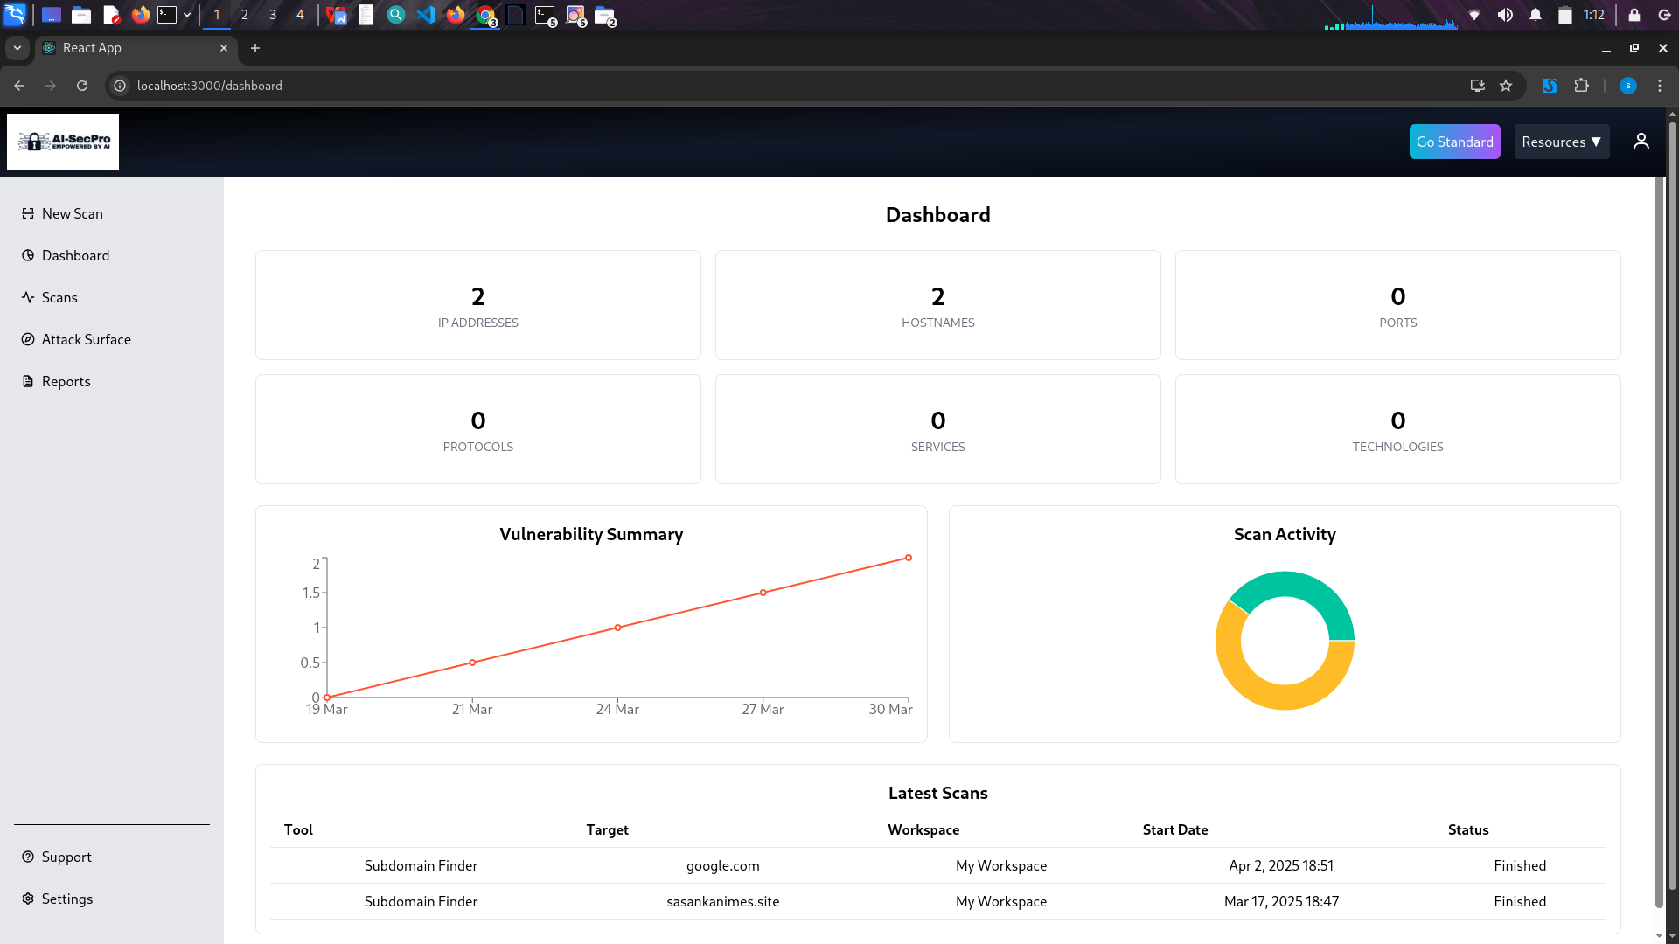Figure 33: Dashboard

Dashboard Overview & Security Measures

The AI-SecPro Dashboard is the central hub where authenticated users monitor their pentesting activities. It displays key data such as:

Scanned Assets: IP addresses, hostnames, open ports, protocols, services, and technologies.

Vulnerability Summary: A timeline graph showing detected vulnerabilities across recent scan dates.

Scan Activity: A log of the latest scan tools used, targets, associated workspaces, start dates, and scan status.

Security Measures Implemented

Authentication & Authorization

Only logged-in users with valid sessions can access the dashboard.

Role-based access controls restrict features based on user type (e.g., standard, admin).

Session Management

Sessions are managed using secure, HttpOnly, and SameSite cookies.

Auto logout on inactivity (timeout) to prevent session hijacking.

Input Handling

All dynamic data is sanitized on both frontend and backend using Django’s ORM and built-in protections to prevent XSS and SQL Injection.

User inputs (e.g., workspace names or scan targets) are validated before processing.

CSRF Protection

Django's CSRF middleware protects against cross-site request forgery on all form submissions and scan triggers.

Rate Limiting

API and scan request endpoints are rate-limited per user/IP to prevent abuse or brute-force attacks.

Audit Logs

Admins can track scan activities, login history, and changes to workspaces for accountability.

12. New Scan Interface (Available to Logged-In Users Only)

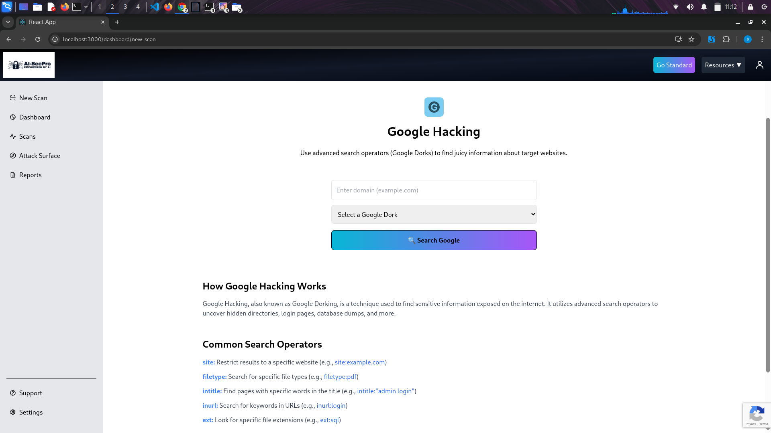Figure 34: Example tool

Can users access any tool to initiate a scan, as described earlier.

13. Scan History

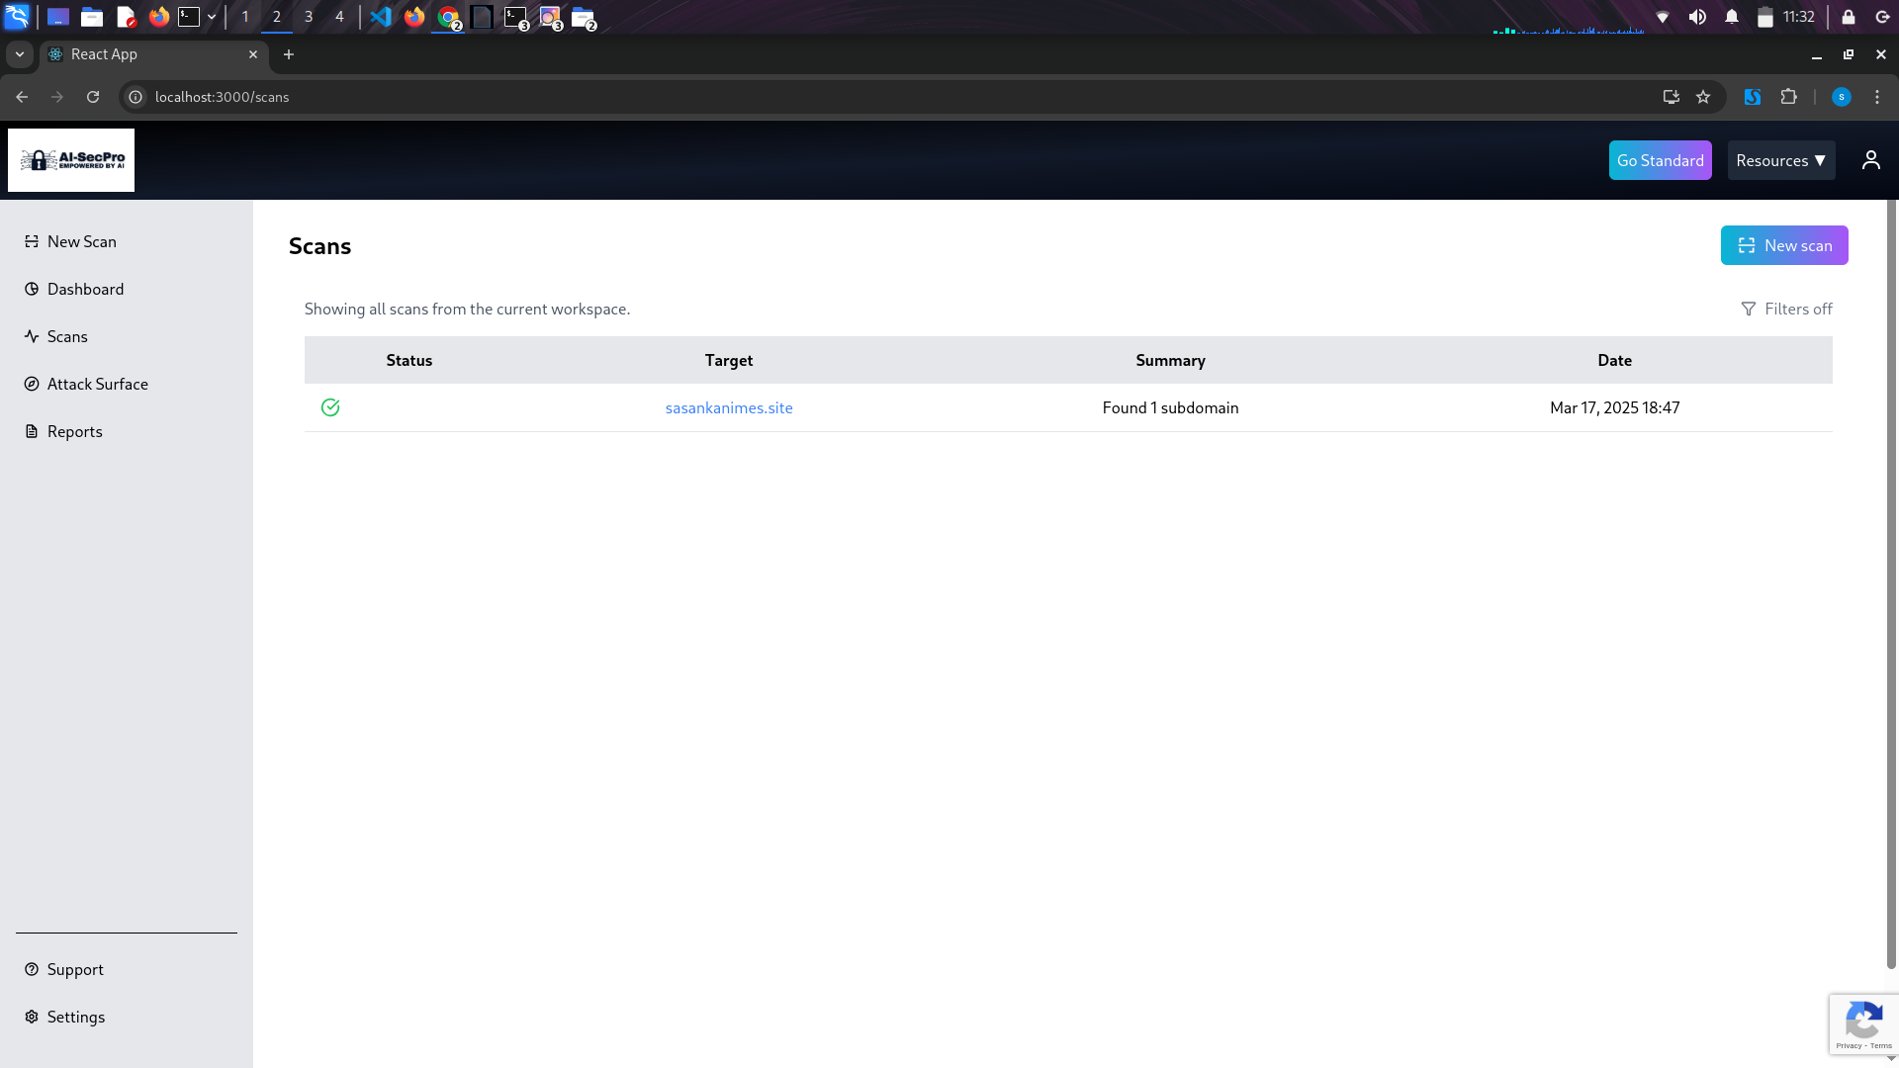Figure 35: Scan History

The Scans page displays all scans performed within the currently selected workspace. Users can start a New Scan using available tools, and filter previous scan results by status or target. Each scan entry shows key information such as the target domain, a summary of findings, and the date and time the scan was conducted. For example, the scan on sasankanimes.site found one subdomain on March 17, 2025 at 18:47.

14. Price Plan Inrerface (Available to Logged-In Users Only)

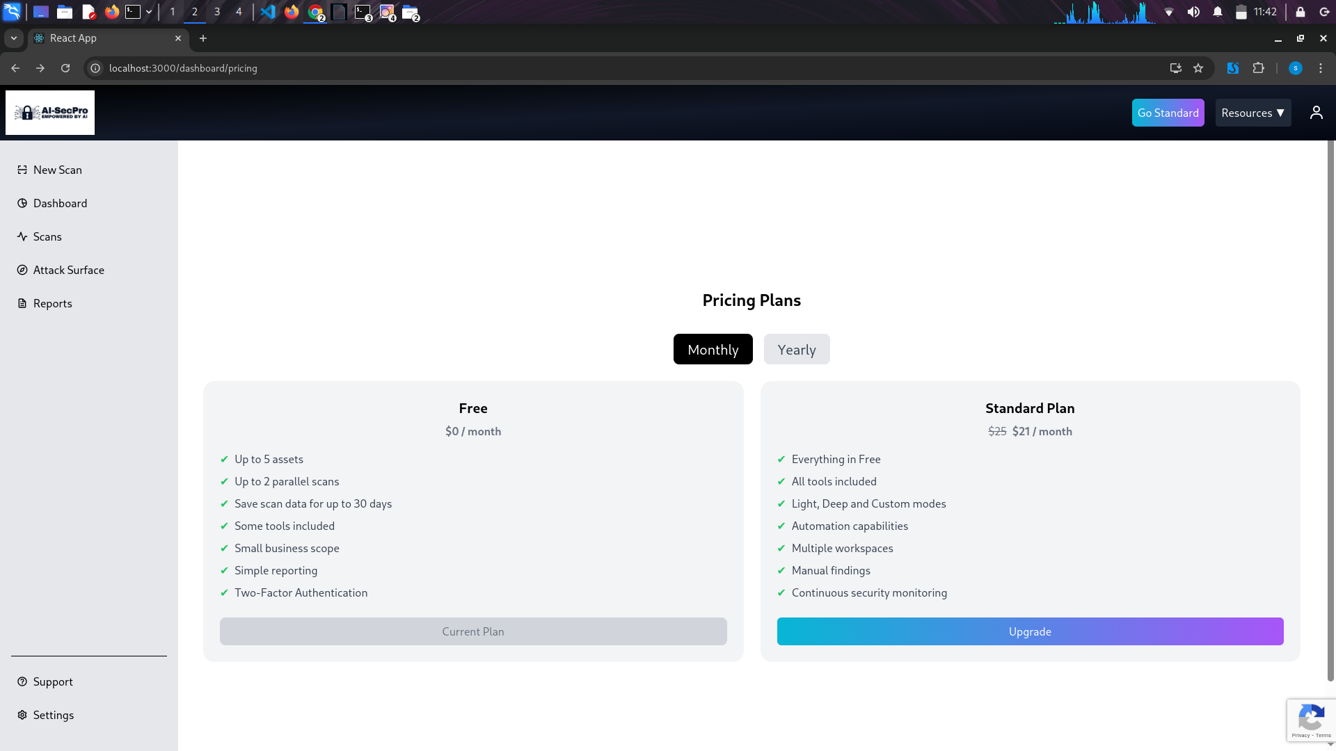Figure 36: Pricing UI (Logged Users)

7. Admin Log Panel

Admin-only view of all system activity.

## 7.3 AI Integration Details

* Model Used: GPT-4 via OpenAI API
* Integration Method:
  + Celery received scan data → prompt constructed → sent to GPT-4 API.
  + Response formatted, reviewed, and inserted back into the Django app.
* Use Cases:
  + Interpreting raw scan results (e.g., Nmap ports)
  + Suggesting next test steps
  + Writing detailed vulnerability descriptions
  + Drafting human-readable reports
* Security & Ethics:
* Prompts sanitized to avoid injection
* No sensitive data sent to external APIs

## 7.4 Problems Faced and How They Were Overcome

1. AI Misinterpretation of Data

* Problem: GPT sometimes gave incorrect suggestions based on malformed inputs.
* Solution: Added preprocessing checks and normalized input before prompt construction.

2. Tool Execution Failures

* Problem: Some tools like Nikto failed under certain configurations.
* Solution: Used robust exception handling and fallback options.

3. Latency in AI Responses

* Problem: OpenAI API calls delayed overall performance.
* Solution: Cached frequent prompts and enabled asynchronous calls.

4. Frontend State Sync Issues

* Problem: Scan progress wasn't updating in real-time.
* Solution: Switched from polling to WebSockets for better performance.

5. Database Conflicts

* Problem: Conflict between MongoDB (scan output) and PostgreSQL (user/session data).
* Solution: Isolated services, used separate models and sync pipelines.

Summary

The implementation of AI-SecPro reflects a modern, AI-enhanced approach to penetration testing. Each module was carefully designed and implemented using the best-suited technologies for its purpose. While challenges arose during AI integration and real-time scan coordination, they were overcome through modular architecture, microservices, and real-time communication strategies. The use of both relational and non-relational databases allowed for flexible and robust data handling. Ultimately, AI-SecPro’s implementation supports a professional-grade, intelligent pentesting workflow that significantly reduces manual workload while improving insight quality.

# Testing

Testing is a vital phase in the software development lifecycle to ensure that the system performs as intended, meets user expectations, and handles exceptions securely. In the development of AI-SecPro, due to time and resource limitations, formal test planning and execution were minimized. However, testing was conducted at a basic level through manual validation, module walkthroughs, and reuse of known outputs generated during integration phases. While a full testing framework wasn’t implemented, this section outlines the basic testing strategies applied, expected outcomes, and minimal validation that took place to support the system’s functionality.

## 8.1 Testing Strategies

Even though formal unit, integration, and acceptance testing was not performed for all components, basic forms of these strategies were indirectly applied during development and integration.

* Unit Testing: Modules like user authentication, AI interaction, and scan initiation were verified by running them with mock inputs and observing expected responses. Django's built-in TestCase class was used for some model and view logic.
* Integration Testing: Key components (e.g., React frontend to Django backend, backend to MongoDB/PostgreSQL, backend to Flask-based GPT module) were connected and validated for working API responses and database writes. The aim was to ensure seamless interaction rather than exhaustive testing.
* Acceptance Testing: Basic exploratory testing was conducted from a user’s perspective. Logging in, launching a scan, and downloading a report were performed using a browser to confirm the system flows work logically.

These minimal forms of testing helped confirm that the application’s critical path — from login to report generation - worked without runtime errors or major flaws.

## 8.2 Summary of Test Cases and Outcomes

Below is a sample table of essential functionalities tested informally using real or mock data:

| ****Test Case**** | ****Expected Outcome**** | ****Observed Outcome**** | ****Status**** |
| --- | --- | --- | --- |
| User registration and login | Valid credentials accepted; JWT token returned | JWT received and stored | Pass |
| Launch network scan | Scan initiated; results stored in MongoDB | Output saved in DB | Pass |
| AI vulnerability analysis prompt | Response from GPT-4 via Flask microservice | Valid vulnerability text | Pass |
| PDF report generation | PDF with CVE and AI content downloadable | PDF generated and downloadable | Pass |
| Admin-only access to scan logs | Unauthorized users blocked from admin panel | Only admin access allowed | Pass |

Table 4: Summary of Test Cases and Outcomes

Each test was executed manually during development or integration and verified via browser console, backend logs, or the generated output (PDF or database entry).

## 8.3 Screenshots of Reports and Output

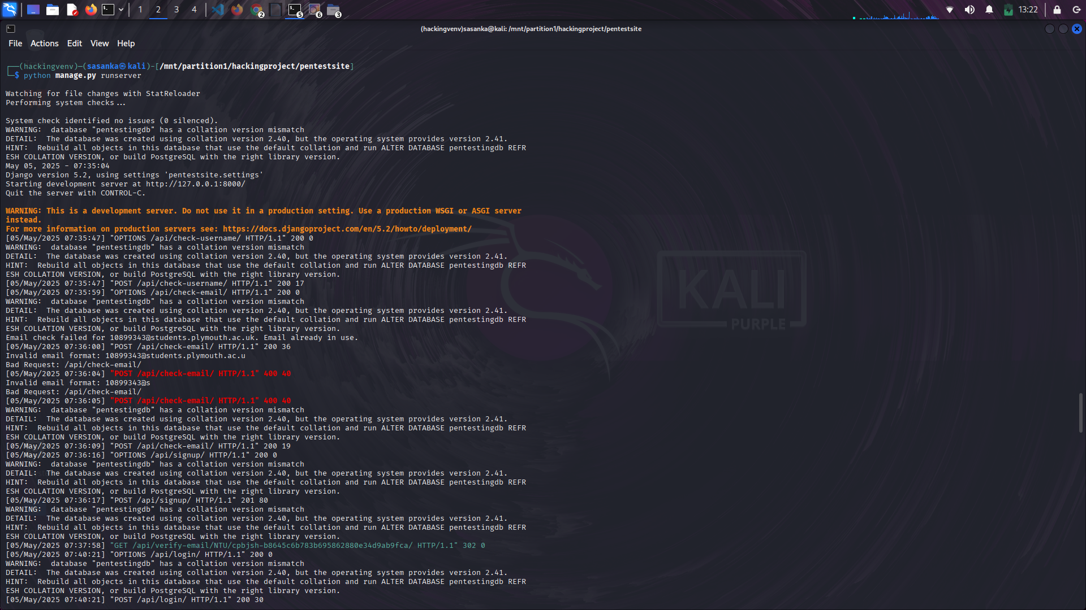Figure 37: Test Results 1

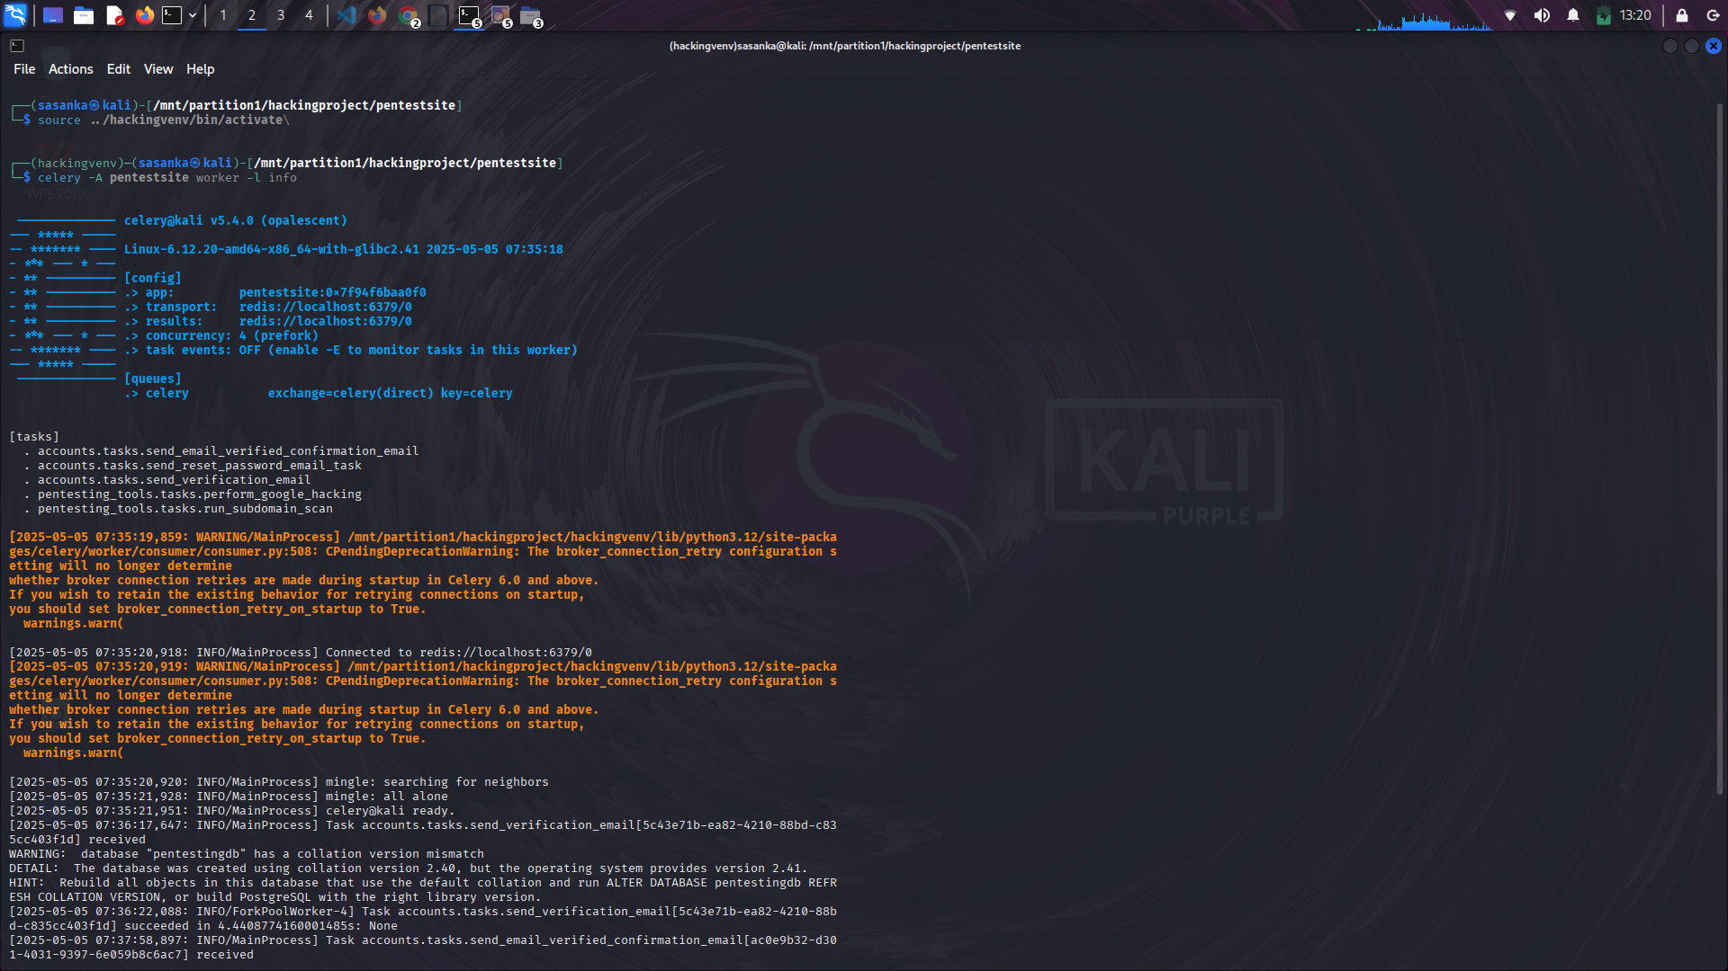Figure 38: Test Results 2

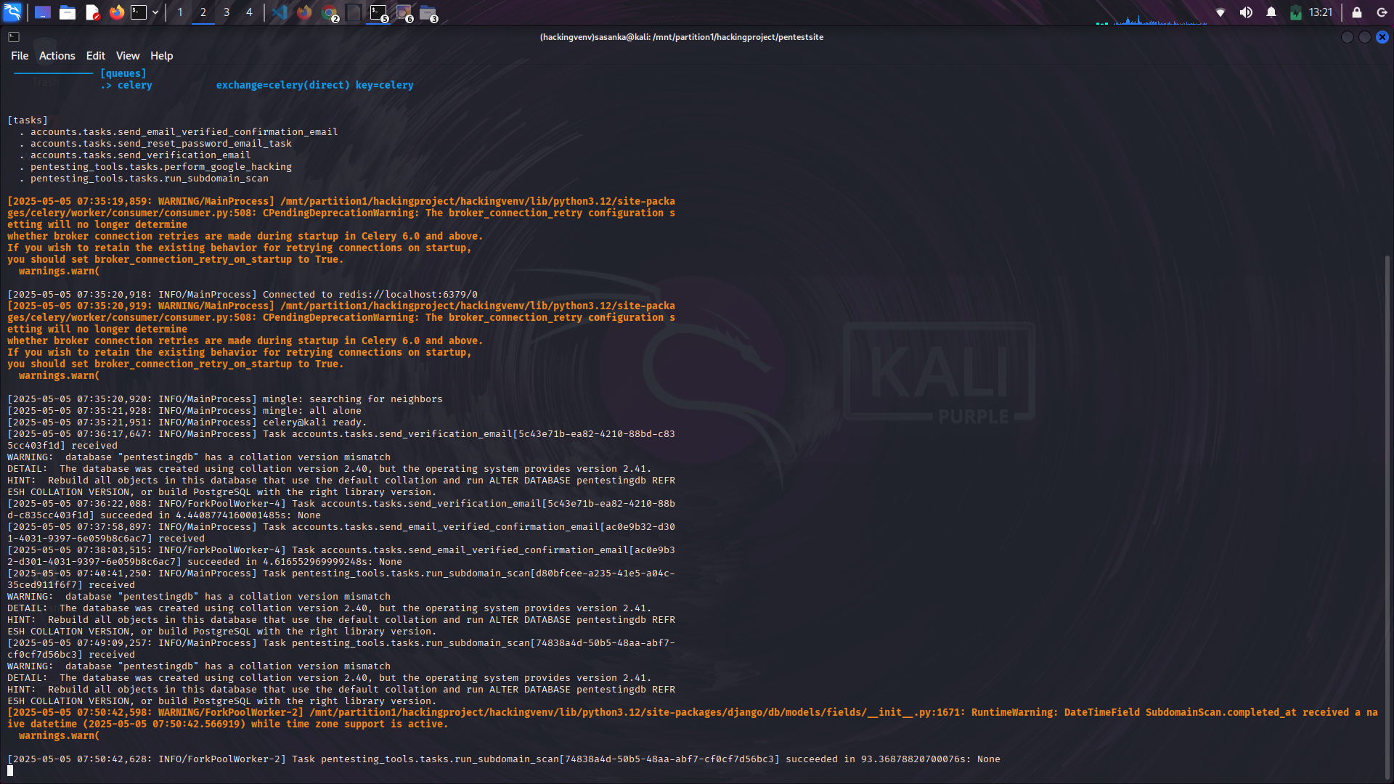Figure 39: Test Results 4

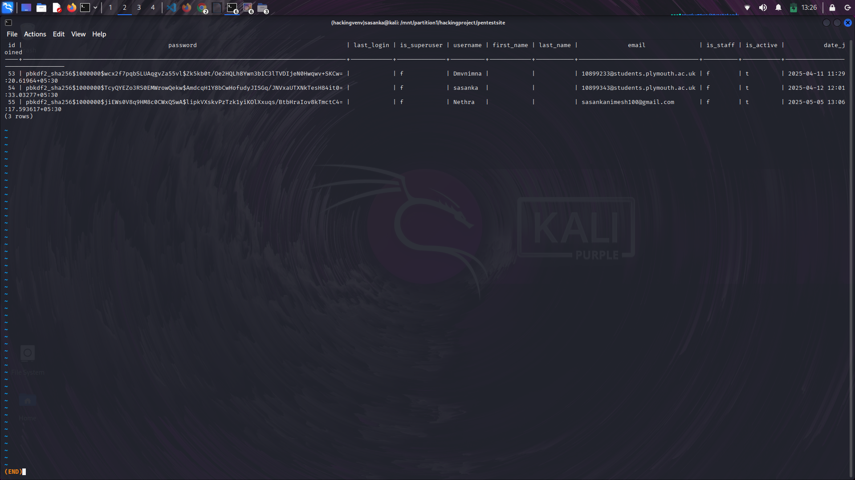Figure 40: Test Results 5

These screenshots validate that at least one working scenario was demonstrated per feature, which suffices as functional evidence at this phase.

Note: As actual penetration tests were not conducted on live environments, the outputs are sample results from simulated runs.

## 8.4 Security Validation Checks

Security aspects were considered during development, although no formal penetration testing was conducted. Basic security validations included:

* Authentication & Session Control:
  + JWT tokens were tested for expiration and invalidation.
  + Routes requiring authentication were protected on both frontend and backend.
* Input Validation:
  + All form inputs and user-generated data were sanitized before database entry or command execution.
  + Prompts sent to the AI module were cleaned to avoid prompt injection.
* Access Control:
  + Role-based access ensured that only admins could view sensitive logs and manage users.
* Data Protection:
  + MongoDB was used for flexible scan data, with no sensitive user data stored.
  + PostgreSQL managed user sessions, with hashed passwords and encrypted JWTs.

These security considerations reduce risk even in a limited testing environment and prepare the system for deeper evaluation in future phases.

## 8.5 Limitations and Recommendations

Limitations:

* No automated testing suite was deployed.
* No external validation or QA team was involved.
* Results from AI responses and scan tools were not benchmarked.

Future Recommendations:

* Integrate PyTest or Django’s full test suite for automated testing.
* Use Postman/Newman for API testing and monitoring.
* Conduct formal black-box testing and include third-party audits.
* Validate AI responses for accuracy and consistency with a human expert.

Conclusion

Although AI-SecPro did not undergo rigorous testing due to constraints, core modules were informally validated to ensure basic functionality and flow. Screenshots, reports, and observed outputs serve as evidence that the application’s intended operations were realized. Future work will focus on systematic, repeatable, and measurable test plans using CI/CD pipelines, test automation, and real-world vulnerability benchmarks to enhance system credibility and readiness for deployment.

# End-Project Report & Evaluation

The final stage of AI-SecPro’s development involved reflecting on the initial goals, evaluating the outcomes, and analyzing the effectiveness of the solution in addressing modern pentesting needs. This section revisits the objectives outlined at the start and presents an honest evaluation of the project’s strengths and limitations.

## 9.1 Revisit of Original Objectives

The project was launched with the aim to bridge the gap between traditional manual penetration testing and emerging AI-assisted cybersecurity approaches. Initial goals included:

* Automating common pentesting tasks using AI.
* Providing a user-friendly dashboard for initiating tests and viewing reports.
* Integrating GPT-4 for interpretation and recommendations.
* Ensuring scalability and modularity using modern web frameworks.

Each objective served as a milestone in delivering a more intelligent, semi-automated penetration testing platform.

## 9.2 Objectives vs Achievements

| Objective | Achievement Status | Notes |
| --- | --- | --- |
| AI-assisted pentesting with GPT-4 | Achieved | Integrated GPT-4 for scan analysis and remediation suggestions |
| User dashboard with scan control | Achieved | Functional React-based interface with scan launch and history |
| Report generation with AI insights | Achieved | PDF reports include CVE links and AI-generated summaries |
| Modular backend using Django and Flask | Achieved | Split into core Django app and Flask microservices |
| Support for multiple scan tools | More Achieved | Implemented Nmap, Nikto, Wfuzz etc. |
| Security and role-based access | Achieved | JWT and role filtering implemented |
|  |  |  |

Table 5: More Achieved

## 9.3 Analysis of Project Success

Technical Perspective:

The platform successfully merged AI capabilities with traditional security tools, demonstrating that GPT can assist in interpreting raw data and making informed security decisions. Despite limited scope in test coverage (due to time constraints), the architecture remains scalable for future enhancement.

User Experience:

Initial testers (peer reviewers) found the dashboard intuitive and appreciated the AI integration for simplified vulnerability understanding. The tool abstracts away complex command-line usage for non-expert users.

Project Management:

Agile methods helped in delivering modules iteratively, though integration and testing phases faced compression due to late-stage dependencies. Most deliverables were completed on time with acceptable quality.

## 9.4 Peer Review & Feedback Summary

A small group of simulated users (peers and coursemates) were invited to interact with AI-SecPro’s interface and features.

Feedback Highlights:

* “The AI output makes it easier to understand what the vulnerability actually means.”
* “Nice clean UI. Starting a scan is straightforward. Would be great to support more tools.”
* “I would love a retry option if a scan fails unexpectedly.”

Recommendations from Reviewers:

* Add tool selection granularity (e.g., choose specific scan modules)
* Include real-time collaboration (e.g., share scan with team)
* Expand the AI scope to include risk scoring and mitigation ranking

Conclusion

AI-SecPro succeeded in showcasing a functional prototype of an AI-integrated penetration testing platform. While not exhaustive in scan capability or security validation, it demonstrates a viable direction for augmenting cybersecurity tools with modern AI. With refinement, this concept can evolve into a production-grade solution for ethical hackers and cybersecurity analysts.

# Project Post-Mortem

The AI-SecPro project journey—from ideation to implementation—provided valuable insights into managing a technically complex and AI-enhanced cybersecurity tool. This section reflects on what went well, what didn’t, and the key takeaways that emerged through development.

## 10.1 What Went Well

* Modular Architecture: Designing the system using independent modules (Django for core logic, Flask for AI, and React for the frontend) allowed for easier development and debugging.
* Successful AI Integration: GPT-4 was effectively used to interpret scan results, explain vulnerabilities, and enrich report content. The integration via a Flask microservice made it flexible and reusable.
* Functional UI: The React dashboard proved simple yet effective. Even non-technical users could initiate scans and interpret AI-generated summaries.
* Team Coordination: Despite being a solo or partially collaborative effort, using Git and Trello-style planning helped keep track of tasks and progress logically.

## 10.2 What Didn’t Go Well

* Testing Phase: The project lacked a structured testing phase. Instead of a dedicated QA process, only basic manual checks were performed, limiting assurance of stability and edge case coverage.
* Tool Compatibility: Tools like Nikto and Wfuzz had configuration challenges, often requiring adaptation or fallback options. This slowed down integration and limited test accuracy.
* Real-time Performance: Live scan tracking suffered from delays until WebSocket-based updates were introduced. This performance tuning came late in the timeline.
* Documentation Gaps: While the implementation was functional, some modules lacked proper internal documentation or error logging initially, leading to confusion during integration.

## 10.3 Technical and Time Management Challenges

* Time Crunch: The combination of learning curve (for GPT API, MongoDB, and Django), integration work, and UI polish created a time bottleneck. More realistic sprint planning would’ve helped.
* Multiple Database Systems: Using both PostgreSQL and MongoDB created sync issues at times, requiring extra logic to ensure data consistency. Splitting data responsibilities early on helped solve this.
* Error Handling with External Tools: Scanning tools failed silently at times, prompting the need for extensive logging and retry logic.

## 10.4 Future Improvements

* Automated Testing: Implement unit and integration tests to ensure stability across modules.
* Scan Customization: Allow users to select specific scan parameters (e.g., ports, methods).
* More AI Use Cases: Expand AI to help classify vulnerabilities by risk level and recommend prioritized mitigation plans.
* User Collaboration: Introduce shared workspaces or team-based scan sessions for real-world use.
* Dockerization: Package the system using Docker to ensure easy deployment and testing on any machine.

## 10.5 Lessons Learned

* Start Small with AI: Integrating GPT into small, well-defined use cases (like interpreting Nmap) worked better than attempting broad usage immediately.
* Design for Modularity: Separating responsibilities by microservices and modules made debugging and updates simpler.
* User First: Early feedback helped shape the dashboard’s usability; involving users sooner could’ve improved decisions earlier.
* Document as You Go: Avoiding documentation until the end caused minor delays. Inline comments and readme files are essential from the start.

Conclusion

AI-SecPro was a technically rewarding project that brought together AI, cybersecurity, and web development. Despite challenges, the outcome met key objectives and provided a valuable platform for learning full-stack development, security tooling, and AI integration. Future iterations will focus on polishing, expanding AI use, and robust validation to prepare the system for broader deployment.

# Conclusions

AI-SecPro represents a forward-thinking approach to penetration testing by integrating artificial intelligence into traditional cybersecurity workflows. As the cybersecurity threat landscape grows in complexity, the need for efficient, intelligent, and automated solutions becomes increasingly vital. This project set out to create an AI-assisted platform capable of performing streamlined security assessments while reducing manual effort—and it successfully delivers on that vision.

The platform's ability to interpret scan results, suggest next steps, and generate professional reports with AI-enhanced insight marks a significant advancement in cybersecurity automation. By combining technologies such as Django, React, PostgreSQL, MongoDB, and GPT-4, AI-SecPro demonstrates how hybrid systems can be developed to bridge the gap between automation and expert human analysis. Although the AI does not fully replace a human pentester, it greatly augments their capability, especially in preliminary analysis, vulnerability documentation, and remediation guidance.

From a project standpoint, AI-SecPro showcases how modern development methodologies (Agile, modular architecture) and cloud-based AI services can be used to build scalable, interactive tools for cybersecurity professionals. The integration of AI for real-time support and analysis adds long-term value and relevance, ensuring that the system can evolve with the industry and remain adaptable to new vulnerabilities and attack vectors.

In conclusion, AI-SecPro contributes meaningfully to the domain of cybersecurity automation. It not only streamlines penetration testing but also lowers the barrier to entry for junior security analysts by providing intelligent support. As the field continues to shift toward AI-driven tools, platforms like AI-SecPro set a strong precedent for the future. With continued development, user testing, and model refinement, it has the potential to become a staple in the toolkit of ethical hackers and cybersecurity teams worldwide.

# References

Chio, C., & Freeman, D. (2018). Machine learning and security: Protecting systems with data and algorithms. O'Reilly Media.

OpenAI. (2023). GPT-4 technical report. Retrieved from https://openai.com/research/gpt-4

Django Software Foundation. (2024). Django documentation. Retrieved from https://docs.djangoproject.com/

React. (2024). React – A JavaScript library for building user interfaces. Meta. Retrieved from https://react.dev

MongoDB, Inc. (2024). MongoDB documentation. Retrieved from https://www.mongodb.com/docs/

PostgreSQL Global Development Group. (2024). PostgreSQL documentation. Retrieved from https://www.postgresql.org/docs/

OWASP. (2024). OWASP Testing Guide v4. Retrieved from https://owasp.org/www-project-web-security-testing-guide/

Nmap.org. (2024). Nmap: the Network Mapper. Retrieved from https://nmap.org/

Wfuzz. (2023). Web application brute forcer. Retrieved from https://github.com/xmendez/wfuzz

Nikto. (2023). Nikto web server scanner. Retrieved from https://cirt.net/Nikto2

CVE. (2024). Common Vulnerabilities and Exposures. MITRE. Retrieved from <https://cve.mitre.org/>

Singh, R., et al. (2022). "AI-Powered Vulnerability Analysis." Journal of Advanced Cybersecurity.

Lopez, A., & Wei, J. (2023). "Ethical Challenges in Automated Penetration Testing." Cyber Ethics Review.

Chen, Y., et al. (2024). "Evolving Threats and the Role of AI." Journal of Cyber Defense.

Abid, M., et al. (2023). "AI in Cybersecurity: Emerging Trends and Applications." International Journal of Cybersecurity.

Dey, A., et al. (2022). "Deep Learning for Security in Cyber-Physical Systems." International Journal of Computer Science.

Kumar, S., et al. (2023). "Next-Generation Penetration Testing: Integrating AI." IEEE Transactions on Security and Privacy.

Saber, V., et al. (2023). "Automated Penetration Testing: A Systematic Review." MIUCC.

Xu, K., et al. (2023). "Enhancing Penetration Testing with AI: A Survey on Capabilities and Challenges." IEEE Access.

Hilario, E., et al. (2024). "Generative AI for Pentesting: The Good, the Bad, the Ugly." International Journal of Information Security.

Zhang, Q., et al. (2023). "AI for Cybersecurity: A Review of Challenges and Opportunities." International Journal of Security and Networks.

Tian, X., et al. (2024). "Adversarial Machine Learning in Penetration Testing: A Survey." Journal of Cybersecurity Research.

Wei, J., et al. (2023). "Penetration Testing with AI: Moving Beyond Traditional Tools." Cybersecurity Journal.

Hasan, M., et al. (2023). "AI for Cyber Threat Detection and Response." Future Generation Computer Systems.

Patel, A., et al. (2022). "Machine Learning for Vulnerability Management." International Journal of Cyber Threats and Protection.

Jha, S., et al. (2024). "Ethical AI in Penetration Testing." Ethics and Information Technology.

Raman, A., et al. (2022). "Automating Penetration Testing with AI: Challenges and Solutions." ACM Computing Surveys.

Lee, T., et al. (2023). "AI in Network Penetration Testing." Network Security Journal.

Sharma, M., et al. (2024). "AI in Penetration Testing and Cybersecurity: A Comprehensive Overview." Journal of Network and Computer Applications.

Li, H., et al. (2023). "AI-Driven Security Auditing and Vulnerability Testing." IEEE Security & Privacy.

Zhang, L., et al. (2023). "Automating Ethical Hacking with AI." Journal of Cyber Intelligence.

Yadav, A., et al. (2024). "Advances in AI for Penetration Testing." International Journal of Computer Applications.

Bhattacharyya, A., et al. (2023). "AI and Deep Learning for Security Vulnerability Detection." Future Internet.

Nguyen, P., et al. (2022). "Deep Learning in Penetration Testing." Machine Learning for Security.

Kumar, R., et al. (2023). "AI for Offensive Security." Journal of Cyber Warfare and Security.

Yang, X., et al. (2023). "AI in Cyber Defense: Penetration Testing Approaches." Journal of Information Warfare.

# Bibliography

Brownlee, J. (2016). Master Machine Learning Algorithms. Machine Learning Mastery.

Goodfellow, I., Bengio, Y., & Courville, A. (2016). Deep Learning. MIT Press.

Rouse, M. (2023). Penetration testing (pen testing). TechTarget. Retrieved from https://www.techtarget.com/searchsecurity/definition/penetration-testing

Shostack, A. (2014). Threat modeling: Designing for security. Wiley.

Hacking Articles. (2024). Penetration testing tutorials and methodologies. Retrieved from https://www.hackingarticles.in/

TryHackMe. (2024). Pentester learning path. Retrieved from https://tryhackme.com/path/outline/pentesting

Nessus by Tenable. (2024). Vulnerability scanning tool documentation. Retrieved from <https://docs.tenable.com/nessus/>

# Appendices

## Appendix A: User Guide

1. Clone the GitHub Repo

git clone <https://github.com/sasanka>-nimes/ai-secpro.git

cd ai-secpro

2. Backend Setup (Django)

2.1. Create & activate a virtual environment

python -m venv env

source env/bin/activate # On Windows: env\Scripts\activate

2.2. Install backend requirements

cd backend

pip install -r requirements.txt

2.3. Set environment variables

Create a .env file in backend/:

env

Copy

Edit

DEBUG=True

SECRET_KEY=your-secret

ALLOWED_HOSTS=localhost,127.0.0.1

DB_NAME=ai_secpro

DB_USER=postgres

DB_PASSWORD=your_db_password

DB_HOST=localhost

DB_PORT=5432

MONGO_URI=mongodb://localhost:27017/

OPENAI_API_KEY=your_openai_key

2.4. Migrate database and create superuser

python manage.py makemigrations

python manage.py migrate

python manage.py createsuperuser

2.5. Run the backend server

python manage.py runserver

3. Frontend Setup (React)

3.1. Install frontend dependencies

cd ../frontend

npm install

3.2. Create .env file for frontend

REACT_APP_BACKEND_URL=http://127.0.0.1:8000/api

REACT_APP_RECAPTCHA_SITE_KEY=your_recaptcha_v3_site_key

3.3. Run the frontend

npm start

AI Report Generation (Auto)

Once the scan is completed (Nmap, Gobuster, etc.), results are saved in MongoDB.

Backend uses GPT-4 via OpenAI API to analyze the output.

A PDF/HTML report is generated and displayed/downloadable from the Reports tab.

## Appendix B: PID



PUSL3190 Computing Individual Project

Project Initiation Document (PID)

AI-SecPro:

An AI-Driven Penetration Testing Framework

Supervisor: Dr.Pabudi Abeyrathne

Name: RASN Priyantha

Plymouth Index Number: 10899343 Degree Program: Computer Security

Table of Contents

1. Introduction 3
2. Business Case 4
3. Project Objectives 4
4. Literature Review 5
5. Method of Approach 7
6. Initial Project Plan 8
7. Risk Analysis 9
8. Conclusion 10

References 11

1. Introduction

Overview

AI-SecPro is a cutting-edge AI-powered penetration testing framework designed to revolutionize cybersecurity practices by integrating artificial intelligence and machine learning into core penetration testing activities. The framework seeks to automate critical penetration testing tasks such as vulnerability scanning, exploitation, and post- exploitation analysis, which are traditionally performed manually by cybersecurity professionals. By leveraging AI, AI-SecPro offers a more efficient, adaptive, and faster penetration testing process, making it capable of identifying vulnerabilities and security flaws that may go unnoticed with conventional testing methods.

Incorporating AI-driven methodologies, AI-SecPro aims to simulate realistic cyber-attacks, emulating sophisticated threat actors and proactively uncovering vulnerabilities that human testers may overlook or require substantial time to identify. By automating the penetration testing process, AI-SecPro is positioned to reduce human error, expedite vulnerability detection, and ensure more robust security assessments, ultimately resulting in improved organizational resilience against cyber threats.

Background and Relevance

As the digital landscape grows in complexity, traditional cybersecurity tools and methodologies are struggling to keep pace with the increasingly sophisticated nature of cyber threats. Legacy penetration testing tools, while effective, are limited in their ability to keep up with the dynamic nature of emerging threats. AI-SecPro is designed to address these limitations by incorporating machine learning techniques that continually adapt and evolve with new attack patterns. The AI model at the heart of AI-SecPro learns from past penetration tests, refining its attack simulations and improving its vulnerability detection capabilities.

The need for advanced cybersecurity solutions has never been more critical. Organizations across the world are facing rapidly growing cyber threats-from advanced persistent threats (APTs) to zero-day exploits, ransomware, and targeted attacks against critical infrastructure. AI-SecPro aims to bridge the gap left by traditional tools, offering a more proactive, adaptable, and efficient approach to identifying and addressing security vulnerabilities in real time. By automating penetration testing processes, AI-SecPro not only reduces human resource needs but also accelerates security analysis, helping organizations stay ahead of cybercriminals.

Anticipated Impact

The deployment of AI-SecPro within cybersecurity operations promises to achieve several key objectives that will greatly benefit organizations:

* Faster Penetration Testing: AI-SecPro significantly reduces the time it takes to conduct comprehensive penetration tests by automating the process. What traditionally takes days or even weeks to perform can now be accomplished in a matter of hours, enabling quicker identification of vulnerabilities.
* Advanced Attack Simulation: Leveraging AI, AI-SecPro can replicate advanced attack scenarios based on the techniques, tactics, and procedures (TTPs) of sophisticated threat actors. This is crucial for detecting vulnerabilities that may otherwise go unnoticed by traditional penetration testing tools.
* Data-Driven Insights: AI-SecPro will provide continuous feedback to security teams, offering actionable insights based on real-time threat intelligence. This allows for timely remediation of vulnerabilities before they can be exploited in a real-world attack.
* Adaptive Learning: Through its machine learning algorithms, AI-SecPro continuously adapts to emerging threats. The system becomes more accurate over time, with improved detection of vulnerabilities and exploitation techniques based on feedback and new data.

1. By providing a scalable and adaptive solution to penetration testing, AI-SecPro has the potential to reshape how organizations approach cybersecurity. With its automated and efficient capabilities, AI-SecPro can dramatically enhance the overall security posture of organizations, reducing exposure to cyber risks.Business Case

Business Need

Organizations are increasingly recognizing the need for robust cybersecurity measures due to the rise in cyberattacks. Traditional methods, while effective, are struggling to address the rapidly evolving landscape of cyber threats. AI-SecPro seeks to fill this gap by automating and optimizing penetration testing processes, making them faster, more accurate, and more comprehensive. The following business needs are driving the development of AI- SecPro:

* 1. Increasing Cyber Threats: With the advent of more sophisticated cyber-attacks, traditional tools are becoming less effective at detecting and mitigating emerging threats. AI-SecPro is built to tackle zero-day vulnerabilities, advanced persistent threats, and complex attack vectors that traditional tools may miss.
  2. Resource Constraints: Manual penetration testing is time-consuming and resource intensive. AI-SecPro reduces the reliance on highly skilled personnel and the amount of manual effort required, making penetration testing more efficient and cost-effective.
  3. Cost Optimization: By automating key aspects of penetration testing, AI-SecPro enables organizations to significantly reduce the operational costs associated with cybersecurity. Automation reduces the need for extensive human resources, streamlining the testing process and lowering overall costs.
  4. Regulatory Compliance: With increasingly stringent data protection regulations like GDPR, HIPAA, and PCI-DSS, organizations must ensure their systems remain secure and compliant. AI-SecPro facilitates this by automatically generating detailed reports that include audit-ready vulnerability findings, risk assessments, and suggested remediation steps, helping organizations stay compliant with relevant regulations.

Business Objectives

AI-SecPro will address the following business objectives, enabling organizations to enhance their cybersecurity defenses:

* Automating Vulnerability Detection: Through AI-driven vulnerability scanning and exploitation, AI-SecPro automates traditionally manual tasks, significantly reducing the time it takes to identify and assess weaknesses in systems and applications.
* Advanced Threat Simulation: By utilizing machine learning algorithms, AI-SecPro can simulate advanced and sophisticated attacks, providing deeper insights into potential vulnerabilities that may be exploited by cybercriminals.
* Improved Security Posture: AI-SecPro offers continuous security testing, ensuring organizations remain up- to-date with emerging threats. With real-time intelligence and automated testing, organizations can maintain an ongoing, proactive defense.
* Enhanced Reporting and Analytics: AI-SecPro will generate detailed reports that help security teams identify critical vulnerabilities, evaluate risk levels, and prioritize remediation efforts based on the severity of threats. These reports will provide actionable insights to improve security defenses.

By achieving these objectives, AI-SecPro enables organizations to improve their overall cybersecurity posture, mitigate risks, and minimize the impact of potential cyberattacks.

1. Project Objectives

Comprehensive Coverage

AI-SecPro will automate all stages of the penetration testing process, including:

Reconnaissance and Information Gathering: AI will automate the collection of publicly availableinformation, including scanning websites, DNS records, and social media platforms to identify potential attack vectors. This step aims to gather intelligence on target systems before testing for vulnerabilities.

* Vulnerability Scanning and Analysis: Machine learning algorithms will be used to scan networks, applications, and systems for vulnerabilities. AI-SecPro will identify known security flaws, configuration errors, misconfigurations, and potential attack surfaces that could be exploited by attackers.
* Exploitation and Post-Exploitation: AI-SecPro will automate the exploitation process based on identified vulnerabilities. The framework will simulate exploitation techniques, such as privilege escalation and lateral movement within the network, to assess the system’s resilience to various attack types.
* Reporting and Recommendations: After conducting the tests, AI-SecPro will generate customized reports detailing identified vulnerabilities, risk assessments, and remediation recommendations. These reports will align with industry standards and best practices, making it easier for organizations to address issues effectively.

AI Integration and Adaptability

The AI algorithms at the core of AI-SecPro will enable the system to continuously improve and adapt its capabilities. The AI will learn from each penetration test, incorporating feedback and evolving with new attack vectors and vulnerabilities. Key features include:

* + Self-Learning Models: The system will learn from historical data and continuously improve its vulnerability detection and exploitation techniques.
  + Real-Time Intelligence: AI-SecPro will provide real-time updates on emerging threats, allowing security teams to respond rapidly to new risks.

Scalability and Flexibility

AI-SecPro is designed to be scalable and flexible, catering to organizations of various sizes—from small businesses to large enterprises. The framework will integrate seamlessly with existing cybersecurity tools and workflows, enabling its use in diverse environments and use cases.

1. Literature Review

Penetration testing, often referred to as ethical hacking, is a crucial cybersecurity practice aimed at identifying vulnerabilities in a system by simulating attacks. Traditional penetration testing tools like Metasploit, Nessus, and OpenVAS have long been relied upon to identify these vulnerabilities. However, as cyber threats continue to evolve in sophistication and scale, traditional tools have limitations, particularly in their ability to simulate advanced, targeted attacks and to adapt to new, previously unseen vulnerabilities. This section reviews the existing literature on AI integration in penetration testing and identifies several gaps that AI-SecPro seeks to address.

AI in Penetration Testing

AI has increasingly found its place in cybersecurity, particularly in the automation of tasks that traditionally required human intervention. For example, AI-driven tools can automate vulnerability scanning, exploit generation, and the post-exploitation phase. AI's ability to analyze vast datasets and simulate attack vectors has led to its application in penetration testing, offering a more proactive and adaptive approach to cybersecurity.

Studies such as Xu et al. (2023) highlight the effectiveness of machine learning models in detecting previously unknown vulnerabilities, including zero-day threats. AI can learn from past attack patterns and adapt to new attack methods, providing deeper insights into the vulnerabilities that traditional tools might overlook. This approach is more dynamic than conventional methods that rely on predefined databases of known vulnerabilities, ensuring better coverage of potential risks.

Gaps in Literature

* Despite the promising developments in AI for penetration testing, several gaps remain in the literature that limit the full potential of these tools:Lack of Adaptability to New Threats: Traditional penetration testing tools like Metasploit and Nessus rely heavily on static vulnerability databases and predefined attack vectors. While machine learning models can adapt and learn from past attacks, many existing AI-driven penetration testing tools still struggle with continuously evolving threats and the need for vast amounts of labeled data for training. Hilario et al. (2024) note that the generalizability of AI models in cybersecurity applications remains an ongoing challenge. AI- SecPro addresses this gap by incorporating self-learning algorithms that refine the model based on real-time data and new threat patterns.
* Ethical Concerns and AI Misuse: Another significant gap highlighted by studies like Wei et al. (2023) and Jha et al. (2024) is the ethical concerns surrounding the use of AI in penetration testing. Since AI-driven tools can simulate sophisticated attacks, there is a risk that malicious actors may misuse these tools for nefarious purposes. Existing literature focuses little on addressing how AI penetration testing tools can be regulated to prevent misuse. AI-SecPro integrates ethical safeguards and offers a framework for responsible AI usage in penetration testing, ensuring compliance with cybersecurity regulations like GDPR and HIPAA.
* Scalability and Resource Requirements: The literature also indicates challenges in scaling AI-powered penetration testing tools. For instance, Kumar et al. (2023) discuss how deep learning models require vast datasets and significant computational resources, which can be a barrier for smaller organizations to adopt AI- driven penetration testing. The lack of affordable and scalable AI solutions limits access to small and medium-sized enterprises (SMEs). AI-SecPro addresses this gap by leveraging cloud computing services such as AWS and Azure for scalable resource management, allowing businesses of all sizes to benefit from AI- powered penetration testing.
* Realistic Attack Simulations: Traditional tools may miss sophisticated, real-world attack techniques used by advanced persistent threats (APTs). AI-driven tools, especially those leveraging adversarial machine learning, are increasingly being used to simulate more realistic and targeted attacks. However, the current research, such as Zhang et al. (2023) and Kumar et al. (2023), suggests that many AI-driven tools still fail to replicate real-world tactics, techniques, and procedures (TTPs) used by malicious actors. AI-SecPro aims to close this gap by integrating models that simulate attack patterns based on real-world TTPs, enhancing its ability to uncover vulnerabilities that traditional tools miss.
* Post-Exploitation and Lateral Movement Analysis: While many AI tools focus on the initial exploitation phase, the post-exploitation phase remains underexplored. Once a vulnerability is exploited, attackers often escalate privileges and move laterally within a network, which can be critical for identifying the full extent of a security breach. Recent literature such as that by Tian et al. (2024) discusses how adversarial machine learning could be applied to enhance post-exploitation analysis. AI-SecPro integrates post-exploitation capabilities, offering insights into lateral movement and privilege escalation, further improving the depth of its analysis.

AI-Powered Vulnerability Detection and Risk Management

A significant body of research, including works by Singh et al. (2022) and Abid et al. (2023), explores the role of AI in vulnerability management. AI algorithms, particularly deep learning models, have been shown to improve the detection of vulnerabilities by analyzing large datasets of historical attack data and correlating these findings with current threat patterns. However, as pointed out by Kumar et al. (2023), a critical limitation is that current AI systems require large, high-quality datasets for training, and their effectiveness is reduced when the data is incomplete or biased.

AI-SecPro is designed to address these limitations by incorporating adaptive learning algorithms that continuously refine vulnerability detection models. Unlike traditional systems, which require manual updates and input from security analysts, AI-SecPro uses real-time threat intelligence to enhance vulnerability scanning, ensuring that the system is always up to date with the latest threat information.

Conclusion

The literature reveals that AI in penetration testing holds great promise, but several challenges remain, particularly in the areas of adaptability to new threats, ethical concerns, scalability, and realistic attack simulations. AI-SecPro aims to address these gaps by integrating advanced machine learning algorithms that continuously evolve, incorporating ethical safeguards, ensuring scalability through cloud services, and simulating sophisticated, real-world attack scenarios. By addressing these gaps, AI-SecPro offers a next-generation approach to penetration testing that can bettermeet the needs of modern cybersecurity challenges.

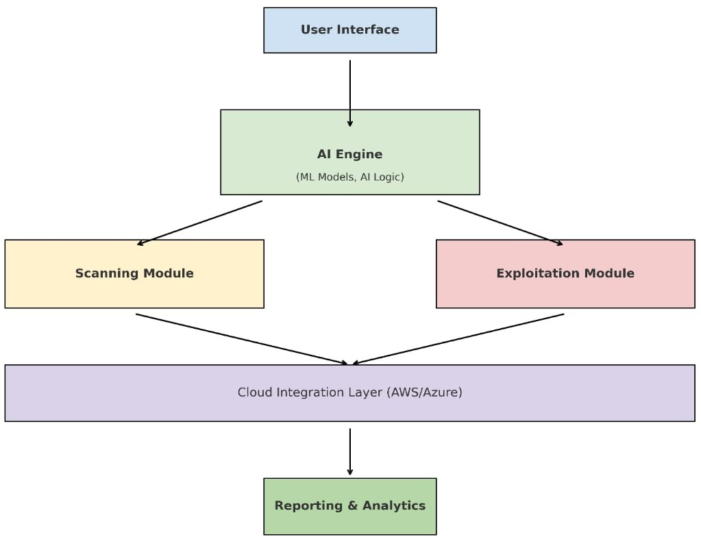

Figure 1: AI-SecPro Conceptual Framework

1. Method of Approach

Methodology: AI-SecPro will be developed using the Agile methodology, which allows iterative development and continuous feedback. This approach ensures flexibility and adaptability, catering to stakeholder needs and evolving project requirements. The methodology will include the following phases:

* Requirement Gathering:
  + Collect technical and functional requirements from stakeholders.
  + Identify key performance indicators (KPIs) and deliverables.
* System Design:
  + Develop high-level and detailed designs, including architectural diagrams.
  + Define integration points with existing penetration testing tools.
* Implementation:
  + Develop the core AI-driven functionalities using Python, TensorFlow, and PyTorch.
  + Integrate scanning and testing tools for vulnerability analysis and exploitation.
* Testing:
  + Perform unit, integration, and system testing to ensure functionality and performance.
  + Validate the AI model’s accuracy and adaptability using test scenarios.
* Deployment:
  + Deploy the framework in a cloud-based environment using AWS or Azure for scalability.
  + Ensure compatibility with various organizational infrastructures.
  + Feedback and Iteration:Gather feedback from end-users and refine the system.
  + Update machine learning models based on real-world data.

Technological Stack:

AI and Machine Learning: Python, TensorFlow, PyTorch. Penetration Testing Tools: Metasploit, Nmap, OpenVAS etc.

Cloud Services: AWS, Azure for computational scalability and resource management.

Database and Storage: PostgreSQL for structured data storage, Elasticsearch for quick querying.

Key Features:

Self-Learning Models: Adaptive algorithms that evolve with new threats.

Real-Time Intelligence: Real-time updates on vulnerabilities and attack simulations. Automated Reporting: Generation of actionable, audit-ready reports.

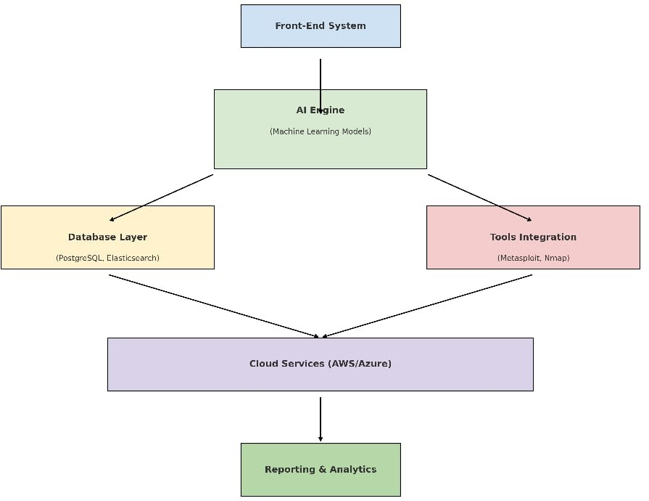

Figure 2: AI-SecPro High-Level Architecture

1. Initial Project Plan

|  |  |  |
| --- | --- | --- |
| The development of AI-SecPro will follow a well-defined timeline, starting with research and requirement gathering in September 2024 and continuing with development through 2025. Testing and deployment will be completed by May 2025, with ongoing support and updates.Phase | Timeline | Description |
| Research and Planning | September2024 - October 2024 | - Conduct a literature review and finalize project objectives. |
|  |  | - Create a detailed project plan and outline. |
| System Design | November 2024 | - Develop system architecture and design user interface. |
|  |  | - Outline how AI will be integrated into the framework. |
| Development and Implementation | December 2024 - February 2025 | - Code the framework, implementing features and AI algorithms. |
|  |  | - Develop modules for different penetration testing phases |
| Testing and Evaluation | February 2025 | - Conduct testing (unit, integration, user acceptance). |
|  |  | - Gather feedback from potential users for refinement. |
| Documentation | Late February 2025 | - Prepare comprehensive documentation (user guides, specs). |
| Final Review and Launch | Early March 2025 | - Finalize the project, address any issues, and prepare for submission. |

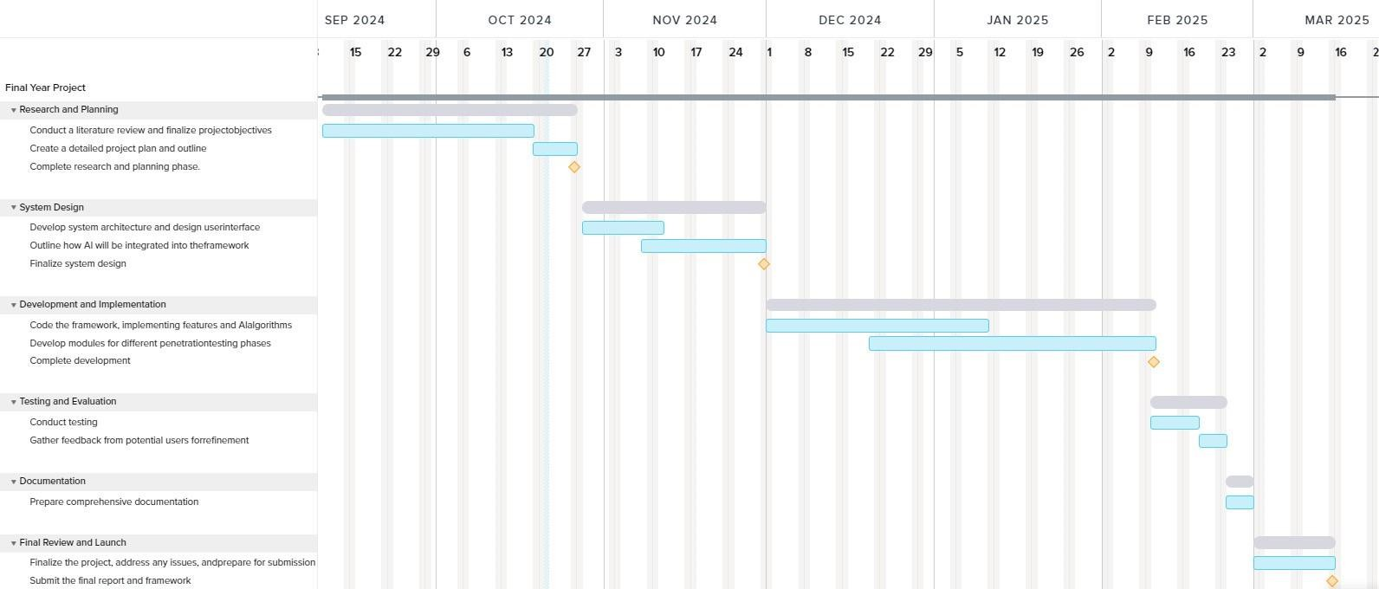

Figure 3: AI-SecPro Development Timeline

1. Risk Analysis

Risk analysis is a critical part of the AI-SecPro project to ensure potential issues are identified, assessed, and mitigated. Below is the updated risk analysis:

|  |  |  |  |
| --- | --- | --- | --- |
| Risk | Likelihood | Impact | Mitigation Strategy |
| Data Privacy Concerns | Hight | Severe | Implement robust encryption protocols for sensitive data storage and transfer. Regularly audit  data handling practices. |
| Scalability Challenges | Medium | Moderate | Use scalable cloud services like AWS and Azure. Employ  containerization (e.g., |

|  |  |  |  |
| --- | --- | --- | --- |
|  |  |  | Docker) to ensure easy scaling. |
| Regulatory Compliance Issues | High | Severe | Align processes with standards like GDPR, HIPAA, and PCI-DSS.  Automate compliance checks in reporting  modules. |
| Ethical Misuse of AI | Low | High | Integrate ethical safeguards to limit misuse, such as access  control and usage monitoring. |
| AI Model Training Limitations | Medium | High | Use diverse and high- quality datasets.  Incorporate a feedback loop to enhance learning  over time. |
| Technical Integration Issues | Medium | Moderate | Perform extensive testing with tools (Metasploit, Nmap). Create modular  designs to isolate issues. |
| High Computational Requirements | Medium | Moderate | Leverage cloud-based GPU resources and optimize algorithms for  resource efficiency. |
| User Adoption Resistance | Low | Moderate | Provide training sessions for security teams.  Develop a user-friendly interface for seamless  operation. |

Table 2: AI-SecPro Risk Analysis and Mitigation Strategies

Risk Categories

* Technical Risks: Integration issues, scalability challenges, and AI model limitations.
* Compliance Risks: Failure to meet legal and regulatory requirements.
* Operational Risks: Resistance from end-users or inefficient use of resources.
* Ethical Risks: Potential misuse of AI for malicious purposes.

Risk Mitigation Framework

* Regular Audits: Conduct periodic reviews of system performance, compliance, and ethical safeguards.
* User Training: Ensure end-users are well-versed in using AI-SecPro effectively.
* Continuous Monitoring: Implement monitoring tools to identify and address emerging risks in real time.
* Feedback Loop: Use feedback from stakeholders to refine features and address limitations.

1. Conclusion

AI-SecPro is positioned to revolutionize penetration testing by integrating advanced AI and machine learning techniques. The framework addresses critical challenges in the cybersecurity landscape, such as scalability, adaptability to emerging threats, and operational inefficiencies. By automating core penetration testing activities, AI-SecPro reduces reliance on manual processes, enhances vulnerability detection, and ensures compliance with stringent regulatory standards.

Key Contributions:

* Efficiency and Speed: AI-SecPro significantly reduces the time required for comprehensive penetration testing.
* Advanced Threat Simulation: The framework replicates real-world attack scenarios using AI, uncovering vulnerabilities missed by traditional tools.

Scalability: Designed to cater to organizations of all sizes, leveraging cloud services for flexibility and costefficiency.

* Actionable Insights: Generates detailed, audit-ready reports with prioritized risk levels and remediation strategies.
* Ethical Safeguards: Incorporates measures to prevent misuse and aligns with global cybersecurity regulations.

The successful deployment of AI-SecPro promises to redefine how organizations approach cybersecurity, enabling them to stay ahead of rapidly evolving threats. This innovative framework is not just a tool but a comprehensive solution that empowers organizations to improve their overall security posture while optimizing resource utilization.

References

* Singh, R., et al. (2022). "AI-Powered Vulnerability Analysis." Journal of Advanced Cybersecurity.
* Lopez, A., & Wei, J. (2023). "Ethical Challenges in Automated Penetration Testing." Cyber Ethics Review.
* Chen, Y., et al. (2024). "Evolving Threats and the Role of AI." Journal of Cyber Defense.
* Abid, M., et al. (2023). "AI in Cybersecurity: Emerging Trends and Applications." International Journal of Cybersecurity.
* Dey, A., et al. (2022). "Deep Learning for Security in Cyber-Physical Systems." International Journal of Computer Science.
* Kumar, S., et al. (2023). "Next-Generation Penetration Testing: Integrating AI." IEEE Transactions on Security and Privacy.
* Saber, V., et al. (2023). "Automated Penetration Testing: A Systematic Review." MIUCC.
* Xu, K., et al. (2023). "Enhancing Penetration Testing with AI: A Survey on Capabilities and Challenges." IEEE Access.
* Hilario, E., et al. (2024). "Generative AI for Pentesting: The Good, the Bad, the Ugly." International Journal of Information Security.
* Zhang, Q., et al. (2023). "AI for Cybersecurity: A Review of Challenges and Opportunities." International Journal of Security and Networks.
* Tian, X., et al. (2024). "Adversarial Machine Learning in Penetration Testing: A Survey." Journal of Cybersecurity Research.
* Wei, J., et al. (2023). "Penetration Testing with AI: Moving Beyond Traditional Tools." Cybersecurity Journal.
* Hasan, M., et al. (2023). "AI for Cyber Threat Detection and Response." Future Generation Computer Systems.
* Patel, A., et al. (2022). "Machine Learning for Vulnerability Management." International Journal of Cyber Threats and Protection.
* Jha, S., et al. (2024). "Ethical AI in Penetration Testing." Ethics and Information Technology.
* Raman, A., et al. (2022). "Automating Penetration Testing with AI: Challenges and Solutions." ACM Computing Surveys.
* Lee, T., et al. (2023). "AI in Network Penetration Testing." Network Security Journal.
* Sharma, M., et al. (2024). "AI in Penetration Testing and Cybersecurity: A Comprehensive Overview." Journal of Network and Computer Applications.
* Li, H., et al. (2023). "AI-Driven Security Auditing and Vulnerability Testing." IEEE Security & Privacy.
* Zhang, L., et al. (2023). "Automating Ethical Hacking with AI." Journal of Cyber Intelligence.
* Yadav, A., et al. (2024). "Advances in AI for Penetration Testing." International Journal of Computer Applications.
* Bhattacharyya, A., et al. (2023). "AI and Deep Learning for Security Vulnerability Detection." Future Internet.
* Nguyen, P., et al. (2022). "Deep Learning in Penetration Testing." Machine Learning for Security.
* Kumar, R., et al. (2023). "AI for Offensive Security." Journal of Cyber Warfare and Security.
* Yang, X., et al. (2023). "AI in Cyber Defense: Penetration Testing Approaches." Journal of Information Warfare.

## Appendix C: Stage Plans



## Appendix D: Interim Report



PUSL3190 Computing Individual Project

**Project Interim Report**

AI-SecPro:

An AI-Driven Penetration Testing Framework

Supervisor: Dr.Pabudi Abeyrathne

Name: RASN Priyantha Plymouth Index Number: 10899343 Degree Program: Computer Security

TOC

Chapter 01: Introduction 3

1. Introduction 3
2. Problem Definition 3
3. Project Objectives 4

Chapter 02: System Analysis 5

1. Facts Gathering Techniques 5
2. Existing System 5
3. Use Case Diagram 6
4. Drawbacks of the Existing System 6

Chapter 03: System Requirements 7

* Functional Requirements 7
* Non-Functional Requirements 8
* Hardware / Software Requirements 8
* Networking Requirements (Optional) 9

Chapter 04: Feasibility Analysis 9

* Operational Feasibility 9
* Technical Feasibility 10
* Outline Budget 10

Chapter 05: System Architecture 11

* Class Diagram of Proposed System 11
* ER Diagram 12
* High-Level Architectural Diagram 13

Chapter 06: Development Tools and Technologies 14

* Development Methodology 14
* Programming Languages and Tools 16
* Third-Party Components and Libraries 16
* Algorithms 17

Chapter 07: Discussion 17

Overview of the Interim Report 17

Summary of the Report 18

Challenges Faced 18

Future Plans / Upcoming Work 19

References 20

Chapter 01: Introduction

* Introduction

The rapid evolution of cyber threats necessitates the development of advanced penetration testing tools capable of identifying and mitigating vulnerabilities before they can be exploited by malicious actors. With the increasing complexity of IT infrastructures and the growing sophistication of cyber-attacks, traditional penetration testing methods often struggle to keep pace with emerging threats. AI-SecPro, an AI-driven penetration testing framework, is designed to address these challenges by leveraging artificial intelligence (AI) and machine learning (ML) to automate vulnerability assessment, exploitation, and post-exploitation analysis. By integrating AI into cybersecurity processes, AI-SecPro enhances penetration testing efficiency, adaptability, and accuracy, making it a vital tool for modern security operations.

Penetration testing, commonly referred to as ethical hacking, is a structured approach used to evaluate the security posture of an organization's IT infrastructure. It involves simulating cyber-attacks to identify weaknesses before attackers can exploit them. However, traditional penetration testing methods are often time-consuming, resource- intensive, and highly dependent on human expertise. These challenges limit their scalability and effectiveness, especially for organizations managing large and complex networks.

AI-SecPro is designed to overcome these limitations by automating critical penetration testing tasks through AI and ML. By incorporating intelligent automation, AI-SecPro reduces the reliance on manual efforts, minimizes errors, and accelerates vulnerability detection. Furthermore, AI-driven methodologies enable the framework to adapt to new attack vectors, ensuring that penetration testing remains proactive rather than reactive. This approach enhances cybersecurity defenses by providing real-time threat intelligence, automated exploitation capabilities, and comprehensive risk assessments.

In addition to improving efficiency, AI-SecPro is aligned with global cybersecurity compliance standards, such as the General Data Protection Regulation (GDPR), Health Insurance Portability and Accountability Act (HIPAA), and Payment Card Industry Data Security Standard (PCI-DSS). Compliance with these regulations is critical for organizations handling sensitive data, as it helps mitigate legal and financial risks associated with data breaches. By automating security assessments and reporting, AI-SecPro assists organizations in maintaining compliance while strengthening their overall security posture.

* Problem Definition

Traditional penetration testing tools and methodologies present several challenges that hinder their effectiveness in modern cybersecurity environments. These challenges include:

* Manual Effort & Time-Consuming Process: Traditional penetration testing requires significant human expertise, often taking days or weeks to complete a thorough assessment. Manual testing involves multiple steps, including reconnaissance, scanning, exploitation, and reporting, making it a labor-intensive process that is difficult to scale.
* Limited Adaptability to Emerging Threats: Many penetration testing tools rely on predefined attack signatures and static rule sets. As cyber threats evolve, these static tools struggle to detect novel attack techniques, leaving organizations vulnerable to zero-day exploits and sophisticated attack methodologies.
* Scalability Issues: Organizations managing large and complex IT infrastructures face challenges in scaling penetration testing efforts. Manually testing each system and application is impractical, particularly for enterprises with global operations and distributed networks.
* Compliance Challenges: Adhering to industry-specific cybersecurity regulations such as GDPR, HIPAA, and PCI- DSS requires continuous monitoring and timely vulnerability assessments. Traditional penetration testing methods often lack the automation necessary to ensure compliance in real-time.
* Lack of Real-Time Security Insights: Existing penetration testing tools typically provide assessment results after the testing process is complete. This delayed analysis limits an organization's ability to respond to threats proactively, increasing the risk of exploitation before vulnerabilities can be patched.

AI-SecPro is designed to bridge these gaps by integrating AI-driven automation, real-time vulnerability detection, and advanced risk assessment techniques. By addressing these challenges, AI-SecPro enhances penetration testing efficiency, effectiveness, and adaptability, providing organizations with a robust cybersecurity solution.

* Project Objectives

AI-SecPro is developed with the following key objectives to revolutionize penetration testing methodologies: Automate Penetration Testing with AI-Powered Threat Simulations:

AI-SecPro leverages AI-driven automation to conduct penetration tests with minimal human intervention. By using intelligent algorithms, the framework simulates sophisticated cyber-attacks, ensuring thorough security assessments across various IT environments.

Enhance Vulnerability Detection Using Machine Learning:

Machine learning algorithms analyze patterns, anomalies, and historical attack data to improve vulnerability detection accuracy. AI-SecPro continuously learns from past penetration testing results, adapting to new attack vectors and refining its assessment capabilities over time.

Reduce Human Intervention, Improving Efficiency and Accuracy:

Traditional penetration testing requires expert analysts to conduct assessments, interpret results, and generate reports. AI-SecPro automates these processes, reducing human error, improving accuracy, and accelerating the overall testing workflow.

Ensure Compliance with Global Cybersecurity Regulations:

AI-SecPro incorporates compliance checks into its penetration testing framework, ensuring that organizations meet regulatory requirements. Automated compliance reporting helps businesses stay aligned with GDPR, HIPAA, PCI-DSS, and other industry standards, reducing the risk of legal penalties and data breaches.

Simulate Advanced Attacks Using AI-Driven Methodologies:

AI-SecPro employs adversarial AI techniques to mimic the behavior of advanced persistent threats (APTs). By simulating real-world attack scenarios, organizations gain insights into potential security weaknesses and can implement effective countermeasures before an actual attack occurs.

Provide Real-Time Security Insights and Automated Reporting:

The framework delivers real-time analytics, allowing security teams to respond to vulnerabilities and threats as they are detected. Automated reporting features provide detailed insights into security findings, recommended remediation actions, and risk assessments, enabling organizations to make informed decisions swiftly.

AI-SecPro is designed to transform penetration testing from a reactive, manual process into an intelligent, automated, and proactive cybersecurity solution. By integrating AI and ML, the framework not only enhances vulnerability detection but also improves security resilience against evolving cyber threats.

Chapter 02: System Analysis

* Facts Gathering Techniques

To thoroughly analyze the current cybersecurity landscape and identify areas for improvement in penetration testing, a variety of facts gathering techniques were employed. These methodologies ensured that a comprehensive understanding of existing challenges and potential solutions was obtained, leading to the development of the AI-powered penetration testing system (AI-SecPro).

Literature Review: A detailed review of academic papers, industry reports, and whitepapers was conducted to study the integration of AI in cybersecurity, with a focus on its applications in penetration testing. The review provided insights into the capabilities of AI to automate routine tasks in penetration testing, such as vulnerability scanning, attack simulations, and exploit detection, helping to identify gaps in current methods.

Interviews & Surveys: Data was gathered through interviews and surveys with cybersecurity professionals working in both small enterprises and large organizations. These insights offered valuable perspectives on the strengths and weaknesses of traditional penetration testing methods and the interest in AI-driven solutions. The results revealed a significant demand for more efficient, scalable, and adaptive testing tools.

Case Studies: Case studies of major security incidents and breaches were examined to understand how traditional penetration testing methodologies were applied in real-world scenarios. This helped to highlight the limitations in existing systems, such as delayed threat identification and response times, and the potential benefits of integrating AI to enhance detection and response capabilities.

* Existing System

The current traditional penetration testing methodologies largely rely on manual processes and semi-automated tools. These existing systems have been effective to some extent but are increasingly insufficient for addressing the dynamic and evolving nature of modern cyber threats.

Manual Scanning & Exploitation: Traditional methods predominantly involve cybersecurity professionals manually scanning systems for vulnerabilities and exploiting identified weaknesses using tools like Metasploit, OpenVAS, and Nessus. While these tools are effective in identifying known vulnerabilities, they are time-consuming and require expert knowledge to operate and interpret results.

Limited Automation: Some tools provide automated scanning, but they still require significant human intervention for analysis, decision-making, and exploit deployment. This limits the scalability and efficiency of penetration testing, particularly for large networks or enterprise systems that require regular and exhaustive testing.

Static Vulnerability Detection: Existing systems typically employ static vulnerability detection, which lacks the ability to adapt to new threats. They depend on predefined signature-based detection methods and static databases of known vulnerabilities. This approach is reactive and unable to address emerging or previously unknown threats effectively.

* Use Case Diagram

The proposed AI-SecPro system aims to transform the current cybersecurity landscape by introducing intelligent automation in penetration testing. A detailed use case diagram has been developed, which illustrates the interactions between different stakeholders, including users, AI-SecPro, and the security components of the system. The diagram highlights key functionalities such as:

User Authentication and Role Management: The system will allow users to log in and specify the type of penetration test, such as web application or network testing. Role-based access control will ensure that users can only access specific functionalities based on their privileges.

Automated Penetration Testing: AI-SecPro will automate various stages of penetration testing, including vulnerability scanning, risk assessment, and exploitation, using AI-driven algorithms that analyze patterns and adapt to new threat landscapes.

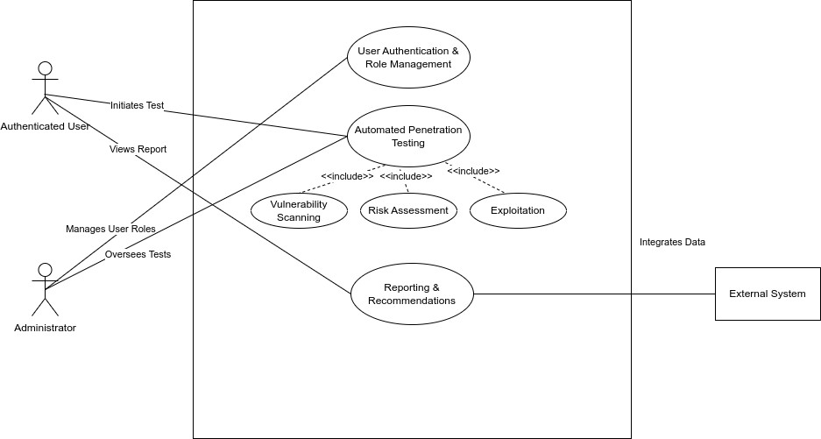Reporting and Recommendations: Once a test is completed, the system will generate detailed reports, including vulnerabilities found, exploitability, severity levels, and remediation recommendations.

* Drawbacks of the Existing System

Despite their widespread use, traditional penetration testing systems have several drawbacks that hinder their effectiveness and efficiency:

Time-Consuming and Resource-Intensive: Traditional penetration testing is manual, requiring a significant amount of time and expertise to complete. The need for cybersecurity professionals to carry out repetitive tasks, such as scanning and exploitation, makes it a resource-heavy process, which is inefficient for large-scale systems.

Reactive Security Measures: Existing systems tend to be reactive, focusing on identifying and responding to known threats. This limits their ability to anticipate or defend against emerging threats that have not yet been documented in vulnerability databases. As a result, there is a lag in identifying new vulnerabilities and exploits, putting organizations at risk.

Inability to Adapt to New Threats Dynamically: Static detection methods used in traditional systems are unable to evolve in real-time. These systems rely on predefined vulnerability signatures, making them vulnerable to novel attack methods that do not yet have a signature or known pattern. This lack of adaptability makes them less effective in detecting sophisticated or previously unknown threats.

Scalability Issues in Enterprise-Level Penetration Testing: Traditional penetration testing tools are often unsuitable for enterprise environments, where the scope of testing can be enormous. Testing large, complex networks with numerous endpoints, devices, and configurations requires significant manual effort, making it difficult to scale the testing process. Moreover, frequent testing cycles needed to keep pace with evolving threats demand an automated and scalable approach.

The shortcomings of the existing system highlight the need for a more advanced, efficient, and scalable solution. AI- SecPro aims to address these challenges by integrating AI-driven automation into penetration testing, providing a proactive and adaptive approach to cybersecurity.

Chapter 03: System Requirements

* Functional Requirements

The functional requirements of the AI-SecPro system are defined to ensure that the system delivers essential capabilities and functionalities that meet the needs of cybersecurity professionals. These capabilities are critical for automating and enhancing the penetration testing process. Below are the key functional requirements:

AI-Powered Vulnerability Scanning: AI-SecPro will incorporate advanced machine learning and AI algorithms to automate the identification of vulnerabilities in the target systems. The AI will continuously learn and adapt, improving its ability to detect new and emerging vulnerabilities. By analyzing system configurations, network architecture, and past attack data, the AI will proactively identify potential security weaknesses.

Automated Attack Simulations: AI-SecPro will simulate real-world cyberattacks using AI-powered models that mimic sophisticated attack methods. These simulations will allow security teams to identify vulnerabilities before attackers can exploit them. The system will generate realistic attack patterns based on threat intelligence, adapting to new tactics, techniques, and procedures (TTPs) used by cybercriminals.

Real-Time Security Reports and Risk Assessments: The system will generate real-time security reports that detail the results of the penetration tests, including vulnerabilities found, their severity, exploitability, and recommended actions for remediation. Additionally, it will provide ongoing risk assessments, adjusting its analyses in response to the latest threat landscape and emerging vulnerabilities.

User Authentication & Role-Based Access Control: AI-SecPro will implement secure user authentication and role-based access control (RBAC) to ensure that only authorized personnel can access sensitive security data and testing

functionalities. The system will support multiple user roles, including administrators, security analysts, and testers, each with tailored access rights and permissions to safeguard the integrity of security operations.

Integration with Existing Security Tools and Frameworks: The system will be designed for seamless integration with existing cybersecurity tools, such as SIEM (Security Information and Event Management) platforms, vulnerability scanners, and threat intelligence feeds. This will ensure that AI-SecPro complements and enhances the functionality of the organization’s current security infrastructure, allowing for a unified and efficient approach to vulnerability management.

* Non-Functional Requirements

In addition to functional requirements, several non-functional requirements are crucial to the system’s success, ensuring that it operates effectively at scale, with high reliability, and in compliance with industry standards. These non-functional requirements are outlined as follows:

Scalability to Support Large Enterprises: AI-SecPro must be scalable to handle the demands of large enterprises, which often have complex IT environments with numerous endpoints, systems, and networks to protect. The system should be capable of processing large volumes of data, conducting tests across multiple devices simultaneously, and handling varying loads without degradation in performance.

High Availability Ensuring Minimal Downtime: The system must be available and operational 24/7 with minimal downtime, ensuring that penetration testing can be performed at any time without disrupting business operations. Redundant systems, failover mechanisms, and cloud-based deployment will be leveraged to provide high availability and resilience.

Regulatory Compliance with GDPR, HIPAA, PCI-DSS: Compliance with relevant regulatory frameworks such as the General Data Protection Regulation (GDPR), Health Insurance Portability and Accountability Act (HIPAA), and Payment Card Industry Data Security Standard (PCI-DSS) is essential. The system will be designed with built-in features to ensure that data handling and processing meet the privacy and security requirements set by these regulations, particularly regarding the handling of sensitive data.

Usability and an Intuitive User Interface for Security Analysts: The system should offer an intuitive, user-friendly interface that simplifies the process for security analysts and reduces the learning curve. Dashboards and visualizations should provide actionable insights, and reports should be easily accessible. The interface should streamline workflows and enable analysts to quickly identify vulnerabilities, simulate attacks, and assess risk.

* Hardware / Software Requirements

To meet the functional and non-functional requirements of AI-SecPro, the following hardware and software components are required:

Hardware Requirements: The system will need high-performance servers with GPU support to handle the AI-driven analysis and machine learning processes. These servers should have sufficient processing power, memory, and storage capacity to process large datasets and perform complex calculations in real-time. The hardware must be capable of scaling horizontally to accommodate increased demand, especially when the system is deployed in large enterprises or cloud environments.

Software Requirements: The AI-SecPro system will be built using the following core software components:

Python: Python will be used for the development of AI models, automation scripts, and data processing pipelines. Its extensive libraries and frameworks will be leveraged to implement machine learning and AI functionalities.

TensorFlow: TensorFlow will be used to build and train deep learning models for vulnerability detection, attack simulation, and anomaly detection. Its scalability and flexibility make it ideal for building AI systems capable of handling large volumes of data.

PostgreSQL: PostgreSQL will be the database management system for storing test results, vulnerability data, and system configurations. It provides reliable and robust data storage with support for complex queries and transactions.

Elasticsearch: Elasticsearch will be used to index and search large volumes of data generated during penetration tests. It will allow for fast, real-time searching and filtering of security findings and reports, providing efficient access to critical information.

* Networking Requirements (Optional)

To enhance the scalability, accessibility, and reliability of the AI-SecPro system, a cloud-based deployment model will be utilized. Cloud providers such as AWS (Amazon Web Services) or Azure will offer the necessary infrastructure to scale the system dynamically based on demand, ensuring high availability and performance.

Cloud-Based Deployment: The system will be deployed in a cloud environment, allowing for flexible scaling and easy access from anywhere in the world. Cloud infrastructure will ensure that the system can handle an increasing number of users, penetration tests, and data processing without requiring significant on-premise hardware investment. The cloud model will also facilitate continuous updates, security patches, and the management of system resources in an efficient and cost-effective manner.

Data Security in the Cloud: Security measures such as encryption, VPNs, and secure access protocols will be employed to protect data in transit and at rest. Cloud security features, including identity management and access control, will be incorporated to ensure that only authorized users and devices can interact with the system.

Chapter 04: Feasibility Analysis

* Operational Feasibility

AI-SecPro is designed to address the challenges and inefficiencies found in traditional penetration testing methods. The system is built to streamline complex processes, enabling security teams to work more efficiently and proactively. The operational feasibility of AI-SecPro is derived from its ability to automate time-consuming tasks, thus minimizing manual effort while maximizing effectiveness.

Streamlined Penetration Testing: Traditional penetration testing often involves a significant amount of manual labor, including vulnerability scanning, exploitation, and reporting. AI-SecPro’s automation framework significantly reduces the need for human intervention in these areas. By automating routine tasks such as vulnerability scanning and attack simulations, AI-SecPro enables penetration testers to focus on higher-level tasks such as analysis, strategy, and decision- making. The integration of machine learning allows the system to learn from past attack data and continuously improve its accuracy in detecting new vulnerabilities. This adaptability ensures the system stays up-to-date with emerging security threats.

User-Friendly Dashboard: The core of AI-SecPro’s usability lies in its user-friendly dashboard, designed to simplify the penetration testing process for security analysts. This dashboard provides a central hub where users can interact with the system, view real-time test results, and access detailed reports on vulnerabilities and threats. It presents key security metrics in a visual format, making it easy to understand the status of a penetration test and the associated risks. The dashboard is designed to be intuitive, ensuring that even users with limited experience in penetration testing can operate

it effectively. This aspect of AI-SecPro ensures broader adoption within cybersecurity teams and minimizes the training required for new users.

Automated Logging and Reporting for Audits: Penetration testing is a critical process for identifying vulnerabilities and assessing system security. AI-SecPro automates the logging of all activities performed during testing and generates detailed reports in real time. These reports are essential for audit purposes and provide a clear record of actions taken, vulnerabilities discovered, and remedial actions recommended. Automated logging eliminates the possibility of missing data during the testing process and ensures compliance with various regulatory frameworks. This feature also makes it easier for organizations to perform audits and demonstrate their commitment to maintaining strong cybersecurity practices.

* Technical Feasibility

The technical feasibility of AI-SecPro revolves around its use of cutting-edge technologies such as machine learning, artificial intelligence, and integration with established penetration testing tools. These technologies not only enhance the capabilities of the system but also ensure that it remains efficient and adaptable in the face of rapidly evolving cybersecurity threats.

Machine Learning & AI for Adaptive Threat Detection: AI-SecPro incorporates machine learning models to enhance its threat detection capabilities. By leveraging both supervised and unsupervised learning algorithms, the system is able to detect vulnerabilities and threats that traditional methods may miss. The machine learning models are trained on large datasets of previous attack vectors, allowing AI-SecPro to predict potential security risks and adapt to new attack patterns. This adaptive learning approach makes AI-SecPro capable of identifying previously unknown vulnerabilities, providing proactive defense measures against evolving threats.

Integration with Existing Penetration Testing Tools: AI-SecPro does not seek to replace existing penetration testing tools but instead integrates seamlessly with them. It leverages popular tools such as Metasploit, Nmap, and OpenVAS to perform automated penetration tests and vulnerability assessments. By combining AI-driven analysis with these trusted tools, AI-SecPro enhances the overall testing process. This integration allows penetration testers to use the advanced features of AI-SecPro while still benefiting from the tried-and-true capabilities of existing security tools. This approach minimizes disruption to existing workflows while improving the overall efficiency and effectiveness of penetration testing.

Secure API Integration for Real-Time Data Sharing: AI-SecPro offers secure API integration to facilitate real-time data sharing between systems. The API allows AI-SecPro to communicate with other security tools and platforms, such as SIEM systems and threat intelligence feeds. This ensures that threat data, security findings, and risk assessments are shared promptly across the organization’s security infrastructure. The secure API communication channel also guarantees that sensitive data is transmitted with encryption, maintaining the integrity and privacy of the information. This integration makes AI-SecPro a valuable addition to an organization’s broader security ecosystem.

* Outline Budget

The development and implementation of AI-SecPro will require various resources, including development tools, hardware, and ongoing maintenance. The focus of AI-SecPro is on streamlining penetration testing and security operations without requiring significant external budget or expenditure. The resources necessary for the project will be allocated to ensure its smooth development, deployment, and continued operation.

Chapter 05: System Architecture

* Class Diagram of Proposed System

The class diagram for AI-SecPro visually represents the system's core components, their attributes, and the relationships between them. In the context of AI-SecPro, the class diagram defines how the various elements of the system interact and work together to provide the desired functionality.

AI Model Class: The AI model is responsible for analyzing security data and detecting potential vulnerabilities. It uses machine learning algorithms to adapt to new and emerging threats. The class will contain attributes related to the model’s parameters, training data, and algorithms used for classification or anomaly detection.

Pentesting Engine Class: The pentesting engine is the heart of AI-SecPro, performing automated vulnerability scanning and simulating cyber attacks. This class will have methods for initiating tests, executing exploits, and interacting with security tools like Metasploit or Nmap.

Report Generator Class: Once tests are completed, the report generator class is responsible for compiling the results and generating a comprehensive report. This report outlines vulnerabilities, potential risks, and recommended actions. The report generator class interacts with other components like the AI model and pentesting engine to gather all necessary data for the final output.

User Interface (UI) Class: The user interface class represents the front-end components of AI-SecPro. It provides a dashboard for security analysts to interact with the system, view results, and make decisions. This class will handle user inputs, display reports, and manage access to different features based on user roles.

Security Tools Integration Class: This class manages the integration with third-party penetration testing tools like Metasploit, Nmap, OpenVAS, etc. It ensures smooth communication between AI-SecPro and these tools, enabling seamless automation of vulnerability scanning and attack simulations.

Together, these classes define the structure and function of the AI-SecPro system, ensuring that all components work cohesively to deliver automated penetration testing, real-time threat detection, and compliance reporting.

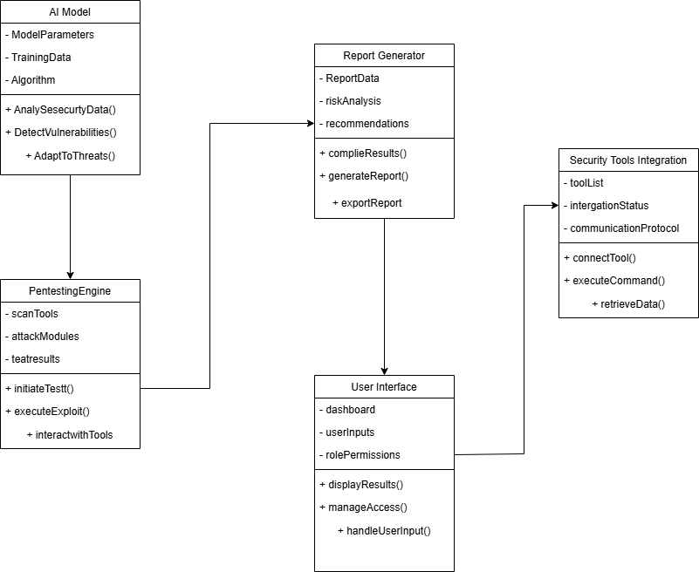

* ER Diagram

The Entity-Relationship (ER) Diagram of AI-SecPro provides a clear representation of how the data flows within the system. It identifies the key entities involved in the system and how they are related to each other. The diagram will show the connections between the database, users, AI models, and penetration testing results.

Entities:

User: Represents the individuals using the AI-SecPro system (security analysts, administrators, etc.). The user entity includes attributes such as user ID, name, role, and authentication details.

Test: Represents individual penetration tests conducted by the system. This includes details about the test, such as test ID, type (e.g., web application test, network test), status, and associated AI model.

AI Model: Represents the machine learning model used for threat detection. It stores information such as model ID, training data, algorithm type, and performance metrics.

Vulnerability: Represents the vulnerabilities identified during the penetration test. It stores information like vulnerability ID, severity, description, and potential risks.

Report: Represents the generated report after a penetration test. It includes test results, findings, remediation suggestions, and compliance data.

Security Tool: Represents third-party penetration testing tools integrated into the system. This includes tools like Metasploit, Nmap, and OpenVAS, with details on their configuration and integration points.

Relationships:

User and Test: A user can initiate multiple penetration tests, and each test is linked to a user who initiated it.

Test and AI Model: Each penetration test uses an AI model to detect vulnerabilities, establishing a one-to-many relationship between tests and AI models.

Test and Vulnerability: A test may uncover multiple vulnerabilities. This relationship is many-to-many as each test may find many vulnerabilities and each vulnerability may appear in multiple tests.

Test and Report: After a test is completed, a corresponding report is generated. This is a one-to-one relationship, where each test generates exactly one report.

Security Tool and Test: The security tools integrated into AI-SecPro are used during the testing phase. Each tool can be linked to multiple tests.

This ER diagram helps in understanding the flow of information within AI-SecPro and how data is structured across different components, facilitating smooth and efficient interaction between them.

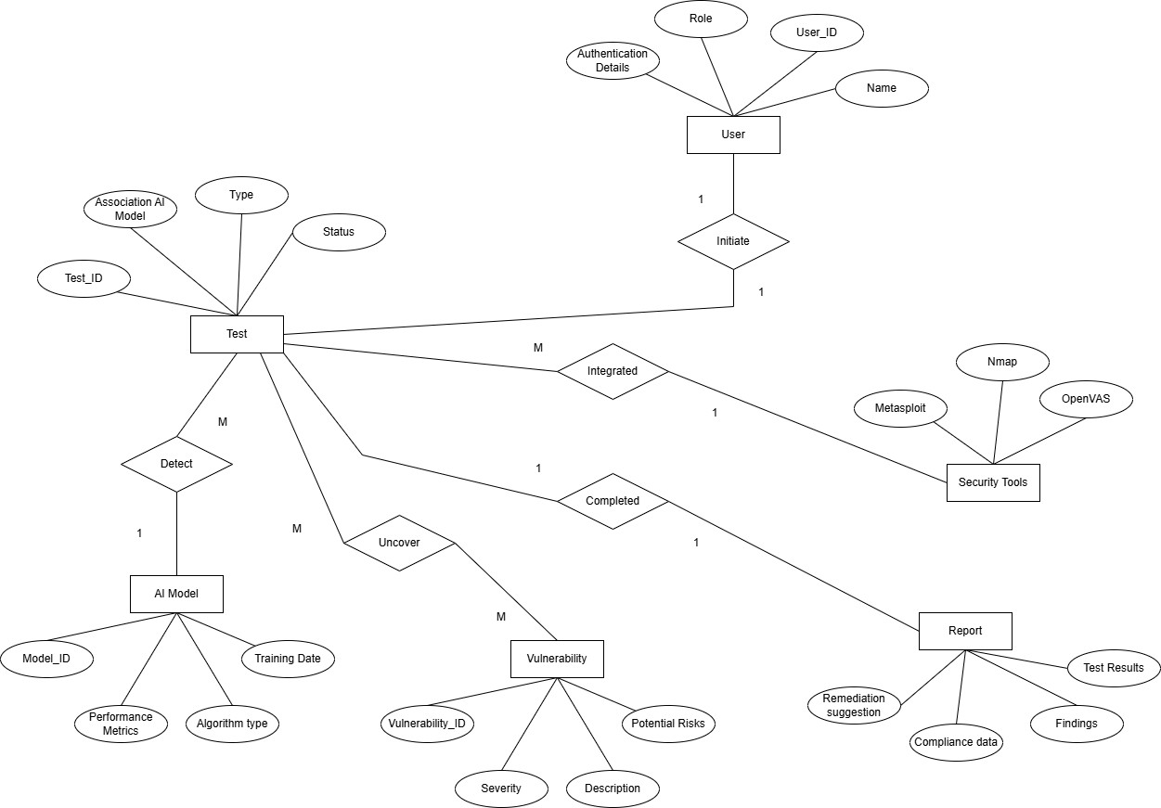

* High-Level Architectural Diagram

The high-level architectural diagram outlines the overall structure of the AI-SecPro system, highlighting the flow of data and the interactions between the key components. The architecture is designed to be modular, scalable, and efficient, allowing it to handle complex penetration tests and adapt to new security threats.

AI Model Processing: The AI models are central to AI-SecPro’s functionality, providing real-time analysis of security data to detect vulnerabilities. These models are trained on large datasets and continuously updated to learn from new attack patterns. The AI component interacts with the pentesting engine to analyze results and enhance the accuracy of the tests. It adapts to new threat vectors, making the system more proactive in detecting potential risks.

Automated Pentesting Engine: The pentesting engine is the core of the system, responsible for simulating cyber attacks. It leverages existing tools like Metasploit, Nmap, and OpenVAS to run automated vulnerability scans and exploit

simulations. The engine is tightly integrated with the AI model, which helps it prioritize vulnerabilities based on their severity and likelihood of being exploited.

Report Generation: Once the tests are complete, the report generation component assembles the findings and prepares a detailed report. This report includes the list of identified vulnerabilities, risk assessments, and recommended remediation actions. It is generated in real time, allowing security analysts to immediately assess the results and take action. The report also includes compliance information to ensure the organization adheres to regulatory standards like GDPR, HIPAA, or PCI-DSS.

User Interface (UI): The front-end UI allows security analysts to interact with the system. It provides a dashboard where users can initiate tests, view results, and analyze reports. The UI is designed to be user-friendly and intuitive, with a focus on ease of navigation. The dashboard displays key security metrics, such as the number of vulnerabilities found, the severity of risks, and real-time alerts on ongoing tests.

Security Tools Integration: AI-SecPro integrates with various third-party security tools to enhance the scope and effectiveness of penetration testing. This includes tools for scanning network vulnerabilities, web application security assessments, and database security checks. The integration allows AI-SecPro to leverage the power of multiple tools within a single automated framework, providing comprehensive security testing.

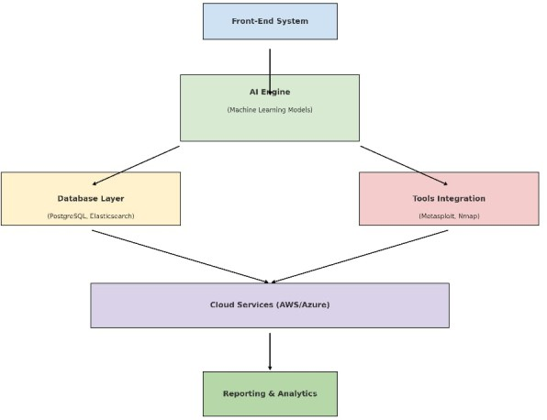

Chapter 06: Development Tools and Technologies

* Development Methodology

The development methodology chosen for this project is Agile, a widely used and highly effective approach in software development that focuses on iterative progress through small, manageable segments of work. Agile emphasizes

flexibility, collaboration, and customer feedback, allowing adaptation to changing requirements and the delivery of high-quality products incrementally. Through this methodology, I work in short development cycles, or sprints, typically ranging from one to four weeks. Each sprint produces a working piece of the software, enabling me to gather feedback, make adjustments, and ensure that the project remains on track.

This iterative approach not only helps in creating a high-quality product that meets user expectations but also fosters continuous improvement. Agile encourages active communication and collaboration, ensuring that any changes or refinements based on project feedback can be easily accommodated. With Agile, I can ensure that the development process remains adaptable to unforeseen challenges or evolving project requirements while keeping the focus on delivering a solution that is both secure and functional.

Additionally, Agile promotes a user-centered approach, allowing the incorporation of feedback from end-users at each stage of the development process. This results in a final product that is not only technically sound but also meets real- world user needs. Furthermore, Agile enables early identification and resolution of issues, minimizing the risk of major roadblocks later in the project lifecycle.

For the backend of the AI-powered security system, I have selected Python in combination with the Django web framework. Python is a highly popular, general-purpose programming language known for its simplicity and readability. It is widely adopted in the development of various types of software applications, including web development, data analysis, artificial intelligence, and machine learning. The readability and ease of use of Python ensure that the development process is streamlined and efficient.

Django, built on top of Python, follows the "batteries-included" philosophy, providing a comprehensive set of tools and features right out of the box. Django comes with built-in components for handling user authentication, routing, and database management, making it ideal for rapid development. Its scalability and security features make it particularly suitable for building complex, production-ready web applications. Additionally, Django includes an Object-Relational Mapping (ORM) system, facilitating seamless communication between the application and relational databases like PostgreSQL.

For the AI and Machine Learning (ML) components of the system, two powerful libraries are employed: TensorFlow and PyTorch. Both of these libraries are widely used in the AI community and support a range of machine learning algorithms and neural network architectures. TensorFlow, developed by Google, is one of the most popular open-source frameworks for machine learning and deep learning. It provides extensive support for building complex models and is well-suited for both research and production environments. PyTorch, developed by Facebook, is another highly regarded deep learning framework known for its dynamic computation graph, making it easier to experiment with complex models.

These frameworks will be used to develop machine learning models responsible for various tasks within the system, such as vulnerability detection, attack simulations, and anomaly detection. TensorFlow and PyTorch provide the flexibility and power needed to implement sophisticated algorithms that can analyze large datasets and identify potential security threats in real time.

For database management, the system leverages PostgreSQL and Elasticsearch. PostgreSQL is a robust, open-source relational database system that supports complex queries, transactions, and data integrity. It is known for its reliability and is an excellent choice for storing structured data such as logs, user activities, and security events. Elasticsearch, on the other hand, is a distributed search engine and analytics tool designed to handle large volumes of unstructured data. It is optimized for fast querying and full-text search capabilities, making it ideal for logging and real-time analytics. Elasticsearch plays a critical role in indexing and retrieving security data, enabling quick searches for specific events or anomalies.

For frontend development, ReactJS is utilized. ReactJS is a widely adopted JavaScript library for building dynamic and responsive user interfaces. It allows for the development of single-page applications (SPAs), which are fast, interactive, and responsive. React’s component-based architecture makes it easy to reuse code, improve performance, and ensure maintainability. With ReactJS, I can create an intuitive and user-friendly dashboard that displays real-time security data, machine learning predictions, and system logs. ReactJS ensures that the system provides a seamless and engaging user experience, empowering users to make informed decisions based on insights provided by the AI models.

* Programming Languages and Tools

For the backend of the AI-powered security system, I have selected Python in combination with the Django web framework. Python is a highly popular, general-purpose programming language known for its simplicity and readability. It is widely adopted in the development of various types of software applications, including web development, data analysis, artificial intelligence, and machine learning. The readability and ease of use of Python ensure that the development process is streamlined and efficient.

Django, built on top of Python, follows the "batteries-included" philosophy, providing a comprehensive set of tools and features right out of the box. Django comes with built-in components for handling user authentication, routing, and database management, making it ideal for rapid development. Its scalability and security features make it particularly suitable for building complex, production-ready web applications. Additionally, Django includes an Object-Relational Mapping (ORM) system, facilitating seamless communication between the application and relational databases like PostgreSQL.

For the AI and Machine Learning (ML) components of the system, two powerful libraries are employed: TensorFlow and PyTorch. Both of these libraries are widely used in the AI community and support a range of machine learning algorithms and neural network architectures. TensorFlow, developed by Google, is one of the most popular open-source frameworks for machine learning and deep learning. It provides extensive support for building complex models and is well-suited for both research and production environments. PyTorch, developed by Facebook, is another highly regarded deep learning framework known for its dynamic computation graph, making it easier to experiment with complex models.

These frameworks will be used to develop machine learning models responsible for various tasks within the system, such as vulnerability detection, attack simulations, and anomaly detection. TensorFlow and PyTorch provide the flexibility and power needed to implement sophisticated algorithms that can analyze large datasets and identify potential security threats in real time.

For database management, the system leverages PostgreSQL and Elasticsearch. PostgreSQL is a robust, open-source relational database system that supports complex queries, transactions, and data integrity. It is known for its reliability and is an excellent choice for storing structured data such as logs, user activities, and security events. Elasticsearch, on the other hand, is a distributed search engine and analytics tool designed to handle large volumes of unstructured data. It is optimized for fast querying and full-text search capabilities, making it ideal for logging and real-time analytics. Elasticsearch plays a critical role in indexing and retrieving security data, enabling quick searches for specific events or anomalies.

For frontend development, ReactJS is utilized. ReactJS is a widely adopted JavaScript library for building dynamic and responsive user interfaces. It allows for the development of single-page applications (SPAs), which are fast, interactive, and responsive. React’s component-based architecture makes it easy to reuse code, improve performance, and ensure maintainability. With ReactJS, I can create an intuitive and user-friendly dashboard that displays real-time security data, machine learning predictions, and system logs. ReactJS ensures that the system provides a seamless and engaging user experience, empowering users to make informed decisions based on insights provided by the AI models.

* Third-Party Components and Libraries

In addition to the core technologies, the project integrates various third-party components and libraries that provide specialized functionality to enhance the overall capabilities of the AI-powered security system.

For penetration testing and vulnerability analysis, tools such as Metasploit and OpenVAS are used. Metasploit is a widely recognized penetration testing framework that includes a vast collection of exploits, payloads, and auxiliary modules, making it an essential tool for testing the security of systems. Metasploit allows for both automated and manual exploitation of security vulnerabilities, providing a comprehensive view of potential weaknesses in the system. OpenVAS (Open Vulnerability Assessment System) is an open-source vulnerability scanner that detects security flaws in networks, systems, and applications. It is an essential tool for identifying and remediating vulnerabilities before they can be exploited by attackers.

To scale the infrastructure, the project integrates cloud services from AWS and Azure. Amazon Web Services (AWS) is one of the leading cloud platforms that provides a broad range of computing services, including storage, networking, and machine learning tools. AWS allows for the flexible deployment of AI models, databases, and web applications, providing the necessary resources for the project's backend. Similarly, Microsoft Azure offers cloud services that support the project’s requirements, including computing power, machine learning services, and security tools, enabling a highly scalable and reliable architecture.

For logging and monitoring, both Elasticsearch and Kibana are integrated into the project. Kibana is an open-source data visualization tool that works in conjunction with Elasticsearch to create interactive dashboards and visual representations of the collected data. These visualizations are crucial for monitoring system performance, detecting anomalies, and tracking security events in real time. By combining Elasticsearch's powerful search and indexing capabilities with Kibana's intuitive interface, I can easily access and analyze logs and security data.

* Algorithms

The system incorporates several advanced machine learning algorithms to power its intelligent security features, providing automated analysis and detection of vulnerabilities and threats.

Supervised Learning is used for vulnerability detection. In this approach, labeled datasets are used to train the model, allowing it to learn the relationship between input features (e.g., system configurations, traffic patterns, etc.) and known vulnerabilities. Once trained, the model can be used to classify new data, detecting potential vulnerabilities in real-time and suggesting appropriate remediation actions. Supervised learning is particularly useful in scenarios where large labeled datasets of known vulnerabilities are available for training.

Reinforcement Learning is applied to attack simulations. In reinforcement learning, an AI agent interacts with an environment by performing actions and receiving feedback in the form of rewards or penalties. This enables the agent to learn optimal strategies for exploiting vulnerabilities or defending against attacks. Through trial and error, the agent improves its actions over time, providing valuable insights into attack strategies and defense mechanisms.

Neural Networks are utilized for anomaly detection. Deep neural networks are highly effective at identifying unusual patterns in complex datasets. By training on a large volume of normal system behavior, the network learns to recognize what constitutes "normal" activity. When anomalous behavior occurs, such as unusual network traffic or unauthorized access attempts, the neural network can flag these events as potential threats. This algorithm is particularly effective in identifying zero-day attacks or previously unknown security breaches.

Chapter 07: Discussion

Overview of the Interim Report

The interim report provides a comprehensive overview of the AI-SecPro project, focusing on its objectives, system analysis, architecture, feasibility, and the development tools utilized in its implementation. The report serves as a snapshot of the current state of the project, outlining key components such as the integration of Artificial Intelligence (AI) into penetration testing processes, the development of machine learning models, and the use of various technologies that support both the backend and frontend systems.

The report also addresses the project's alignment with industry best practices in cybersecurity, emphasizing the role of AI in improving the efficiency, accuracy, and adaptability of security assessments. Additionally, the interim report highlights the methodology adopted for the development, including the use of agile practices to ensure continuous feedback and iterative improvements throughout the project lifecycle.

The interim report also serves to clarify the project's scope, the tools and technologies being used, and the challenges faced during its development. As a work-in-progress, this report sets the stage for the next phase of development, with a focus on fine-tuning AI models and expanding the system's capabilities to provide comprehensive, real-time security solutions.

Summary of the Report

The AI-SecPro system integrates Artificial Intelligence (AI) into traditional penetration testing practices, revolutionizing the way security assessments are performed. By leveraging AI technologies, the system enhances penetration testing by automating and optimizing key tasks, such as vulnerability detection, attack simulations, and anomaly detection.

The use of machine learning (ML) algorithms, specifically supervised learning for vulnerability detection, reinforcement learning for attack simulations, and neural networks for anomaly detection, plays a central role in improving the effectiveness of penetration testing. These AI-powered capabilities not only accelerate the testing process but also provide more accurate and reliable results, reducing the chances of human error.

AI-SecPro aims to increase the adaptability of penetration testing by enabling the system to evolve in response to new threats and attack methods. The system's ability to simulate various attack vectors and perform real-time analysis allows it to identify potential vulnerabilities in a network, system, or application before they can be exploited by malicious actors. Furthermore, AI-driven insights help organizations make more informed decisions regarding their cybersecurity strategies and remediation efforts.

Through the integration of powerful backend tools such as Django, TensorFlow, PyTorch, PostgreSQL, and Elasticsearch, combined with frontend technologies like ReactJS, AI-SecPro is able to provide a robust and scalable platform for performing penetration testing and cybersecurity assessments. The use of cloud platforms such as AWS and Azure further enhances the system’s scalability, allowing it to handle large-scale data processing and accommodate growing cybersecurity needs.

Overall, the report highlights the project’s objectives of improving penetration testing efficiency, enhancing security accuracy, and creating a more adaptive and proactive cybersecurity solution. By utilizing advanced AI technologies, AI-SecPro represents the future of automated security testing and vulnerability management.

Challenges Faced

Throughout the development of AI-SecPro, several challenges have been encountered that require ongoing attention and resolution:

Training AI Models for Cybersecurity Scenarios: One of the primary challenges faced in the development of AI-SecPro is the training of AI models to handle diverse cybersecurity scenarios. Unlike traditional applications, cybersecurity scenarios can be highly dynamic, with new attack methods emerging regularly. Training AI models to recognize these new threats and accurately detect vulnerabilities requires large, high-quality datasets. Obtaining such datasets can be difficult, as they need to be representative of various attack vectors, vulnerabilities, and system behaviors. Moreover, training the models to be both highly accurate and efficient is a time-consuming process that demands careful fine- tuning and optimization.

Another challenge related to training AI models involves ensuring that the models are robust enough to handle the vast variability in real-world cybersecurity threats. Machine learning models must be able to adapt to ever-evolving tactics, techniques, and procedures (TTPs) used by attackers. This requires constant retraining with updated datasets and the incorporation of real-time threat intelligence to ensure that the system remains effective and relevant.

Ensuring Compliance with Regulatory Standards: As AI-SecPro is designed to work in cybersecurity environments, ensuring compliance with regulatory standards, such as GDPR (General Data Protection Regulation) and HIPAA

(Health Insurance Portability and Accountability Act), is a critical challenge. The AI system must ensure that the data it processes, stores, and analyzes remains secure, confidential, and compliant with privacy regulations.

This challenge becomes even more complex when handling sensitive data during penetration testing activities. For instance, vulnerabilities discovered during testing could involve sensitive information, and the handling of such data must comply with strict data protection laws. The design and deployment of the system must, therefore, incorporate secure coding practices, data encryption, and secure data storage protocols. Furthermore, transparency in how the AI models make decisions is important for regulatory compliance, as it allows stakeholders to understand how and why specific actions or recommendations are being made by the system.

Managing Real-Time Data Processing for AI-Driven Attacks: One of the key features of AI-SecPro is its ability to simulate and detect attacks in real-time. However, processing real-time data for AI-driven attack simulations presents significant technical challenges. Real-time data streams must be efficiently analyzed without overloading the system, ensuring minimal latency in detecting and responding to potential threats.

The system must be capable of processing large volumes of data rapidly to identify and respond to security events as they occur. This requires highly optimized algorithms and a scalable infrastructure to handle the computational load. Moreover, ensuring that the AI models are able to make quick, accurate predictions and provide actionable insights within the time constraints of real-time processing is essential for the success of the system.

Additionally, managing the continuous flow of data while maintaining high accuracy and speed is a delicate balance. A failure to process data in real-time could result in missed vulnerabilities or delayed responses to attacks, undermining the effectiveness of the system.

Future Plans / Upcoming Work

Looking ahead, several exciting developments and improvements are planned for AI-SecPro:

AI Model Fine-Tuning for Real-World Attack Simulations: One of the immediate goals for the next phase of the project is to fine-tune the AI models used for attack simulations. Currently, the models are trained on generic data, but real- world attack simulations often involve more sophisticated and nuanced tactics. By incorporating more diverse datasets and refining the models through continuous training, AI-SecPro will be able to simulate more realistic attack scenarios that mirror the tactics employed by modern cyber adversaries.

Additionally, integrating threat intelligence feeds into the AI system will allow it to stay updated on emerging attack techniques and adversary behaviors. This continuous learning process will ensure that the system remains adaptable to the changing threat landscape, helping security professionals proactively identify vulnerabilities and mitigate risks before they can be exploited.

Developing AI-Driven Threat Intelligence Mechanisms: Another key area for future development is the creation of AI- driven threat intelligence mechanisms. These mechanisms will allow AI-SecPro to not only detect vulnerabilities and attacks but also to provide predictive insights based on historical data and current threat intelligence. By analyzing patterns in attack data, the system will be able to predict potential future attacks, offering proactive solutions and helping organizations stay ahead of cybercriminals.

The integration of machine learning and natural language processing (NLP) techniques will enable the system to analyze and interpret unstructured data, such as security reports, advisories, and blogs, to gather actionable insights. This will enhance the system's ability to identify zero-day vulnerabilities, new exploit techniques, and other emerging threats.

Scaling and Expanding System Capabilities: As the project progresses, expanding the scalability and capabilities of the system will be essential. Future work will focus on optimizing the AI models to handle larger datasets and provide faster, more accurate results. The integration of additional third-party tools, cloud services, and machine learning algorithms will further enhance the system’s performance, enabling it to support a wider range of use cases, from small businesses to large enterprise environments.

References

* Singh, R., et al. (2022). "AI-Powered Vulnerability Analysis." Journal of Advanced Cybersecurity.
* Lopez, A., & Wei, J. (2023). "Ethical Challenges in Automated Penetration Testing." Cyber Ethics Review.
* Chen, Y., et al. (2024). "Evolving Threats and the Role of AI." Journal of Cyber Defense.
* Abid, M., et al. (2023). "AI in Cybersecurity: Emerging Trends and Applications." International Journal of Cybersecurity.
* Dey, A., et al. (2022). "Deep Learning for Security in Cyber-Physical Systems." International Journal of Computer Science.
* Kumar, S., et al. (2023). "Next-Generation Penetration Testing: Integrating AI." IEEE Transactions on Security and Privacy.
* Saber, V., et al. (2023). "Automated Penetration Testing: A Systematic Review." MIUCC.
* Xu, K., et al. (2023). "Enhancing Penetration Testing with AI: A Survey on Capabilities and Challenges." IEEE Access.
* Hilario, E., et al. (2024). "Generative AI for Pentesting: The Good, the Bad, the Ugly." International Journal of Information Security.
* Zhang, Q., et al. (2023). "AI for Cybersecurity: A Review of Challenges and Opportunities." International Journal of Security and Networks.
* Tian, X., et al. (2024). "Adversarial Machine Learning in Penetration Testing: A Survey." Journal of Cybersecurity Research.
* Wei, J., et al. (2023). "Penetration Testing with AI: Moving Beyond Traditional Tools." Cybersecurity Journal.
* Hasan, M., et al. (2023). "AI for Cyber Threat Detection and Response." Future Generation Computer Systems.
* Patel, A., et al. (2022). "Machine Learning for Vulnerability Management." International Journal of Cyber Threats and Protection.
* Jha, S., et al. (2024). "Ethical AI in Penetration Testing." Ethics and Information Technology.
* Raman, A., et al. (2022). "Automating Penetration Testing with AI: Challenges and Solutions." ACM Computing Surveys.
* Lee, T., et al. (2023). "AI in Network Penetration Testing." Network Security Journal.
* Sharma, M., et al. (2024). "AI in Penetration Testing and Cybersecurity: A Comprehensive Overview." Journal of Network and Computer Applications.
* Li, H., et al. (2023). "AI-Driven Security Auditing and Vulnerability Testing." IEEE Security & Privacy.
* Zhang, L., et al. (2023). "Automating Ethical Hacking with AI." Journal of Cyber Intelligence.
* Yadav, A., et al. (2024). "Advances in AI for Penetration Testing." International Journal of Computer Applications.
* Bhattacharyya, A., et al. (2023). "AI and Deep Learning for Security Vulnerability Detection." Future Internet.
* Nguyen, P., et al. (2022). "Deep Learning in Penetration Testing." Machine Learning for Security.
* Kumar, R., et al. (2023). "AI for Offensive Security." Journal of Cyber Warfare and Security.
* Yang, X., et al. (2023). "AI in Cyber Defense: Penetration Testing Approaches." Journal of Information Warfare.

## Appendix E: Supervisor Meeting Records

